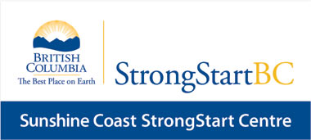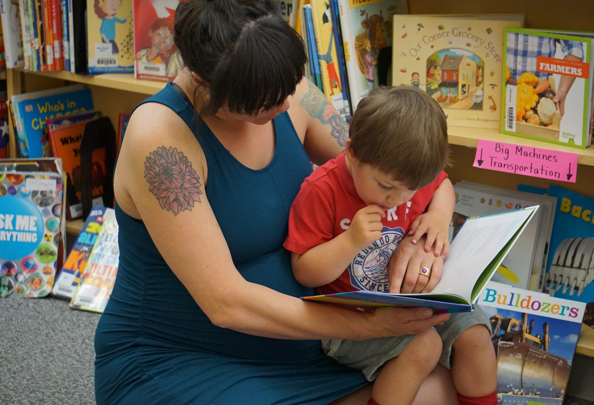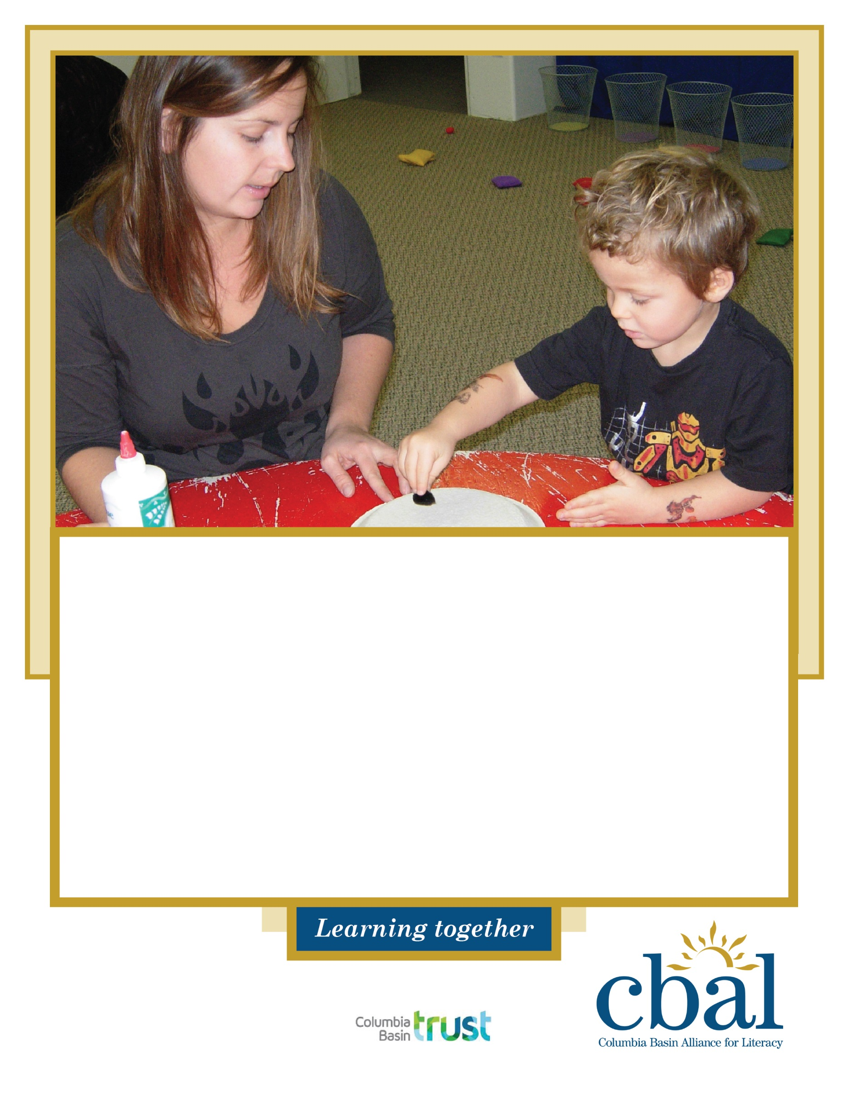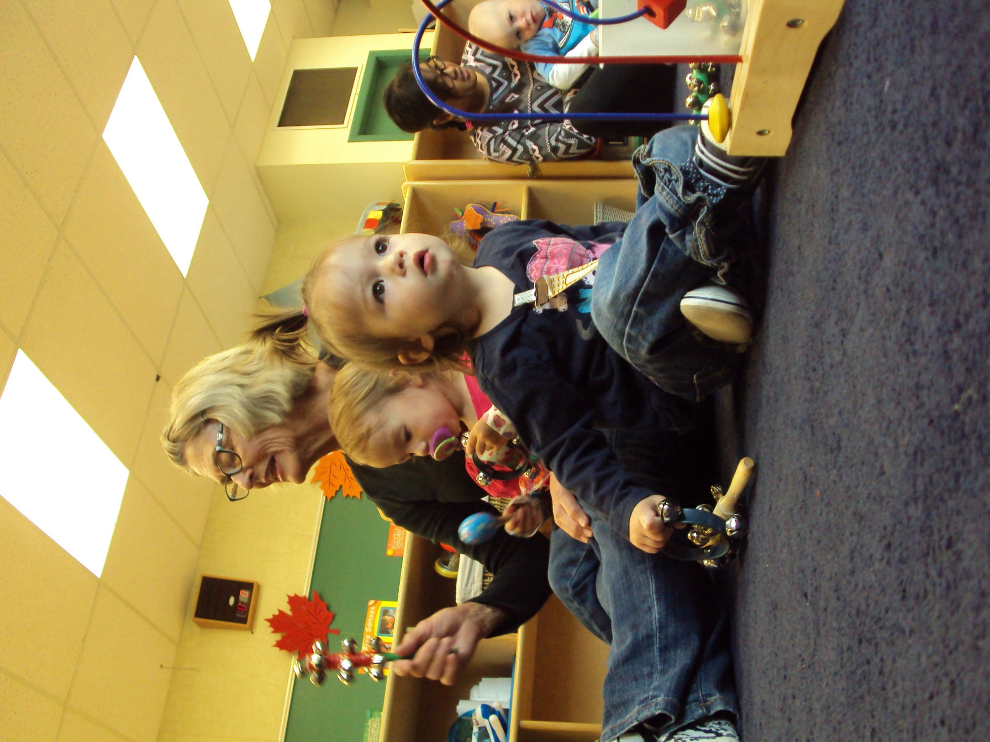

**Free registered program for parents and caregivers with pre-schoolers (children birth to 5 years).**

# Monday to Friday : 9:00 – 11:00 AM

# STARTS MONDAY, OCTOBER 26, 2020

In-person programming available for 14 (adults and children included). Register online or contact us below to receive more information.

Located at Steeples Elementary School, 700 24th Ave N <https://signup.com/go/dJewTMo>

Amy Woodland Elementary School, 911 6th St S <https://signup.com/go/dGFCdnK>

For information, contact: Alison - Community Literacy Coordinator

250-420-7596 afacey@cbal.org

**StrongStart**