Jaffray Elementary Junior Secondary
2021-2022
Vision/Mission:
Growth, success and confidence through the collaboration of students, staff and our community.
Educational Outcome:
To improve students’ skills and confidence in numeracy. The development of a continuum of learning across grade levels with a common assessment to guide learning. Confidence and skills in numeracy allow our students to be successful as they transition into the workplace or post-secondary education.
Objective:

70% of students will be proficient or extending in numeracy expectations for each grade level as reported by teachers on the students’ year-end summative progress report.

Target:

To increase numeracy results for students in Grade 3 and 4 through targeted professional development focused on strategies and skills for teaching numeracy. Grade 3 and 4 teachers will have access to Mathology, Math Place, and teacher collaboration time.
After targeted numeracy support, our students in Grade 3 and 4 will show a 10% improvement on their numeracy score as reported by teachers on the students’ year-end summative progress report.

Rationale:

Based on school data and FSA data we have determined that numeracy should be our focus area following our success in our literacy goals in previous years. Teachers explored the FSA results following their release and determined that numeracy results indicated a need for further development. Our teachers’ year-end summative progress reports mirrored the FSA results, confirming our need to shift focus to numeracy as a school. Even though our numeracy scores are higher than district average and comparable to provincial results, we feel that performance in numeracy can be further improved. We wonder if targeted professional development opportunities in numeracy for all teacher K-10 as well as district targeted professional development for our Grade 3 and 4 teachers will translate to improvement in numeracy results.

Data:

As reported on the year-end summative progress report for the 2020-2021 school year, only 60% of our Grade 2 and Grade 3 students were proficient or extending in numeracy. We would like to see a 10% improvement in these scores at the end of the current school year as these students leave Grade 3 and 4.

According to our FSA results for the 2020-2021 school year, our scores on numeracy at the Grade 4 level were as follows:

Upon review of the school level results and the district level results, our students are comparable however, we feel as school we can increase these scores with targeted professional development. According to teacher assessment on progress reports, 62% of our students from K-10 are proficient or extending in numeracy. In three years, we would like to see 75% of all students K-10 either proficient or extending in numeracy.

District Grades 4 – 7 FSA Data:

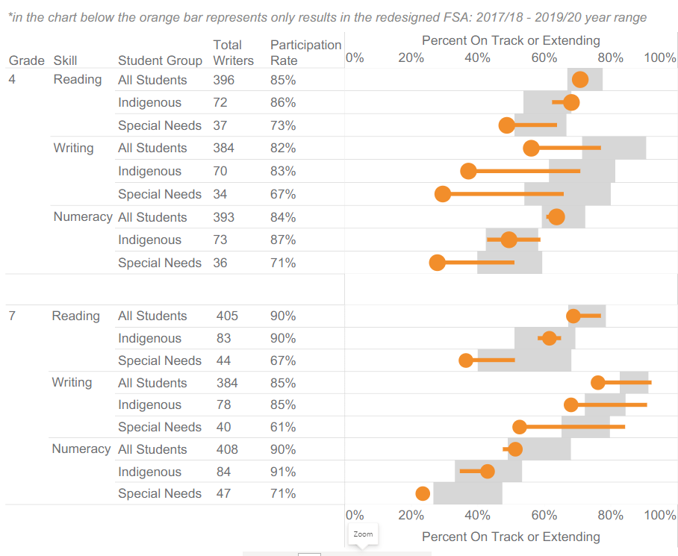

Strategies:
- Our Grade 3 and 4 numeracy team will be working together with the FESL numeracy focus group throughout the year. This year we will be experimenting with the Mathology Program (Grade 3 and 4). This year we will be exploring the Mathology program for Grade 3 and 4 and will look to add in other grade levels if needed.
- Focused professional development
  - Dot Galvin – Numeracy continuum K-6
  - Collaboration time for grade partnerships
- Development of a school-wide common assessment K-6.

Action Plan:
In the 2021-2022 school year, we will work as a staff on creating a climate of collaboration and teaching around numeracy.
K-5 teachers will be involved in the SD5 Numeracy project that meets 6 days to collaborate around building students skills and confidence in numeracy.
Our teachers will be using PLC time bi-monthly to develop lessons and assessments.
We will work on developing a school wide common assessment.

YEAR END SUMMARY

Year | 2021/2022 | 2022/2023 | 2023/2024 | 2024/2025
Targets | Grade 3 and 4 students will show a 10% increase in numeracy scores compared to last year.
Action Plan | We will work as a staff on creating a climate of collaboration and teaching around numeracy.  We will work on developing a school wide common assessment and will use Professional Development Days, the FESL Numeracy Group and scheduled time at staff meetings to build this resource.
Lead | Erin Boehm  Carlene Lochrie  Courtney Freeman  Rose Holmes  Shelley Salanski
Start and Due Dates | 2021/2022

Progress

Results
Budget Resources | Support for in-service and resources

