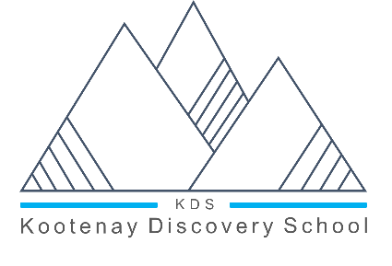
KOOTENAY DISCOVERY SCHOOL
FERNIE/CRANBROOK
250-423-4921
www.kootenaydiscoveryschool.com

Monday, February 8, 2021

To the Parents/Guardians of Students attending Kootenay Discovery School:

Re: K-12 COVID-19 Protocols Update – February 5, 2021
The Ministry of Education and BC CDC updated the guidance for K-12 protocols and released the updated documents online. There are enhancements in the documents that provide clarity around the school setting, reminders of the preventative measures, additional measures we are to put in place and further details for specific activities within a school.

The most notable changes at the elementary level include the following and are to be implemented immediately:
- K-12 staff and Middle/Secondary students should wear non-medical masks at school – both within and outside of their learning group,
- except when:
  - Sitting in (or standing at) their seat or desk/workstation in a classroom or learning space;
  - There is a barrier in place;
  - Eating or drinking; and
  - Outdoors
*Exceptions will be made for individuals who cannot tolerate masks (e.g. health or behavioural reasons)
  - It is not mandatory for Primary students to be wearing masks while at school.

The staff at Kootenay Discovery School thank you for your continued support and renewed emphasis regarding the following important Covid safety practices:

  - Prevent CROWDING AND GATHERING: particularly at the start and the end of the day; please support us with ensuring students are picked up in a timely manner.
  - Parents and caregivers are aware that their child should not come to school if they are sick or are required to self-isolate as per public health direction. .
  - Remind parents/caregivers of common symptoms of COVID-19 and that they are checking with their child daily to see if the child is experiencing any of these symptoms (as well as ensuring their child is not required to self-isolate).
  - Avoid close face-to-face contact whenever possible.
  - Staff and other adults entering the school are aware they should not come to school if they are sick or are required to self-isolate.
  - Outside of learning group: those wearing masks must still seek to practice physical distancing. There must be no crowding or congregating of people, even if masks are worn.
  - Within learning groups: physical distancing should include avoiding physical contact, minimizing close, prolonged, face-to-face interactions, and spreading out as much as possible within the space available.
  - Practice frequent hand hygiene.

The link to the BC Self-Assessment Tool https://www.k12dailycheck.gov.bc.ca/healthcheck?execution=e1s1

Thanks!

THE KDS TEAM

