Safe, Kind & Calm On Our Learning Journey Together

Following the Ministry of Education COVID-19 Health & Safety Guidelines for K-12 Settings and SD5 protocols, we look forward to welcoming our students to Laurie Middle School for the 2020/21 school year.

https://www2.gov.bc.ca/assets/gov/education/administration/kindergarten-to-grade-12/safe-caring-orderly/k-12-covid-19-health-safety-guidlines.pdf

Learning Groups
What is a learning group?  (More information can be found in the link in Appendix B on pages 6-7) | - Students have been organized into learning groups/cohorts for in-class instruction. This helps to limit contact and potential exposure. The cohort will consist of their regular classroom teacher(s), students and regular scheduled Education Assistants.  - Students have been organized into learning groups of approximately 24 students and two groups creates a COHORT of learners around 48 students for in-class instruction when two co-teachers work together. This helps to limit contact and potential exposure. The cohort will consist of their regular classroom teacher(s), students and regular scheduled Education Assistants.  - All Middle School Staff and Students are required to wear a mask both within and outside of their learning group – except when:  - Sitting in or standing at their seat or desk/workstation or learning space  - There is a barrier in place  - Eating and drinking  - Outdoors  - Physical Distancing for Students in Learning Groups  - Must limit physical contact  - Must minimize prolonged face to face interactions  - Spread out as much as possible withing the space provided  - Staff who are not members of the COHORT group need to follow the physical distancing and mask guidelines whenever they enter or interact with the COHORT. Distancing, barriers or masks will allow other staff like YCW, AbEd, EA’s and support staff to work with students from outside of their own COHORT.  - On call and replacement staff coming into the building are considered outside members of the COHORT and must adhere to the same distancing and PPE guidelines.  - Administration will keep a detailed cohort list for contact tracing purposes  - Consistent seating plans and routines are encouraged to keep contact tracing as reliable as possible within the COHORTS  - Grade 7, 8, and 9 students will be taught primarily by two teachers who belong to their COHORT.  Once in the COHORT teachers will collaboratively work with support staff to teach the curriculum and ensure kids are safe and engaged.  Middle School students are capable of consistently maintaining physical distancing and they are expected to properly use the PPE they bring to school or are provided with each day. Students not following the guidelines will be addressed by admin and expectations will be made very clear.
How do they work? | - The composition of the learning group will remain consistent for all activities that occur in schools. Students must now wear a mask within the COHORT space unless:  - Sitting in or standing at their seat or desk/workstation or learning space  - There is a barrier in place  - Eating and drinking  - outdoors  - Within the learning group minimal physical contact should be encouraged, but a physical distance of two meters does not need to be maintained if students are wearing their masks when not seated at their work station or desk.  - If students would like to interact with peers in other learning groups they may do so outside during breaks as long as they are maintaining physical distance or using masks (outdoors is a lower risk environment)  - Staff members who enter into various cohorts must wear PPE and physically distance in that setting

Shape of the Day
Before School | - Students are asked to arrive no earlier than 8:00  - Class in session as normal 8:25 – 12:01, 12:55-3:09  - Student will enter the school with their mask on and proceed to their COHORT classroom.  - Bus students will arrive according to their bus schedules and enter the school with their mask on and go to their COHORT classroom  - Students will be required to wash/sanitize hands immediately when entering their classroom (as per protocols attached)  - Before, during and after school kids will have access to lockers, which will be assigned, outside of the COHORT classroom they are assigned to. Hand washing will be an emphasized and important part of the locker routine each day.
Washroom/body breaks | - Students must stay with their learning group except to use the bathroom. Students must wear their mask in the bathroom.  - Classroom teachers will allow students to go to the bathroom one at a time to avoid congestion.  - No wandering the hallways.  - Masks must be worn at all times in common areas like the hallways and in the bathrooms.
Lunch | - Students will be able to eat lunch in their assigned COHORT classroom for the first 15 minutes each day.  - Students will be able to go outside for the remainder of lunch.  - Students are not allowed to share food or drinks  - Microwaves will not be made available to students  - Cutlery will not be made available to students  - Lunch Schedule  - 12:01 to 12:16 Eat in COHORT classroom if students choose  - 12:18 to 12:55 Move outside for the rest of lunch  - Intramural activities in the gym will be scheduled for individual COHORTs as an option. A schedule will be posted for COHORTS and students will not be able to cross COHORT boundaries in the gym during intramural activities.
Break | - Students need to remain in their COHORT classroom and avoid wandering the hallways or crossing into other COHORTS to visit  - Wash/sanitize hands before leaving the classroom and upon re-entry if students go out to their lockers to get snacks  - Must minimize physical contact when amongst cohort members and use their mask when not seated at their desk/workstation
Technology | - Wash your hands before using iPads/laptops  - iPads/laptops must be sanitized after each use
Library | - Wash your hands and wear a mask in the hallway to the library or the library teacher can teach students in their designated classroom and bring in a book cart  - Teachers will book times in the library when it is available to be scheduled
PE | - Wash/sanitize your hands before entering the gym  - Cohorts will be scheduled together when possible  - It is recommended to wear active clothing on PE days to reduce close contacts in the change rooms with other cohorts  - Teachers should plan physical activities that limit the use of shared equipment and minimize physical contact  - Shared equipment between cohorts should be cleaned and disinfected after each use  - Masks are to be worn during low intensity activities in the gym. If students are participating in high intensity activities they may take off their mask if they need to for breathing purposes.
Fine Arts | - All classes, programs and activities can occur where physical contact is minimized for those within the same learning group  - When students are attending music in the Fine Arts room, wear a mask in the hallway or Fine Arts teacher can teach students in their designated classroom  - Band Classes will be scheduled with COHORTS in mind. Grade 7 and 8 band classes will be kept together throughout the day and able to interact within their own COHORT bubble. Grade 9 band will have kids moving from three COHORTS, the classroom will be setup with social distancing in mind, and kids will have to wear masks during transition and setup in the band room.  *** All classes, programs and activities (e.g. Band, Choir) can continue to occur where:  Under Stage 2:  - physical contact is minimized for those within the same learning group;  - physical distance (2m) can be maintained for staff and for middle and secondary school students when interacting outside of their learning groups;  - physical distance (2m) can be maintained for elementary students when interacting outside of their learning groups when indoors.
General | - Assemblies – virtual assemblies  - No interschool sporting events  - No school wide performances
After school | - End of Day: Students will wash hands and leave through their assigned outside door. Please ensure physical distancing when picking up at the end of the day.  - Students who choose to stay and use school facilities after school, must physically distance and/or wear masks

Teaching and Learning
Curriculum | - Focus on core competencies  - Ministry of Education BC curriculum still followed
Instruction | - Build relationships and community first  - Addressing students passion and interests  - Instruction within learning group
Communicating Student Learning | Parents can expect that reporting and communication will start with the students returning to school September 10, 2020.  The return to full in-class instruction in September will include the following:  - Provincial curriculum for all students at all grade levels  - Regular reporting  - Regular assessments at the classroom and provincial level

Itinerant and other Staff
- Staff outside of a learning group must practice physical distancing when interacting with the learning group. For example, a learning assistance teacher or a counsellor can work with students from multiple learning groups, but they should maintain physical distance from students and other staff as much as possible.

Transportation
- The transportation department plan will be shared when it is finalized and a link is made available.
- Parents will be encouraged to drive their children if possible but bus service will be available
- Middle school students have to wear a mask when riding on the bus. This is mandatory.
- No eating or drinking while riding the bus

Parent Specifics
Preparing your child to return to school | - Have conversations with your child(ren) about wearing masks, no physical contact, physical distancing, classrooms looking different, more structure, handwashing and hygiene, no personal items brought and shared at school
Health Checks | - Parents will be provided with a health check waiver/confirmation form which will be sent to parents to be returned before the students are able to attend school. The form will describe the symptoms and the parent will confirm that they understand the requirement to complete the assessment on a daily basis before their child leaves for school.  - The parent will be responsible for completing daily health checks prior to sending their child to school. If there are any changes to the initial symptoms that include a “yes” response the child is to say home and the school contacted.
School access | - Limited access for visitors. Any access must be arranged through the office in advance  - Visitor access during school hours will be prioritized to those supporting activities that benefit student learning and well-being (e.g. teacher candidates, public health nurse, RCMP)  No community use in Stage 2
Communication | - Please check school website for up to date COVID plans  - Email  - PAC Facebook Page
If child gets sick at school | - Any child who appears or vocalizes feeling unwell will be sent home to ensure safety of all staff and students in the building  - Parents are required to pick up their child immediately  - Parents must have an emergency contact  If you have questions about whether or not you should be tested for COVID-19, use the self -assessment tool at https://bc.thrive.health/covid19. The province has created a phone service to provide non-medical information about COVID-19, including the latest information on travel restrictions. Information is available in more than 110 languages, 7:30 a.m. - 8 p.m. Pacific Standard Time at 1-888-COVID19 (1-888-268-4319) or via text message at 604-630-0300
Other information: | - Encourage your child to minimize physical contact with their friends  - Parents/Guardians, please remind children to cough/sneeze into elbow, sleeve or tissue  - Parent/Guardians are required to stay outside of the building for both drop off and pick up of students  - Appointments: If your child has an appointment during the day, please send a note with your child to show the secretary when they sign out at the office.  - Phone Messages: Secretaries will call into a classroom if there is a message to a student from a parent. Please try to limit any interruptions as much as possible.  - No food sharing is permitted  - Fountains are closed – refill stations remain open. Bring your own water bottle.  - Cutlery will not be provided, all students need to bring everything they need for their lunch.  - No access to microwaves  - We will only be able to recycle paper at school. All other recycling and refundable will need to go home.

Staff Specifics
Entering the building | - Please wash your hands and/or hand sanitize when you enter the building
Breaks | - In common areas (staffroom): When staff are interacting with people outside of their learning group; physical distance cannot be consistently maintained; staff are required to wear a non-medical mask.
PPE and Physical distancing | - Non-medical masks are required to be used in situations where a person cannot maintain physical distance and is in close proximity to a person outside of their learning group or household
Common areas | - When staff are in any common area, and are unable to physical distance, masks must be worn.
If you are sick at home | - Submit absence to SRB, contact school admin, provide TTOC plan
If staff become sick at school | - Isolate from your learning group  - Put your absence in SRB and notify admin to cover

Health and Safety Protocols
District Health and Safety plan | - Document will be linked here once it is published
Cleaning | - Laurie Middle School has a daytime custodian on site during the school day.  - A general cleaning/disinfecting of the premises will occur once every 24 hours  - High touch surfaces will be cleaned twice in a 24 hour period  - Teachers will have disinfectant and wipes in their classroom spaces to also wipe down surfaces when needed  - Checklist to be created by the district for custodial staff to keep track of cleaning
Hand hygiene | - Teachers/Parents will teach and review proper hand washing technique  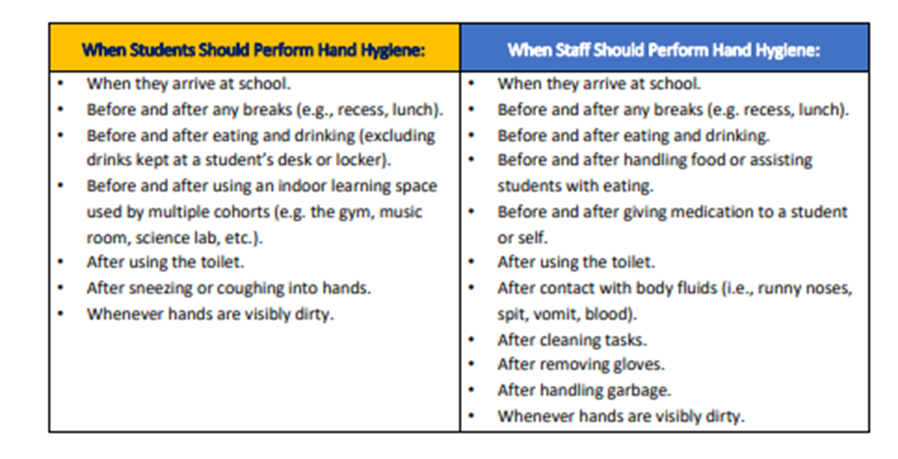
Personal Protective Equipment (PPE) | - Supply of extra/emergency PPE will be stored in the medical room  - Masks will be made available to all staff and students by the district  - Students will safely store their own masks and have them on their person at all times. They will be supplied two reusable masks by the school district for their own use.  - Masks need to be worn in the hallways, bathrooms and other communal space where social distancing is unavailable.
Entering/exiting the building | - Students will enter and exit through designated doors at all times when coming into the school. Students must enter into the school with their mask on and keep it on until they get to their COHORT classroom.  - Staff will enter through the staff entrance and sanitize their hands. Staff must come into the building with their mask in place and keep it on until they have gone to a space that allows them to physically distance.  - Parents/visitors will not be allowed in the building without previous consent from the office and must complete a health screening check upon entering
Physical Distancing | - Students and staff will be placed in COHORTS of no more than 60 people total  - Plastic barriers will be placed in areas where there may be higher traffic (between clerical staff, at office counter, at library counter)  - All assemblies or big school events will be held virtually with students remaining in their classrooms
Traffic Flow | - Directional arrows will be placed in the hallways to indicate flow of traffic  - Students will use the spaced out dots when lining up for their bus at the end of the day while wearing their mask  - Staggered break and lunch
First Aid | - Extra PPE (masks, face shields, gloves) will be on hand for our first aid attendants to use when treating injuries  - If an injury is minor, it is recommended that the first aid attendant talks the student through the injury (ie cleaning or bandaging a minor wound, applying an ice pack)  - Classrooms will have supplies of band-aids and cleaning wipes on hand to minimize students needing to go to the office for first aid
Health & Safety Checks (checklist can be found in Appendix B on page 16 of document) | Staff: Staff are required to complete a daily health screening before coming to work. If they have any of the listed symptoms they are to stay home.  Students: The parent will be responsible for completing daily health checks prior to sending their child to school. If there are any changes to the initial symptoms that include a “yes” response the child is to stay home and the school secretary is contacted about the absence.  Parents will be provided with two copies of this Health Check. One will be completed and provided to the school on first day of attendance.  - Once at school, any child who appears or vocalizes feeling unwell will be isolated in an isolation room and sent home to ensure safety of all staff and students in the building  - Parents are required to pick up their child immediately  - Parents must have an emergency contact on hand in the event that a parent cannot get to the school right away.  - If you have questions about whether or not you should be tested for COVID-19, use the self -assessment tool at https://bc.thrive.health/covid19. The province has created a phone service to provide non-medical information about COVID-19, including the latest information on travel restrictions. Information is available in more than 110 languages, 7:30 a.m. - 8 p.m. Pacific Standard Time at 1-888-COVID19 (1-888-268-4319) or via text message at 604-630-0300.  Visitors/Parents: Please note: No parent visitors are permitted without prior office approval. Please contact the school office for appointments.  Any necessary visitors will be asked the BC CDC guidelines listed above and that documentation will be kept on file by administration
Health and Safety Training | - Staff will be trained in the school on September 8th and 9th and do a walk through of the space to understand safety protocols  - Students will be trained on September 10th about protocols and safety items for their return to the school.
Health and Safety Continuance | - The school JOHSC committee comprised of Aaron Thorn (P), Maggie Lindsay-Tadey (VP), Mena Pocha (CDTA) and Eldon Harter (CUPE) will meet monthly or on an as needed basis to review and ensure school wide maintenance of health and safety protocols.
Isolation Room if staff or student becomes ill | We have two separate spaces in the office that will be available for sick students or students that need to be isolated.  - Sick room #1  - Reflection Room #2

Students with Diverse Abilities/Disabilities
- As per previous practice, EA’s will join COHORTS to support kids and student service teachers will work as case managers to support and coordinate plans and services throughout the year for students with an IEP.

Appendices:

***A hallway map with the flow of traffic, entrances and exits will be shared on this document once we have a published quality document completed.

A: https://www2.gov.bc.ca/assets/gov/education/administration/kindergarten-to-grade-12/safe-caring-orderly/k-12-education-restart-plan.pdf

B: http://www.bccdc.ca/Health-Info-Site/Documents/COVID_public_guidance/Guidance-k-12-schools.pdf?bcgovtm=20200506_GCPE_AM_COVID_9_NOTIFICATION_BCGOV_BCGOV_EN_BC__NOTIFICATION

