**Sparwood Secondary School**

**Grade 8 – 12**

**Course Planning Booklet**



***2019 -2020***

***HOME OF THE SPARTANS!***

**TABLE OF CONTENTS**

Table of Contents

Using This Booklet

Student Learning Plan - Graduation

The Required Courses

Graduation Requirements

Fine Arts / Applied Skills

Career Education / Work Experience

Graduation Program Examinations

Challenge-Equivalency-External Credits

Youth Work in Trades/ Youth Train in Trades

Dual Credit Course

Student Support Services

Summary of Courses

Course Description by Department

Business Education/Information Technology

English

Fine Arts

French/French Immersion

Home Economics

BAA Courses

Mathematics

Physical Education

Science

Social Studies

Technology Education

***USING THIS BOOKLET***

This booklet is intended to provide students and parents/guardians information about the curriculum and programs at Sparwood Secondary School. Grade seven courses are pre-determined.

The booklet gives descriptions of the courses students must take and electives students may select. It also gives suggestions to help with planning and course selection for the coming academic year.

## **HOW TO USE THIS BOOKLET**

Students and parents/guardians should:

1. Study the program and courses offered for the specific grade level.

2. Study the different programs and graduation requirements.

3. Read the course descriptions and determine what background knowledge is beneficial.

4. Choose the program and course sequence, which they feel to be most suitable to the student’s interests, abilities and possible future vocation. Senior students must keep in mind that it is their responsibility to ensure that graduation requirements are met.

5. A student or parent/guardian who is in doubt about any aspect of a program, or who has questions that are not answered in the booklet, should speak to a counsellor (250-425-6666)

#### PRE-PLANNING STAGE

To use this booklet effectively, the student should attempt to answer as fully as possible the following questions:

1. What courses must I take to fulfill my grade requirements?
2. Of the Elective courses, which ones best suit my interests, abilities, and possible future vocations?
3. Do I have the proper requirements to take a certain course?
4. What are the entrance requirements of the university, college, vocational school or job that I plan on attending or starting after secondary school?

**NOTE:** If you don’t know the answer to one or more of the above questions you have some additional research to do before selecting your programs.

**REMEMBER:**

* The final responsibility rests with the student and parents to ensure that proper programming occurs.
* The school timetable is developed on the basis of students’ course selections. Please choose wisely.
* Please choose alternates for elective courses. Your first choice may not be possible in all cases.

## **STUDENT LEARNING PLAN - GRADUATION**

**GRADE 10 GRADE 11 GRADE 12**

**_______________ _____ Cr. _______________ _____ Cr. _________________ _____ Cr.**

**_______________ _____ Cr. _______________ _____ Cr. _________________ _____ Cr.**

**_______________ _____ Cr. _______________ _____ Cr. _________________ _____ Cr.**

**_______________ _____ Cr. _______________ _____ Cr. _________________ _____ Cr.**

**_______________ _____ Cr. _______________ _____ Cr. _________________ _____ Cr.**

**_______________ _____ Cr. _______________ _____ Cr. _________________ _____ Cr.**

**_______________ _____ Cr. _______________ _____ Cr. _________________ _____ Cr.**

**_______________ _____ Cr. _______________ _____ Cr. _________________ _____ Cr**

***Grad Requirements***

|  |  |  |  |
| --- | --- | --- | --- |
| **Subject Area** | **Course Chosen** | **Credits** | **Completed** |
| English 10 | COMP/LITSTUDIES/CRWR/NEWM/SPLA | 4 |  |
| English 11 | ENG 11 | 4 |  |
| English Studies 12 | ENST12 | 4 |  |
| Social Studies 10 |  | 4 |  |
| Social Studies 11/12 | MEPSS11/BCFN 12/LAW12/SJ12/MWH12 | 4 |  |
| Science 10 |  | 4 |  |
| Science 11/12 | CH 11/PH 11/ ES11/ LIFESC11 | 4 |  |
| Math 10 | FMP10/AWM10 | 4 |  |
| Math 11/12 | PREC11/FOM11/WMA11/HOM11 | 4 |  |
| Physical Education 10 |  | 4 |  |
| Fine Arts/Applied Skills |  | 4 |  |
| Career life education |  | 4 |  |
| Career life connections/Cap. |  | 4 |  |
| Num. Assess |  |  |  |
| Lit. Assess 19/20 |  |  |  |
| Total of 52 credits required from the above | | | |
| **Elective Courses** | | | |
| Elective 12 |  | 4 |  |
| Elective 12 |  | 4 |  |
| Elective 12 |  | 4 |  |
| Elective |  | 4 |  |
| Elective |  | 4 |  |
| Elective |  | 4 |  |
| Elective |  | 4 |  |
| Total of 28 elective credits required | | | /80 |

*POST-SECONDARY GOALS*

It is the responsibility of the student and parents to be sure that all grad requirements and post-secondary program requirements are met in the learning plan. The Counsellor is available to assist students and parents.

THE REQUIRED COURSES

# Grade 9

English Language Arts 9

Social Studies 9

Science 9

Math 9

Physical/Health Education 9

French 9

_______________________

______________________________________________

_______________________

# Grade 8

English Language Arts 8

Social Studies 8

Science 8

Math 8

Physical/Health Education 8

French 8

______________________

______________________

______________________

______________________

# Grade 11

Language Arts 11

Any Socials 11 or 12

Any Science 11 or 12

Any Math 11 or 12

____________________________________________________________________________________________

# Grade 10

Language Arts 10

Social Studies 10

Science 10

Any Math 10

Physical/Health Education 10

Career Life Education 10 _______________________

_______________________

# Grade 12

English Language Arts 12

Career Life Connections/Capstone

_________________________________________________________________________________________________________

_____________________

_____________________



##### **GRADUATION REQUIREMENTS**

**STUDENTS MUST EARN A MINIMUM OF 80 CREDITS OVER GRADE 10, 11 AND 12**

**48 REQUIRED CREDITS (Foundation Studies)**

* Language Arts 10 (4 credits) Composition/New Media
* Language Arts 11 (4 credits)
* English Studies 12 (4 credits)
* Social Studies 10 (4 credits)
* Social Studies 11 or BC First Nations Studies 12 (4 credits) or Social Studies 12 options (4 credits)*
* Science 10 (4 credits)
* Science 11 or 12 (4 credits)*
* Mathematics 10 (4 credits)*
* Mathematics 11 or 12 (4 credits)*
* Physical & Health Education 10 (4 credits)
* Fine Arts and/or Applied Skills 10, 11, or 12 (4 credits)*
* Career Life Education 10 (4 credits) or FI Career Life Education 10 (4 credits)
* Career Life Connections and Capstone
* Complete a minimum of 28 elective credits

(*one from a number of course options)

An unlimited number of credits from board- or independent school authority – authorized or post-secondary electives may count toward graduation.

A minimum of 16 credits (including English Language Arts 12) from either ministry – or board/authority-authorized or post – secondary courses are required at the Grade 12 level.

Assessments = Numeracy Assessment Grade 10, 2 Literacy Assessments (one in Grade 10 and one in Grade 12). These Assessments are being transitioned into grades 10-12.



**FINE ARTS AND/OR APPLIED SKILLS**

These courses of study help students understand and appreciate various forms of artistic and aesthetic expression and/or hands-on applied learning. Students are required to earn 4+ credits in Fine Arts and/or Applied Skills at any time during the Graduation Program. The 4 credits can be in Grade 10, 11 or 12 level courses.

**FINE ARTS**: All Fine Arts courses at SSS are 4 credits.

**ART DRAMA**

Art Studio 10, 11 or 12 Drama 10

Theatre Company 11 or 12

**APPLIED SKILLS** All Applied Skills courses at SSS are 4 credits.

**TECHNOLOGY EDUCATION HOME ECONOMICS**

Metalwork 10, 11 or 12 Textiles Studies 10, 11 or 12

Woodwork 10, 11 or 12 Food Studies 10, 11 or 12



**BUSINESS/COMPUTER COURSES**

Computer Information Systems 10, 11 and 12

**CAREER EDUCATION PROGRAM**

**Career Life Education 10**

This course helps students develop the confidence and skills they need to become self-directed individuals, who display initiative, set priorities, establish goals, make thoughtful decisions, and take responsibility for pursuing their goals in an ever-changing society. Career Life Education will focus on personal development, connections to the community and developing a career life plan that will transition into the Career Life Connections and Capstone upon graduation.

Career Life Education 10 also encourages students to explore a full range of career and education choices; to think about their prospects for success in those careers; and to plan the actions required to pursue their chosen career paths and post-secondary education destinations.

**Career Life Connections and Capstone**

This course is a continuation of the Career Life Education Course and will focus on personal development, connections to the community and a career life plan. Career Life Connections has a final capstone project presented to a panel that will culminate the learning that has transpired throughout your years of learning. The personal integrated plan for post-graduation will articulate choices related to career, education, finances, health and well-being.

**WORK EXPERIENCE 12A/12B**

Career Preparation is a type of Career Program in which students gain experience in the career field of their choice through a combination of course work and work experience for credits towards graduation. The program is scheduled in a manner that allows for creative use of the timetable to provide classroom time as needed and allow students to be at work placements during school time.

Work Experience 12 provides students with an opportunity to get actual work experience in a particular work environment in the community.



**GRADUATION PROGRAM ASSESSMENTS**

In accordance with the 2018 Graduation Program transition, all grade 12 students are required to the following Assessments:

* Literacy
* Numeracy

Present Grade 10-12 students will be transitioned in as follows:

* [Graduation Numeracy Assessment – Grade 10](https://curriculum.gov.bc.ca/assessment/numeracy-assessment) (graduation requirement)
* [Graduation Literacy Assessment – Grade 10](https://curriculum.gov.bc.ca/assessment/literacy-assessment) (graduation requirement starting in 2019/20)
* [Graduation Literacy Assessment – Grade 12](https://curriculum.gov.bc.ca/assessment/literacy-assessment) (graduation requirement starting in 2020/21)



CHALLENGE-EQUIVALENCY-EXTERNAL CREDITS

**GUIDELINES FOR CHALLENGE**

Challenge refers to the process of receiving credit for a provincial or locally developed Grade 11 or 12 course, taught within a school district, through an assessment of a student’s undocumented prior learning.

Challenge is for students who can give compelling evidence they will succeed in the challenge and that it is in their best interest. Please see the School Counsellor for specific details.

**GUIDELINES FOR EQUIVALENCY**

Equivalency is the process of granting credits for a Grade 10, 11 or 12 provincial or locally developed course that is offered in a school district, if supporting documentation shows that a student has achieved the course’s learning outcomes at another institution and/or in another education jurisdiction. The most common situation will involve a student who has moved from another province and will be attending school in BC.

**FOR FURTHER INFORMATION AND GUIDELINES WITH REGARD TO CHALLENGE, EQUIVALENCY AND/OR EXTERNAL CREDIT SEE A COUNSELLOR.**

**\*\*\*\*\*\*\*\***

**EXTERNAL CREDITS**

Students who have successfully completed a Ministry approved External Credential are entitled to receive credit towards secondary school graduation. Some of the external credentials may meet Foundation Studies requirements. The following list of External Credentials is available for credit.

-**Advance Placement & International Baccalaureate Courses**

**-Music**

* Associated Board of the The Royal School of Music
* BC Conservatory of Music
* Royal Conservatory of Music
* Victoria Conservatory of Music
* Trinity College: London
* London College of Music

**-Dance**

* Royal Academy of Dancing
* Imperial Society of Teachers of Dancing
* British Association of Teachers of Dancing
* Canadian Dance Teachers Association

**-Drama, Speech & Effective Communications**

* Trinity College: London
* London College of Music
* Royal Conservatory of Music

**-Languages**

* Various Language Assessments and Certificates

**-Sport**

* Athlete (Provincial & National Teams)
* Coach (NCCP)
* Official

**-Youth Development**

* Air/Army/Sea Cadets
* 4-H
* Guides
* Scouts

**-Industrial and Occupational**

* Fitness Leader
* Boating
* Canadian Pony Club
* Tourism
* Wood Products Manufacturing (Woodlinks)
* Red Cross Water Safety Instructor
* WCB Occupational First Aid
* ICBC Driver Education

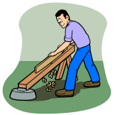

**YOUTH WORK IN TRADES**

Youth Work in Trades allows students to register as an apprentice in a trade through the Industry Training Authority (ITA) and start the hands-on, work-based training component while still in secondary school. A real employer in the trade area of interest provides the on-the-job paid work experience. Sixteen Grade 11 and 12 secondary school credits and 480 work-based training hours toward a trade are earned. The school does not connect students with employers but facilitates the coordination between student, ITA, and secondary school.

# YOUTH TRAIN IN TRADES

Youth Train in Trades allows a student to start the technical training component of a trade while still in secondary school. The training may take place within a secondary school or college setting. Depending upon the trade and finding a suitable employer, a student may be able to register in a Youth Work in Trades program. With Youth Train in Trades secondary school and post-secondary credits are earned at the same time.

Both Youth Work in Trades and Youth Train in Trades programs are supported by the Industry Training Authority (ITA), the agency responsible for trades in BC. To find out more about these programs see a counsellor.

**DUAL CREDIT COURSES WITH COLLEGE OF THE ROCKIES**

Dual credit is an opportunity for high schools to provide students with course choices that are not otherwise available at the high school and accelerate a student’s career pathway. Dual credit courses give students high school credit as well as post-secondary credit towards a credential in the BC public post-secondary system and elsewhere.

**1. What college courses can a student take for dual credit?**

As long as the students have met the prerequisites, they can take any post-secondary course that leads to a certificate, diploma, or degree as a dual credit course. College courses in Arts, Science, Kinesiology, Tourism and Recreation Management, Business, and Child, Youth, and Family Studies would qualify, as would trades programs such as Youth Train in Trades (formerly Accelerated Credit Enrollment in Industry Training).

**2. Does the College provide dual credit awards?**

Yes, the College offers 35 course tuition awards to encourage enrollment in academic courses.

**3. Must students meet course prerequisites to take a college course?**

Yes.

**4. How many credits does the high school award?**

The high school awards 4 credits for a typical 3 credit college course (see Handbook of Procedures for the Graduation Program).

**5. Do the College and high school agree on who takes dual credit courses?**

When the student seeks a course at the College, the College gives the student a permission form to be signed by the school principal allowing the student to take the dual credit course.

**6. Are dual credit courses taught in high schools?**

The College can deliver the course either at a high school or at the College with a qualified instructor. Dual credit courses are also available through online delivery.

**7. Where can I get more information about taking a dual credit course?**

Brian Conrad, Regional Transitions Coordinator, conrad@cotr.bc.ca, College of the Rockies Education Advisors, studentservices@cotr.bc.ca or your school counsellor.

**STUDENT SUPPORT SERVICES**

Student Support Services at Sparwood Secondary School are designed to help students realize their potential in school. These services include, the Life Skills Program, the Resource Room, as well as a Learning Assistance Room which services students experiencing learning problems and the Alternate Education Program (STRIVE) which provides service to those students who are experiencing social, behavioral and/or scholastic difficulties in the regular school system.

A student placement in these programs is the result of careful consideration of the student’s needs by the School Based Team (SBT).

The SBT reviews teacher recommendations, academic records, standardized test results and psycho-educational assessments. In no case will a student be permanently placed in any of these programs without the approval of the student’s parents.



Success

Through

Student

Support

Services

**SUMMARY OF COURSES**

In their grade 8-9 year students sample the junior elective subjects

**Humanities**

Social Studies 8

Social Studies 9

English 8

English 9

French 8

French 9

**Physical and Health Education**

Physical & Health Ed 8

Physical & Health Ed 9

**Mathematics**

Math 8

Math 9

**Science**

Science 8

Science 9

**Applied Design Skills & Technologies**

Information Technology 8

Information Technology 9

Food Studies/Textiles Studies 8

Food Studies/Textile Studies 9

Design 8

Design 9

**Arts Education**

Art 8

Art 9

Drama 8

Drama 9

**Career Education**

Careers 8

Careers 9

**Business Education**

Computer Information Systems 10, 11 & 12

## **Career/Personal Planning**

Career Life Education 10

Career Life Connections & Capstone (grade 12 year)

Work Experience 12A

Work Experience 12B

**Fine Arts**

Drama 10

Theatre Company 11 & 12

Art Studio 10, 11 & 12

**Home Economics**

Food Studies 10, 11 & 12

Textiles 10, 11 & 12

**Humanities**

Social Studies 10

Social Studies 11

Century World History 12

**Humanities con’t**

Composition 10, 11 & 12

Creative Writing 10, 11 & 12

Literary Studies 10, 11 & 12

New Media 10, 11 & 12

English Studies 12

French 10, 11 & 12

**Math**

Foundations of Math 10

Workplace Math 10

Foundations of Math 11

Workplace Math 11

Pre Calculus 11

History of Mathematics 11

Foundations of Math 12

Pre Calculus 12

Calculus 12

**Technology Education**

Metalwork 10, 11 &12

Woodwork 10, 11 & 12

**Physical Education**

Physical & Health Education 10

Active Living 11 and 12

Fitness & Conditioning 11 and 12

**Sciences**

Science 10

Life Science 11

Anatomy and Physiology 12

Chemistry 11& 12

Environmental Science 11

Physics 11 & 12

**APPLICATION NECESSARY:**

* **Tutoring 11 &12 (BAA)**
* **Leadership 10-12**

**(BAA)**

**OTHER COURSES MAY BE OFFERED THROUGH DISTRIBUTED LEARNING**

**BUSINESS EDUCATION/COMPUTER STUDIES**

Business Education/Computer Studies puts the major goals of education into a business environment, encourages students to apply problem solving, decision-making, and critical thinking skills to a variety of business situations, and to communicate solutions to others. Students are encouraged to work alone, to work cooperatively, and to work in a business setting. Computer Studies provides personal life and employment skills, experience with an application of business technology.

**Information Technology 8**

Information Technology 8 is an Applied Design, Skills, and Technologies option where students learn to work together to solve technical problems and to develop interpersonal communication skills. Technology literacy is a skill set that is in high demand in our global community. The three uses of information technology in a modern society are information technology (electronic resources), communication technology (telecommunication), and processing technology (software that help us do better, faster work). Technology is a tool and not an answer in and of itself. It should be seen as a learning tool that students learn with, not from. During this course, students will explore the following areas:

Computational Thinking: The introduction to coding and how programming works.

Computer and Communication Devices: The uncovering of the impact of technologies in today’s world. The practicing of keyboarding skills.

Digital Literacy: Explore the elements of personal networks and future technologies.

**Information Technology 9**

Information Technology 9 is an Applied Design, Skills, and Technologies option where students enhance their skills in specific computer programs and softwares. This course builds on students’ natural curiosity, inventiveness, and desire to create and work in practical ways. This course incorporates a fair amount of flexibility allowing the student to select areas of IT that interest them. Many of the skills learned in IT9 are directly applicable in other classes, improving assignments and projects, making them stronger and more engaging. During this course, students will explore the following areas:

What is Computer Science? : What is a computer, humans and computers, application and uses.

Problem Solving: Problem solving strategies, searching, sorting, solving simple mazes, solving simple puzzles, making algorithms.

Data and Codes: Encoding and decoding data, data representation with binary numbers, encoding

and decoding with cups, data representation using LEGO blocks.

Web Design: Safety and security, social responsibility, HTML5, CSS3, JavaScript, Photoshop, Moviemaker.

Software Exploration: Office 365, Photoshop, Moviemaker, Microbit, Kudo.

Programming – introduction to graphical programming, building algorithms, physical computing

**Computer Studies 10**

Computer Studies 10 is an introduction to key aspects of computer hardware and software, troubleshooting, programming, and digital literacy.

**Computer Information Systems 11/12**

This course focuses on evaluation and implementation practices related to computer hardware, software, and networks. Learning includes network management tools, troubleshooting techniques, and digital security awareness. This course offers students who have completed the introductory courses in graphics, animation, 3D modelling or programming and are looking for additional exploration in their area of interest an opportunity to delve deeper into those programs. Students will develop their own portfolios and presentation skills for potential clients in their field. This course is hands-on and project based.

**ENGLISH LANGUAGE ARTS**

The purpose of the English program is to develop the student’s communication skills of

reading, writing, speaking and listening. There is a gradual progression through the basics

at the junior level to that degree of sophistication that will equip the student for college or

university. English courses may be adapted to accommodate students who have difficulty

with the regular materials.

English Language Arts 8

English Language Arts 9

Language Arts 10 – Composition, Creative Writing, Literary Studies, New Media, Spoken

Language 10 (choose two – 2 credit courses)

Composition 11

Creative Writing 11

Literary Studies 11

New Media 11

Spoken Language 11

English Studies 12 (required)

Composition 12

Creative Writing 12

Literary Studies 12

New Media 12



**ENGLISH LANGUAGE ARTS 8**

Basic skills are emphasized at this level. In the writing strand this involves sentence

recognition, language skills, and paragraph development. Reading includes novels,

short stories, and poetry, the principle focus being comprehension. Generally writing

exercises are based on the literature selections studied. Oral reading and oral presentations

are an integral part of the course.

**ENGLISH LANGUAGE ARTS 9**

The English 9 course builds on skills developed in Grade 8. Student work focuses on

proper sentence structure and the use of various techniques in paragraph development and

advanced writing skills. Students continue to receive practice in oral presentations.

Literature study includes novels, short stories, poetry, and drama, selected to suit the abilities

of particular classes. Appropriate writing exercises are assigned to check the comprehension

and student response to materials studied.

**LANGUAGE ARTS 10 (2+2 credits combinations to = 4 credits)**

Students have the option of two the following:

**Creative Writing 10 (2 credits)** is designed for students who have an interest in creative

expression through language. The course provides students opportunities to build their writing

skills through the exploration of identity, memory, and story in a range of genres. Within a

supportive community of writers, students will collaborate and develop their skills through

writing and design processes. This course is intentionally grounded in the sampling of writing processes, inviting students to express themselves creatively as they experiment with, reflect

on and practice their writing.

**New Media 10** **(2 credits)** is a program of studies designed to reflect the changing role of

technology in today’s society and the increasing importance of digital media in communicating

and exchanging ideas. This course is intended to allow students and educators the flexibility to develop a program of study centred on students’ interests, needs, and abilities, while at the

same time allowing for a range of local delivery methods. New Media 10 recognizes that digital

literacy is an essential characteristic of the educated citizen. Coursework is aimed at providing students with a set of skills vital for success in an increasingly complex digital world by

affording opportunities to demonstrate understanding and communicate ideas through a variety

of digital and print media. New Media 10 explores tasks and texts designed to introduce

students to the study of New Media.

**Composition 10** **(2 credits)** is designed to support students in their development of written communication through a critical process of questioning, exploring, and sampling. Within a supportive community of writers, students will work individually and collaboratively to

explore and create coherent, purposeful compositions. Students will read and study compositions

by other writers and consider a variety of styles as models for the development of their writing.

The course builds students’ writing competencies by introducing them to varied structures,

forms, and styles of compositions. Students have opportunities to individually and collaboratively study, create, and write original pieces, exploring audience and purpose. They also develop

their craft through processes of drafting, reflecting, and revising.

**Literary Studies 10** **(2 credits)** designed for students who are interested in the literature of a particular era, geographical area, or theme, or in the study of literature in general. The course

allows students to delve more deeply into literature as they explore specific themes, periods,

authors, or areas of the world through literary works in a variety of media. Giving students the

choice of a range of literary topics allows them to follow their passion and at the same time:

• increase their literacy skills through close reading of appropriately challenging texts

• enhance their development of the English Language Arts curricular competencies, both

expressive and receptive

• expand their development as educated global citizens

• develop balance and broaden their understanding of themselves and the world

• develop higher-level thinking and learning skills

**Spoken Language 10** **( 2 credits)** is designed to support students in their development of spoken communication through processes of questioning, exploring, and sampling. The course builds students’ spoken language competencies by introducing them to varied structures, forms, and styles of oral compositions and by providing opportunities for students to individually and collaboratively study, draft, and use language to create original pieces such as:

* Performance—spoken word/slam poetry, poetry recitation, oral storytelling, readers’ theatre, radio/podcasts/video posts related to First Peoples themes
* Professional applications—speech writing/presenting, proposals, interviewing, event facilitation, radio/podcasts/video posts (information items) related to First Peoples themes

**LANGUAGE ARTS 11 Choose one of the following (4 credits)**

**Composition 11 (4 credits)**

The following are possible areas of focus within Composition 11:

* narrative, expository, descriptive, persuasive, and opinion pieces
* planning, drafting, and editing processes
* writing for specific audiences and specific disciplines
* how to cite sources, consider the credibility of evidence, and evaluate the quality

and reliability of the source

**Creative Writing 11 (4 credits)**

The following are possible areas of focus within Creative Writing 11:

* shortfiction and poetry – suggested content includes flash-fiction (micro-fiction, drabble,

non-fiction, twitterature), graffiti, sub-genres   
(e.g., adventure, children’s literature, comic/graphic, fantasy, fan fiction, historical fiction,

horror, sci-fi, dystopian, suspense, thriller, tragedy, romance), drama, script writing, poetry, authenticity versus sentimentality, literary devices and techniques, various forms,

the relationship between form and function

* creativenon-fiction ***–*** suggested content includes columns, features, articles, queries,

captions, layout, reporting, interviews, reviews (fashion, movie), advertising, titles,

bylines, sample readings

* memoir – suggested content includes place-based writing, narrative, film memoir, sample readings

**Literary Studies 11 (4 credits)**

The following are possible areas of focus in Literary Studies 11:

* canonical literature by era (Middle Ages, Renaissance, Restoration, Romantic,

Victorian, 20th century)

* genre-specific studies (poetry, short stories, novels, drama, graphic novels, children’s literature)
* world literature
* diasporic literature
* feminist literature
* Canadian literature
* First Peoples texts
* specific author studies
* specific topic, theme, or inquiry
* literature by era (Middle Ages, Renaissance, Restoration, Romantic, Victorian, 20th century)

**New Media 11 (4 Credits)**

The following are possible focus areas in New Media 11:

* mediaand film studies – suggested content/topics include the globalization of the media

industry, influence of media on users’ perceptions, and documentaries in the age of

digital media

* journalism and publishing – suggested content/topics include the changing roles and

structures within news organizations; and risks, challenges, and opportunities associated

with professional journalism

* digital communication – suggested content/topics include blogging, writing for the web,

writing for social media, gaming, and podcasting

**Spoken Language 11 (4 credits)**

The following are possible areas of focus in Spoken Language 11:

* performance – suggested content/topics include spoken word/slam poetry, poetry recitation, oral storytelling, readers’ theatre,   
  radio/podcasts/video posts
* oral tradition – suggested content/topics include oratory, local story knowledge, oral history

professional applications – suggested content/topics include speech writing/presenting, proposals, interviewing, event facilitation, radio/podcasts/video posts (information items), voice-overs

**ENGLISH STUDIES 12 (4 credits) REQUIRED FOR GRADUATION**

The required English Studies 12 course builds on and extends students’ previous learning experiences in ELA and EFP 10 and 11 courses. It is designed for all students and provides them with opportunities to:

* refine their ability to communicate effectively in a variety of contexts and to achieve

their personal and career goals

* think critically and creatively about the uses of language
* explore texts from a variety of sources, in multiple modes, and that reflect diverse worldviews
* deepen their understanding of themselves and others in a changing world
* gain insight into the diverse factors that shape identity
* appreciate the importance of self-representation through text
* contribute to Reconciliation by building greater understanding of the knowledge and perspectives of First Peoples
* expand their understanding of what it means to be educated Canadian and global citizens

**ELECTIVE COURSES:** Composition 12, Creative Writing 12, Literary Studies 12 and

New Media 12

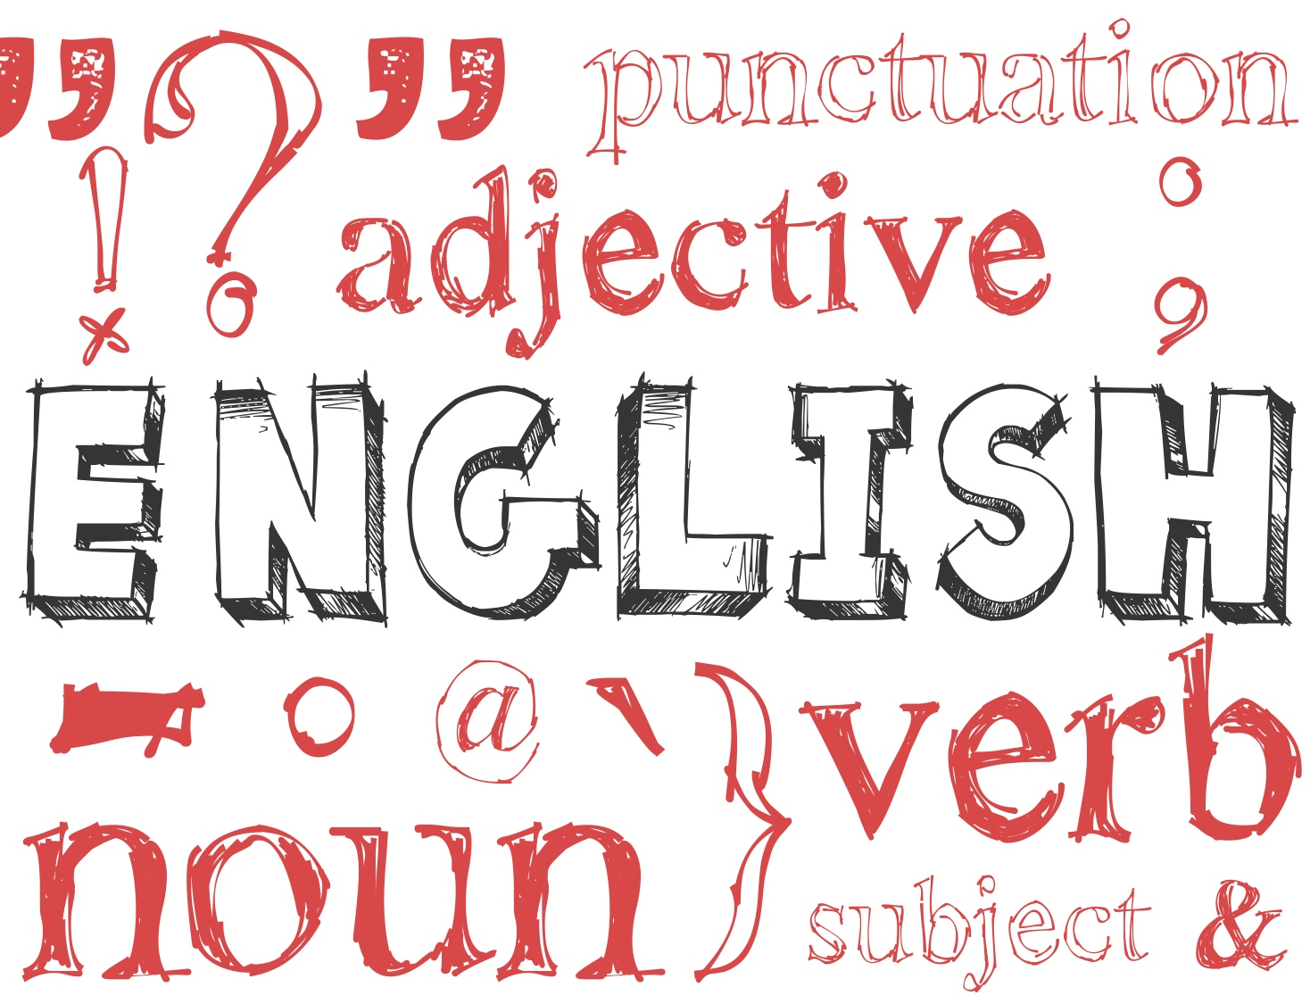

**FINE ARTS**

The Fine Arts program is for students who have an interest in Music, Arts and Drama.

These courses help students to become more creative and to broaden their mind in Fine Arts.

**ART 8**

This course is designed to introduce and provide a foundation of the key elements of art and principles of design. Colour theory will be emphasized and other principles and elements will be brought to light. Two-dimensional pieces will be produced through working with various mediums such as; pencil, pencil crayon, charcoal, pastels and acrylic paint. Art history will play an important role in course development, promoting inquiry application. A focus of working with the pencil

and/or pencil crayon to help create 3 D images will be explored. Studying and creating 3

dimensional art will be addressed. Students will work with clay to produce a 3 D piece of art.

**ART 9**

In Art 9 an introduction to the key elements of art and principles of design will be reinforced.

Colour theory will be emphasized and other principles and elements will be brought to light.

Two-dimensional pieces will be produced through working with various mediums such as;

pencil, pencil crayon, charcoal, pastels and acrylic paint. Art history will play an important

role in course development, promoting inquiry application. A focus of working with the pencil

and/or pencil crayon to help create 3 D images will be explored. Studying 3 dimensional art

will be addressed. Students will have opportunity work with clay to produce a 3 D piece of art

and functional pieces.

**ART STUDIO 10 (4 credits)**

In Art 10 prior concepts related to art will be readdressed. A strong emphasis towards creating

3 dimensional images on paper and/or canvas will be addressed. The elements of art and

principles of design will be reinforced and the concepts involved in creating a strong composition

will be reviewed. Art history will play an important role in this course.  Art 10 is a continuation

from prior grades, however, there are no prerequisites for Art 10. As well, 3 dimensional work

will be addressed with a strong emphasis placed on pottery theory and practice.

**ART STUDIO 11/ ART STUDIO 12 (4 credits)**

The mandate for both courses Visual Arts 11 & 12 are very similar, the level of exploration

will increase as the grade increases. Art history will play an important role in this course.   These comprehensive courses are designed to facilitate a broad range of experience in 2 and 3

dimensional pieces. A strong focus on the elements and principals of art and design relating

to composition will be addressed. 2D work in drawing and painting will be addressed. 3D work

will be explored, with a strong emphasis on pottery. For students at both the grade 11 and

grade 12 level – this provides an excellent opportunity to start creating portfolio quality pieces

that would be suitable to use when applying for post-secondary studies in the arts.

**DRAMA 8/ DRAMA 9**

The aims of these courses are to develop an awareness of the world through the senses; to

develop the students’ ability to concentrate; to develop students’ sense of confidence; and to encourage enjoyment of drama. These courses may be described as introductory courses in developmental drama. They include theatre games, movement, mime, plays and character development.

**DRAMA 10 (4 credits)**

The aim of this course is to allow the student to develop basic speaking and acting skills.

Working in an activity situation, the student will lose many inhibitions and be able to react

without shyness or self-consciousness in new surroundings. This course may be described

as an activity course geared toward developing basic speaking and acting skills. There is a

mandatory classroom unit including theatre history and terminology.

**THEATRE COMPANY 11 (4 credits)**

Students will be performing in many different types of theatre production, to learn about character development, stage etiquette, movement, dramatic elements, etc.  They will be learning the many elements required to put together a successful production. This course will encourage students to

create and show work that they are passionate about.

**THEATRE COMPANY 12 (4 credits)**

Students will be collaborating with their classmates to create, write, produce, direct, and perform dramatic works of their own making.  Students will be encouraged to use their interests inside and outside of school to influence and inspire their creative processes.  Students who are keen on the performing aspect of things will have just as large a role, as those who do not.  This course will encourage students to create and show work that they are passionate about.

**FRENCH**

The study of a second language is extremely beneficial for a variety of reasons in our global society. Not

only do students acquire the skills and techniques to master another language they also learn to appreciate

and respect other cultures. Students who plan to go directly to some universities require a second language

up to the Grade 11 level and depending on the faculty sometimes up to Grade 12. Many careers in Canada prefer a fluency in French. It is expected that languages are going to be an essential part of education for

those students who want to broaden their horizons beyond the borders of our country.

French 8

French 10

French 9

French 12

French 11

[](https://www.google.ca/url?sa=i&rct=j&q=&esrc=s&source=images&cd=&cad=rja&uact=8&ved=2ahUKEwjIyLGl08TZAhVM22MKHXU0D5sQjRx6BAgAEAY&url=https://www.pinterest.com/ddawson_611/fs-project/&psig=AOvVaw1OhZSaXIU4rXu95zKoKk6k&ust=1519771233980596)

**FRENCH 8**

In this course students will expand their interest in and knowledge of French. The program is

based on a communicative and thematic approach. Oral and written proficiency as well as aural

and reading skills will be taught. The program follows modern philosophy on the teaching of

second languages.

**FRENCH 9**

This course is a continuation of French 8. The program is based on a thematic and communicative approach and stresses all four skills: oral, aural, reading, and writing with emphasis on oral and

aural. It is our objective to make the acquisition of a second language more relevant and therefore

more interesting for students.

**FRENCH 10 (4 credits)**

This course expands the aims and objectives of the French 8 and 9 courses. Students entering

French 10 should know how to ask and answer simple questions in full sentences. As well, they

should have a command of common verbs (regular and irregular) in the present and future tenses. French 10 places an emphasis on practical communication skills, both oral and written. They will

learn to use a range of common vocabulary and expressions, and will be expected to relay

information in past, present and future time, both orally and in written form.

**FRENCH 11 (4 credits)**

Structures and tasks in this course are much more sophisticated than those covered in French 10.

French is the language of communication in the classroom and it is expected that students

demonstrate their ability to understand spoken French and communicate in French at a level

consistent with the structures being presented. This course will include a variety of

supplementary materials to help improve all skill areas.

**NOTE: This course meets the second language requirement for direct university entrance**

**in British Columbia where required.**

**FRENCH 12 (4 credits)**

French 12 completes the sequence of French courses offered at SSS. Emphasis is placed on

expanding oral and written comprehension as well as refining oral and written communication

skills. French is the language of communication in the classroom.

[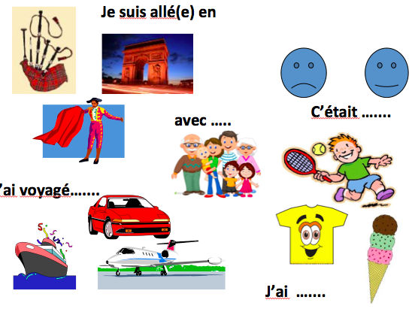](https://www.google.ca/url?sa=i&rct=j&q=&esrc=s&source=images&cd=&cad=rja&uact=8&ved=2ahUKEwjskLn33MTZAhUY3GMKHfJVBMYQjRx6BAgAEAY&url=https://www.tes.com/en-us/teaching-resources/hub/high-school/world-languages/french/travel-and-tourism/shopping-and-souvenirs/&psig=AOvVaw1OhZSaXIU4rXu95zKoKk6k&ust=1519771233980596)

**HOME ECONOMICS**

Home Economics is a field of applied knowledge with multi-disciplinary roots; it draws from the

arts, sciences, and humanities. The purpose of the Home Economics Program is to educate young people by providing experience and knowledge, which develops attitudes, skills and techniques as individuals and family members throughout their life cycle.

**TEXTILES 8/ TEXTILES 9**

The aim of these courses is to teach the operation of a sewing machine, fabric preparation and

simple clothing construction. Small projects such as pencil cases, boxer shorts, ski toques or

mitts or aprons or gym bags or PJ bottoms may be sewn during this session.

TS 8/9 is combined with FS 8/9 as part of the Junior elective program.

**FOOD STUDIES 8/ FOOD STUDIES 9**

Foods Studies 8 and 9 are introductory food courses that cover basic cooking principles and

techniques as well as an introduction to nutrition. Topics for this course include: safety,

sanitation, measuring, nutrition, flour mixtures, eggs, pasta, fruit and vegetables.

FS 8/9 is combined with TS 8/9 as part of the Junior elective program.

**FOOD STUDIES 10 (4 credits)**

Students in this class will understand the preparation of balanced meals. Each student will learn

about nutrients, functions of food in the body, and individual’s food needs and how to balance

good eating habits. The students will apply basic preparation skills in practical projects. The

course consists of practical and written work. Some units covered in this course are: nutrition,

eggs, flour mixtures, pasta and more.

**FOOD STUDIES 11 (4 credits)**

The Food Studies 11 program is designed to expand basic cooking principles and techniques

and also develop a deeper understanding of human nutrition. Basic principles of meal planning, budgeting, consumerism, kitchen and time management are studied. Students are expected to

follow a recipe accurately, work co-operatively in a group and evaluate prepared products according

to established standards.

This course includes both written and practical work. The units covered throughout this course

include: quick breads, yeast breads, salads and salad dressings, fruits and vegetables, vegetarian cookery, catering and fancy baking, cereals and pasta, eggs, cheese and meal planning and meat.

**FOOD STUDIES 12 (4 credits)**

The Food Studies 12 program involves advanced cooking principles, methods and techniques.

This course includes both group and individual projects as well as an in-depth study of human

nutrition. The units covered include: appetizers, beverages, advanced flour mixtures, food

preservation, soups, weight control, special diets, vegetarian cooking, catering, and international

foods.

**TEXTILES 10 (4 credits)**

This sewing course covers the following basic areas: equipment, safety, fabrics, patterns,

alterations, fabric preparations and construction techniques. Projects include a zipper project

and shirt or coat.

**TEXTILES 11 (4 credits)**

In this course, construction techniques are covered in more detail. Some areas of study will

include; color and design, fabric analysis, alterations and sewing a variety of different fabric

types. Projects may include outerwear, knit sportswear and garments of your choice.

**TEXTILES 12 (4 credits)**

The topics covered in this course will include advanced pattern alterations, history of fashion,

fabric analysis, tailoring and a variety of advance clothing construction techniques. Garment

projects may include a tailored jacket or prom dress and a design project that involves changing

a commercial pattern to suit individual tastes.

[](https://www.google.ca/imgres?imgurl=https://i.pinimg.com/736x/17/ce/90/17ce90f63b35280697ba88c45d4fb1fb--brother-sewing-machines-antique-sewing-machines.jpg&imgrefurl=https://www.pinterest.com/devanburen/sewing-machines/&docid=R2T4i3hHzpwINM&tbnid=q-UF09K1VIUpBM:&vet=10ahUKEwihzp_FkLvZAhUsyoMKHbHJD2gQMwheKCAwIA..i&w=390&h=300&bih=568&biw=1350&q=google%20images%20sewing%20machine&ved=0ahUKEwihzp_FkLvZAhUsyoMKHbHJD2gQMwheKCAwIA&iact=mrc&uact=8) [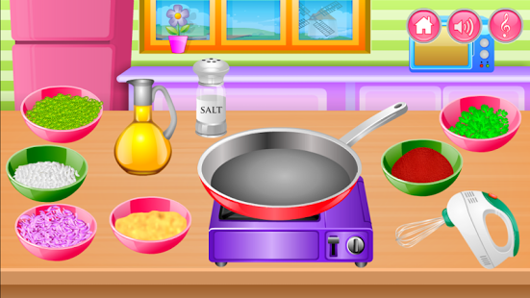](https://www.google.ca/url?sa=i&rct=j&q=&esrc=s&source=images&cd=&cad=rja&uact=8&ved=2ahUKEwj0ssz_kLvZAhUH7oMKHfEUC8gQjRx6BAgAEAY&url=https://play.google.com/store/apps/details?id%3Dcom.tgg.kidscooking&psig=AOvVaw3bN180BjTQK3fZDNR4658h&ust=1519444232671247)

**BOARD AUTHORITY AUTHORIZED COURSES**

Teachers in the School District have developed BAA courses. They are courses that meet a

particular school or district need and for which no provincial curriculum exists. BAA courses

provide opportunities for students that would otherwise not be available.

**LEADERSHIP 10, 11 and 12 (4 credits)**

This course is designed to provide students the opportunity to master the traits, skills, and responsibilities cultivated in leadership and to use those skills to serve their school, extended community, and lead others

in the spirit of service.

**TUTORING 11 & TUTORING 12 (4 credits)**

This is a participatory course that prepares and motivates students to provide assistance to a

teacher in their schools and communities. Students will work under the supervision of a teacher

or mentor to provide assistance to a teacher in a variety of teacher activities. Students will develop

skills in organization, self-directedness, communication, interpersonal relationships, leadership, teamwork, and in confidentiality. Students will apply these skills daily in activities related to

supporting a teacher**MATHEMATICS**

**“Which Math course is best suited to my child?”**

While there is no “rule” about which Math course is right for each student, the decision can be

made easier by thinking about your child’s ability in Math, his/her interest in Math, and his/her

future education and career plans. The new courses have been designed to facilitate student

success after high school. For example:

If your child has worked hard in Math 8 or 9, enjoys working on projects or “hands-on” activities,

or intends to pursue a trade or technical job after high school, then choose the **Workplace pathway.**

If your child has worked hard in Math 8 or 9, enjoys working on projects or “hands-on” activities,

or is planning further study in the in the Social Sciences like Economics, Geography, Psychology,

Arts or Humanities at post-secondary, then the **Foundation pathway** will be the best choice.

If your child has been very successful in Math 8 and 9, enjoys the challenges of Math, and is

thinking about future education or a career that involves Sciences or Engineering at a university,

then starting the **Pre-Calculus pathway** will be the best choice.

Your child’s education choices after high school depend, in part, on the courses he/she takes in high school. To find out more information about each pathway option, please talk to your child’s Principal, counsellor and math teacher as well as visit [www.wncp.ca](http://www.wncp.ca) for more curriculum information.

**Parents need to remember that grade 10 has ONLY two courses but there are three pathways**

**in grade 11 to 12. Please review the diagram on the next page. Students who choose grade 10 Workplace cannot move to the Foundations stream easily.**

**Workplace Mathematics (Courses at grade 10 and 11)**

This pathway is specifically designed to provide students with the mathematical understandings,

and critical-thinking skills identified for entry into the majority of trades at post-secondary and

for direct entry into the work force. Topics to be covered include: statistics, finance, probability, geometry, measurement, surface area and volume, trigonometry, graphing, puzzles and games.

**Foundations of Mathematics (Courses at grade 10,11 and 12)**

This pathway is designed to provide students with the mathematical understandings and

critical-thinking skills identified for post-secondary studies in programs that do not require the

student of theoretical calculus like Economics, Geography, Arts or Humanities. Topics include financial mathematics, geometry, measurement, number, logical reasoning, relations and functions,

and statistics and probability. Most students will choose this pathway.

**Pre-calculus (Courses at grade 11 and 12)**

This pathway is designed to provide students with the mathematical understandings and

critical-thinking skills identified for entry into post-secondary programs that require the study

of theoretical calculus like Sciences or Engineering. Topics include algebra and number,

measurement, relations and functions, trigonometry, permutations, combinations and

binominal theorem.

**MATHEMATICS**

Mathematics 8

Mathematics 9

Workplace Math 10 Foundations of Math and Pre-Calculus 10

History of Mathematics 11

Workplace Math 11

Pre-Calculus 11

Foundations of Math 11

Pre-Calculus 12

Foundations of Math 12

Calculus 12

**Mathematics 8**

Math 8 is intended to reinforce and extend the basic skills of elementary mathematics.

The topics covered are: squares and cubes, percent, decimals and fractions, discrete linear relations, ratios and rates, two step equations, surface area and volume, probability and financial literacy.

**Mathematics 9**

Students will build on math skills they can use at work, in finances and in daily life as well as in future professional applications like scientific research or engineering. More specifically students will explore: operations with rational numbers, exponents and operations with polynomials, two variable linear relations, multistep one variable linear equations, statistics and financial literacy.

**Workplace Mathematics 10**

**Prerequisite:** Math 9

This pathway is specifically designed to provide students with the mathematical understandings, and critical-thinking skills identified for entry into the majority of trades at post-secondary and for direct entry into the work force. Topics include puzzles, games, graphing, trigonometry, measurement and conversions, surface area and volume, central tendency, statistics and financial literacy.  In general, students will improve their spatial awareness, analytical and logic skills.

**Foundations of Mathematics and Pre-Calculus 10**

**Prerequisite:** Math 9

This course is for students wanting to pursue academic post-secondary programs. Students who plan to apply for technical programs involving the study of first-year Calculus, such as engineering, computer sciences, medical sciences, etc., need to take this course.  Non-math/science University programs including Psychology, Sociology, Humanities, and the Electrical Trades program. Topics include working with exponents, graphing linear functions, solving linear systems of equations, multiplying and factoring polynomials, trigonometry, probability and financial literacy.

**Workplace Mathematics 11**

**Prerequisite:** Workplace Math 10 or Foundations of Mathematics 10

This option is designed to provide students with the mathematical understanding and critical-thinking skills identified for the entry into the majority of trades and for direct entry into the work force. This course will expand on topics introduced in WM 10. Topics include puzzles and games, understanding and applications of personal investments, loans, budgeting, rate of change, probability and statistics, interpreting graphs in society, and 3D objects: angles, views and scale diagrams.

**Foundations of Mathematics 11**

**Prerequisite:** Workplace Math 10 or Foundations of Mathematics 10

This option is designed to provide students with the mathematical understanding and critical-thinking skills identified for the entry into the majority of trades and for direct entry into the work force. This course will expand on topics introduced in WM 10. Topics include mathematical reasoning, angle relationships, graphical analysis (linear inequalities, quadratic functions, systems of equations and optimization), statistics, scale models, and financial literacy (compound interest, investments and loans).

**History of Mathematics 11**

This course is designed to engage students with mathematical concepts through a historical lens. It allows students to go deeper through applications of those concepts. Students develop mathematics understandings and critical thinking skills as they apply concepts to historical problems and topics. Cultural and societal influences on mathematics are investigated. Curricular content include early number systems, patterns and algebra, geometry, tools and technology, probability and statistics, cryptography, calculus and philosophy.

**Pre-Calculus 11**

**Prerequisite:** Pre-Calculus 10

Calculus is the gateway into other higher level math courses in university, and is also usually required of students enrolled in sciences, engineering, computer programming and other technical post-secondary programs. Pre-Calculus may also be a high school prerequisite for many post-secondary medical field professional certification programs such as nursing. Topics include: working with quadratic functions and equations, trigonometry involving angles from 0 degrees to 360 degrees, manipulations and operations with radical and rational expressions, linear and quadratic inequalities, powers of rational exponents, polynomial factoring and financial literacy (compound interest, investments, and loans).

[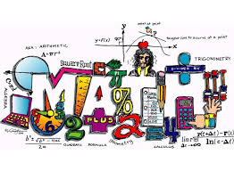](https://www.google.ca/url?sa=i&rct=j&q=&esrc=s&source=images&cd=&cad=rja&uact=8&ved=2ahUKEwiM1cDskbvZAhXM6YMKHcq9D58QjRx6BAgAEAY&url=https://freeclipartimage.com/article/top-80-math-clip-art/2&psig=AOvVaw1PmjnPT5G312iakoV6970F&ust=1519444454565105)

**Foundations Mathematics 12**

**Prerequisite:** Foundations of Mathematics 11

Foundations will appeal to students who prefer to see how numbers can be used practically to model real world situations, but it also gives you a great sampling of a wide variety of math topics, demonstrating the diversity of math beyond Calculus. As part of the Foundations pathway, it is designed for students who plan on applying to Social Sciences or Humanities faculties in university, which do not require math courses, or require only courses in statistics. Topics include: geometric explorations (constructions, conics, and fractals), graphical representations (polynomials, logarithmic, exponential and sinusoidal functions), regression analysis, probability, combinations and financial planning.

**Pre-Calculus 12**

**Prerequisite:** Pre-Calculus 11

This course is for students wanting to pursue University Mathematics, Sciences, Engineering, Medicine, most Medical Technician programs and the Electrical Trades program. Topics covered include: function transformations, logarithmic and exponential functions, polynomial functions, rational functions, trigonometry (functions, equations and identities) and geometric sequences and series.

**Calculus 12**

**Prerequisite:** Pre-Calculus 12

This course covers Pre-Calculus 12 and first year University Calculus topics at most post-secondary institutions. This course is for students wanting to pursue University Sciences, Mathematics, Engineering, Medicine, most Medical Technician programs and the Electrical Trades. Topics covered include: limits, the derivative and rules, applications of the derivative, the integral and applications of the integral.

[](http://www.google.ca/url?sa=i&rct=j&q=&esrc=s&source=images&cd=&cad=rja&uact=8&ved=2ahUKEwiIg5vQkbvZAhUD_IMKHchSA8gQjRx6BAgAEAY&url=http://gclipart.com/math-clip-art_20269/&psig=AOvVaw0u9dPq7H36x8Y7TT-Y3MRP&ust=1519444393938025)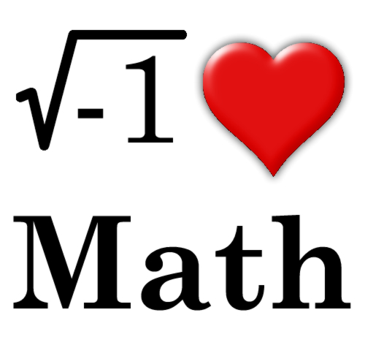

**PHYSICAL AND HEALTH EDUCATION**

The Physical and Health Education program at Sparwood Secondary School aims to improve a student’s physical intellectual, emotional and social characteristics and attitudes. Each student is presented with the opportunity to develop proficiency in a wide variety of skills offered in a structured framework. The skills range from developing a knowledge and understanding of physical education theory such as rules, techniques and strategies to developing and maintaining a personal level of physical fitness.

The program allows students the opportunity to develop and maintain a level of proficiency in a wide variety of activities under the general heading of team and individual activities.

Physical and Health Education is a required course up to and including the grade 10 level.



**PHYSICAL & HEALTH EDUCATION 8**

The objective of this course is to introduce students to a wide variety of group, individual and dual sports/activities. Students continue to develop, refine and apply fundamental movement skills in various activities and environments (gymnasium, fitness room and outdoors). Emphasis is placed on students’ development and demonstration of safety, fair play and leadership. Students are encouraged to participate daily in physical activity designed to enhance and maintain health components of fitness. Students will discuss a variety of health topics that promote healthy/active living, social and community awareness and mental well-being.

**PHYSICAL & HEALTH EDUCATION 9**

This course is an extension of the grade 8 program with a greater emphasis placed on refining fundamental skills, strategies and concepts in a variety of activities and environments (gymnasium, fitness room and outdoors). Game play is more extensive, with more importance placed on applying concepts and strategies in a variety of group, individual and dual sports and activities. Students begin to explore a more individualized fitness program with emphasis on performing exercises that meet their fitness goals. Students will discuss a variety of health topics that promote healthy/active living, social and community awareness and mental well-being.

**PHYSICAL & HEALTH EDUCATION 10 (4 credits)**

The grade 10 course is a required course. The students’ will continue to refine proper techniques for movement skills, concepts and strategies through a variety of traditional and non-traditional sports/activities. These activities will be explored in a variety of environments (gymnasium, fitness room and outdoors). Students continue to improve their individualized fitness programs to meet their goals throughout the course. FITT and SAID principles will be taught and utilized throughout the fitness unit. Students will discuss a variety of health topics that promote healthy/active living, social and community awareness and mental well-being. First aid skills for responding to emergencies will also be taught.

**Physical & Health Education 10 is required for graduation.**

**ACTIVE LIVING 11 and ACTIVE LIVING 12 (4 credits for each course)**

This course is primarily located in our gymnasium and field facilities with access to the community’s resources. The course emphasizes safety, fair play, and leadership in a variety of physical activities. Proper techniques to prevent injury are emphasized, as students learn to develop and demonstrate skills needed to plan, organize, and safely participate in recreational events and other preferred physical activities. Proper fundamental movement patterns will be taught; including non-locomotor (balancing, bending, lifting), locomotor (running, skipping, rolling), and manipulative (striking, bouncing, kicking, passing) skills. This course will emphasize leadership, volunteering and mentoring others. Injury prevention and management will be reinforced throughout the course, providing students with the knowledge and tools to follow personal safety practices and applying rules and guidelines for participating safely in specific activities. Additionally, this course will explore the recreational resources available in the community.

**Fitness and Conditioning 11/12**

This course is primarily located in our fitness room, with access to the community’s facilities and fitness programs. This course explores personal fitness and emphasizes participation in a variety of activities at different intensity levels. Students will continue to learn how their bodies move and function and how to move safely during exercise. Students will acquire proper training guidelines and techniques in order to reach their health and fitness goals. Students will examine their own personal choices and how those choices influence health and fitness goals. Individualized fitness programs will be developed throughout the course, allowing students to adapt their program to meet their specific goals. Anatomy and physiology will be emphasized throughout the course. Students will identify and describe how muscles produce movement in different parts of the body and how to specifically train those muscles. Overall, students will demonstrate leadership, proper etiquette and safety skills in different types of fitness activities and environments.

**Outdoor Education 12**

This course focuses on preparing for, and participating in, outdoor activities. Students learning a variety of skills for outdoor activities such as emergency preparation, nutrition and hydration, and activity planning. While the focus is clearly on outdoor activities, the curriculum allows for a wide range of indoor and outdoor physical activities to prepare students for specific activities.

 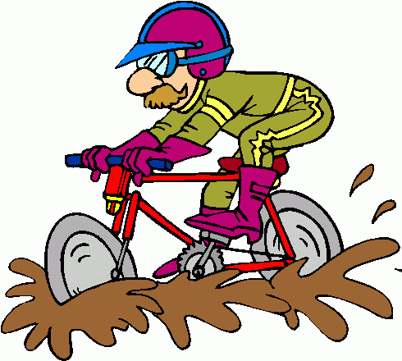

 

**SCIENCE**

The Science Program at Sparwood Secondary focuses on analyzing, predicting, questioning and processing scientific information and connecting this information to real-life experiences through inquiry. Students are encouraged to “think outside the box” to help them recognize and solve problems. Regular classroom discussions promote collaborative learning experiences as students seek answers to questions about the world around them. This program is meant to continually engage the curiosity of all of our students in order to pursue learning.

**Sparwood Secondary offers a wide and varied selection of science courses to meet the needs of all students.**

The junior science program (grade 8-10), covers a wide range of sciences which will prepare you for more specialized sciences in grades eleven and twelve. Graduation requirements include a grade 10 and a grade 11 level science course.

These are Life Science 11, Anatomy and Physiology 12, Chemistry 11, Chemistry 12, Environmental Science 11, Physics 11 and Physics 12.

Anatomy and Physiology12

Life Science 11

Physics 12

Physics 11

Chemistry 11

Chemistry 12

Science 8

Science 9

Science 10

Environmental Science 11

Environmental Science 12

**SCIENCE 8**

The Science 8 course continues to build on the concepts introduced in Grade 7. The course covers a wide range of topics related to each science discipline. Some examples of content covered is cell theory, immune system, properties of light, atomic theory, plate tectonics and First Peoples knowledge of local geological formations.

**SCIENCE 9**

The Science 9 course continues to build on the concepts introduced in Grade 8. Some examples of content covered is mitosis, meiosis, the periodic table and its properties, circuits, matter cycles and First Peoples knowledge of interconnectedness and sustainability.

**SCIENCE 10 (4 credits)**

Science 10 gives students a more in-depth knowledge of all the science disciplines. The course content covers chemistry, physics, biology and earth science. This wide range can help students recognize possible interests which may help guide them in their science course selection for their grade 11 and 12 years.

The content covered in each discipline is listed below:

Chemistry and Physics – chemical formulae, the periodic table and its properties, simple chemical reactions, transformations of kinetic and potential energy, fission verses fusion,

Biology –DNA, genes, chromosomes, inheritance

Earth Science- formation of the universe “The Big Bang Theory”

First Peoples perspective on energy and chemical processes and their implications.

**CHEMISTRY 11 (4 credits)**

Prerequisite: Science 10, but it is strongly recommended that Pre-calculus 11 be taken concurrently.

The Chemistry 11 program is designed to be both a general survey course or as a foundation for further chemical study. The chemistry program deals with the description of matter and its transformations. Emphasis is placed on the quantitative analysis of chemical reactions. An introduction to organic chemistry is also presented. The course consists of 5 modules: Atoms and Molecules, The Mole, Chemical Reactions

(Stoichiometry), Solution Chemistry and Organic Chemistry.

**CHEMISTRY 12 (4 credits)**

Prerequisite: Chemistry 11 and Pre-calculus 11 strongly recommended.

Chemistry 12 is designed primarily for students planning to continue in post-secondary studies in technology or science. Chemistry 12 consists of 5 modules: Reaction Kinetics,

Chemical Equilibrium, Solubility Equilibrium, Acid- Base Chemistry and Oxidation-Reduction.

[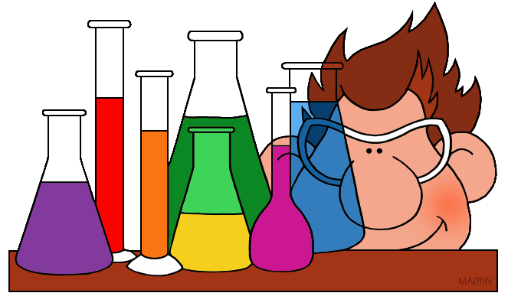](http://www.google.ca/url?sa=i&rct=j&q=&esrc=s&source=images&cd=&cad=rja&uact=8&ved=2ahUKEwjX0sTTkrvZAhVm9IMKHYDUADkQjRx6BAgAEAY&url=http://clipart-library.com/chemistry-clip-art.html&psig=AOvVaw1yToxoZ5aoIfk1flNV5MB3&ust=1519444670002891)

**ENVIRONMENTAL SCIENCE 11 (4 credits)**

This course will look at both global and local environmental topics. It offers students the opportunity to understand, explore and communicate ideas on environmental science education. Academically, the course will be predominantly assignment and project-based. The Big Ideas covered in this course are:

* Diversity in Local Ecosystems: Local environments contain diverse ecosystems with many roles and relationships.
* Processes and Changes in Local Ecosystems: Inter connected systems sustain healthy ecosystems. Ecosystem stability is an important result of sustainability
* Sustainability in Local Ecosystems: Human practices affect the sustainability of ecosystems.
* Conservation and Restoration of Ecosystems: Humans can play a role in conservation and restoration of ecosystems.

**ENVIRONMENTAL SCIENCE 12 (4 credits)**

Environmental Science 12 is an introduction to global issues impacting Earth. Students will explore global water systems, global warming and climate change, land use and sustainability, and environmental changes at both the local and global scale.

**LIFE SCIENCE 11 (4 credits)**

Prerequisite: Science 10

Life Science 11 examines how the structure and function of a cell allows for the development of a vast array of organisms. This diversity of life will be examined using established classification systems, with an emphasis on unifying characteristics for kingdom and phyla groupings. To this end, students will arrive at an understanding of how organisms conduct life processes, and at the same time, maintain equilibrium with the biosphere. Microscope skills are developed and dissection techniques are introduced.

**ANATOMY and PHYSIOLOGY 12 (4 credits)**

Prerequisite: Life Science 11 and Chemistry 11 recommended

Anatomy and Physiology 12 is an overview of human anatomy and physiology from the molecular level to the organ system level. The first part of the course covers cell structure and function. The second part covers basic human anatomy and physiology. The underlying theme of the course is homeostasis – the maintenance of a steady state within the organism. Microscope skills and dissection technique will continue to be developed.

**PHYSICS 11 (4 credits)**

Prerequisite: Science 10. It is strongly recommended that Foundations of Math & Pre-calculus 10 be completed and that Pre-calculus 11 be taken concurrently. Topics to be covered include:  1D Kinematics, 1D Dynamics, 1D Momentum, Energy, Electric Circuits and Waves and Optics.

**PHYSICS 12 (4 credits)**

Prerequisite: Physics 11

Physics 12 is an extension of Physics 11, taking some topics to greater depth and introducing some new topics. It provides a more rigorous treatment of fewer topics than Physics 11.

The topics covered include: 2D Kinematics, 2D Dynamics, 2D Momentum and Energy, Equilibrium, Circular Motion and Gravitation and Electrostatics.

**SOCIAL STUDIES**

Social Studies is a core subject and graduation requirements include the successful completion of a Social Studies course in each grade 8 through 11.

Social Studies 8

Social Studies 9

Social Studies 10

Explorations in Social Studies 11

**OR**

20th Century World History 12

**SOCIAL STUDIES 8**

Social Studies 8 is the introductory Social Studies course in secondary schools. The theme of the course is the diverse heritage of Canada. The course includes:

Geography – interpreting maps and globes, locating information.

History – Middle Ages in Western Europe, Eastern Europe, Middle East, India, China, Japan; the Renaissance and Reformation in Europe and Exploration and Conquest I the New World.

**SOCIAL STUDIES 9**

Grade nine Socials Studies builds on the themes developed in grades seven and eight. In this year students are introduced to a Canadian strand in the overall theme of distinctive cultures developing in response to a variety of influences. Geographic skills and knowledge are integrated with the historical topics as well as interpreting maps and globes and locating information. The themes introduced will be: North America to 1815, Canadian Nation – Building, Industrialization,

Current Events and Relevant Field Studies.

**SOCIAL STUDIES 10 (4 credits)**

This course is entitled “Canada: Nationhood and Economic Relationships”. The focus is on the development of Canada as a nation, with emphasis on the development of Western Canada. The Geography section examines Canada’s economic activities and Canada’s relationship with the Pacific Region and the Indian Sub-Continent.

**EXPLORATIONS IN SOCIAL STUDIES 11 (4 credits)**

The Social Studies 11 course is a contemporary study of Canada and World Affairs. The student will study Canada’s government, laws, politics, and social issues. They will examine Canadian society and our role in world affairs. In the Geography section topics such as the Global Village, World Population, Resource Use, Industrialization, and Urbanization will be covered. Students will also examine Current Events and relevant issues of the time.

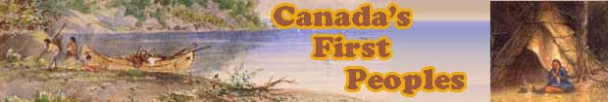

**20th CENTURY WORLD HISTORY (4 Credits)**

This course follows an inquiry -based model involving improved communication and critical and creative thinking skills. It looks more in depth at how the 20th Century was a pivotal one not only for Canada, but also for the entire world. A solid understand of Socials 10 and 11 is recommended. Different countries are focused on in this class such as South Africa and its apartheid movement, the rise of the American mafia, America’s segregation and civil rights eras, Sierra Leone and its link to blood diamonds, Russia’s revolutionary changes, and China’s development as a global power. Military history and the long-term impacts of war are interwoven into each unit. Students will also improve their research skills and gain a better understanding of human geography concepts like population growth, environmental changes, terrorism and globalization.

**TECHNOLOGY EDUCATION**

This department is emphasizing "skills" and "design" oriented courses. Design oriented versions of the traditional Woodworking and Metalworking courses are offered. Art Metal will also emphasize creative design. Automotive courses can be taken as an introduction to basic mechanics.

Woodworking and Metalworking also have career preparation courses that will prepare students for a trade in house construction, fabricating and the welding fields.

**WOODWORK 8 /9**

The aim of the course is to introduce hand tool work as well as some basic machines to the student. The student will layout and fashion wood to a smooth finish. The practical aspect of this course usually consists of small projects to facilitate the use of most basic joints, tools and machines. The only fee applicable would be that students would be required to pay for materials if hardwood is desired.

**METALWORK 8/9/10**

The aim of this course is to give the students enough metalwork background that they can design, draft and produce their own projects. The course will cover welding, machining and casting in addition to care and maintenance of equipment. Skills in all areas will be learned through selected projects. The balance of the school year will be for student designed projects.

Safety glasses are required – a shop coat is recommended.

(Grade 10 level courses are worth 4 credits)

**WOODWORK 10 (4 credits)**

Students enrolled in this course will have the opportunity to safely operate basic wood working machinery. There will be common projects constructed, as well as individual projects. A design problem will be solved and constructed. Students are expected to draw all projects. Students will pay for individual projects only.

**WOODWORK 11 (4 credits)**

The aim of this course is to develop skills, knowledge and confidence in woodworking tools,

machinery and cabinet construction. Students will also be expected to illustrate how their manufactured project is beneficial. This course will consist of a common core project, a design problem project, as well as, supplementary projects.

Students will be responsible for knowledge of theoretical components of house construction.

Students are expected to pay for all supplementary project materials.

**WOODWORK 12** **(4 credits)**

Students will be expected to follow advanced machine and power tool procedures. Cabinet construction theory will be an integral part of this course. Students will be expected to draft all projects prior to construction. Students will also be expected to apply many types of wood finishes. Students will be responsible for knowledge of theoretical components of house construction. The course will also consist of common projects, design problem solving projects and supplementary projects. Students are expected to pay for all supplementary projects material.

[](http://www.google.ca/url?sa=i&rct=j&q=&esrc=s&source=images&cd=&cad=rja&uact=8&ved=2ahUKEwi5gPnylLvZAhUjwlQKHVDZC-8QjRx6BAgAEAY&url=http://moziru.com/explore/Jewelry%20clipart%20icon/&psig=AOvVaw1GpEomF3dAIL3_TH-DWpK3&ust=1519445274912374)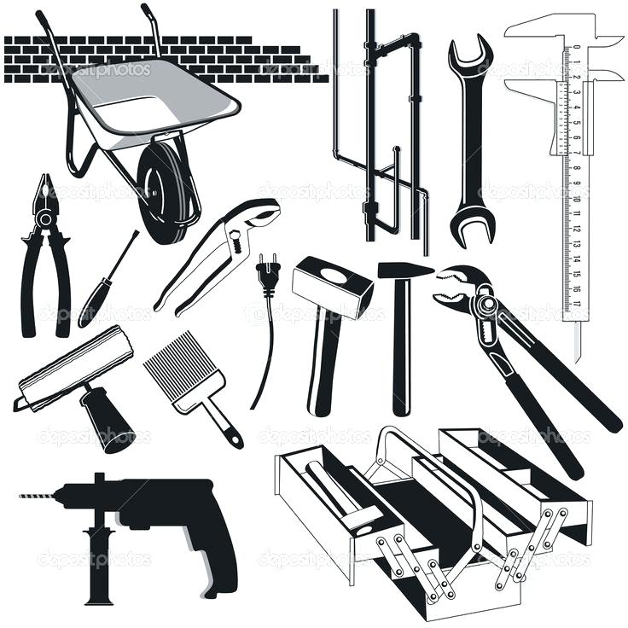[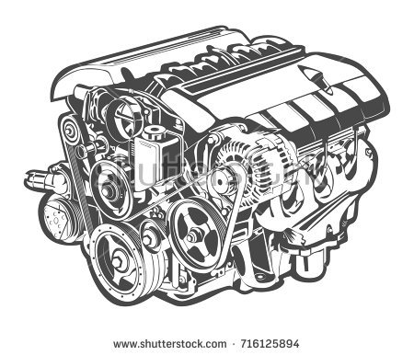](https://www.google.ca/url?sa=i&rct=j&q=&esrc=s&source=images&cd=&cad=rja&uact=8&ved=2ahUKEwiOpfKMlbvZAhVhh1QKHVuEDO8QjRx6BAgAEAY&url=https://www.shutterstock.com/search/engine&psig=AOvVaw0DhTv9nCyRscTD1HL8v6zf&ust=1519445331044531)

**METALWORK 11 (4 credits)**

In this course, the student should expand his abilities in the application of principles of the technology of the metal trades: fundamental skills of allied trades of welding, sheet metal and foundry, systematic planning and procedures and safe work habits, skills and knowledge in use of lathes, milling machines and drill presses, care and maintenance of equipment.

This is a senior metal work course. Some projects are compulsory. After that, students will be able to choose their own projects in consultation with the instructor. Individual attention will be given when needed and creativity is encouraged. Each student must have his/her own pair of safety glasses.

**METALWORK 12 (4 credits)**

In this course, the student should expand his/her abilities in the applications of principles of the technology of the metal trades and how these principles relate to practical situations, fundamental skills of the allied trades of welding, sheet metal and foundry work, in-depth knowledge of one or more of the metal areas, skills and knowledge in the use of milling machines, lathes, drill presses, safety consciousness and good work habits, the vocational opportunities available in metal trades, care and maintenance of equipment. This is a senior metalwork course involving students working on their own individual projects. The Instructor will give individual help when needed. Creativity on projects is encouraged. Each student must have his/her own pair of safety glasses.