Updated April 6th 2021

|  |  |
| --- | --- |
| ***Health and Safety Protocols*** | |
| **COVID-19 Protocols for School Operations** | * *Document link:* * *https://www.sd5.bc.ca/Documents/COVID-19%20Protocols%20for%20School%20Operations%20(March%2031).pdf* |
| **Cleaning** | * Two daytime custodians have been hired in addition to our two evening custodians * A general cleaning/disinfecting of the premises will occur once every 24 hours * High touch surfaces will be cleaned an additional two times in a 24 hour period * Teachers will have disinfectant and wipes in their classroom spaces to also wipe down surfaces when needed * Please see the Appendix called Enhanced Cleaning Procedures * No additional cleaning procedures are required when different learning groups use the same space |
| **Hand hygiene** | * Extra sinks have been installed in the school to facilitate hand-washing practices * Hand sanitizer bottles are in every classroom and available at every door * Teachers will teach and review proper hand washing technique |
| **Personal Protective Equipment (PPE)** | * Five 2 ply and two 3 ply reusable masks per staff member were provided to staff by the district, as well as a supply of disposable masks * Any staff who request a face shield will be provided with one * Supply of PPE will be stored in the medical room and office * All staff, students (gr. 4 – 6) and visitors are required to follow the mask guidelines for schools, except for those who meet one of the two exceptions below: * a person who cannot tolerate wearing a mask for health or behavioural reasons * a person who is unable to put on or remove a mask without the assistance of another person   Students in K-3 are encouraged to wear a mask  Those who can wear masks can also remove them temporarily in the following circumstances:   * for the purposes of identification * engage in an educational activity that cannot be performed while wearing a mask (e.g. playing a wind instrument, engaging in high-intensity physical activity, etc.) * while eating or drinking * if a person is behind a barrier (The walls of a room/space qualify as a barrier when the person is alone) * while providing a service to a person with a disability or diverse ability where visual cues, facial expressions and/or lip reading/movements is important. * No student needs to wear a non-medical mask if they do not tolerate it * Please refer to the How to use a Mask Appendix |
| **General Ventilation and Air Circulation** | At this time, there is no evidence that a building’s ventilation system, in good operating condition, is contributing to the spread of the virus. Good indoor air ventilation alone cannot protect people from exposure to COVID-19; however, it may reduce risk when used in addition to other preventative measures.  SD5 has ensured that heating, ventilation and air conditioning (HVAC) systems are designed, operated, and maintained as per standards and specifications for ongoing comfort for workers (Part 4 of the OHS Regulation). |
| **Respiratory Etiquette** | * All staff and students should cough/sneeze into their elbow, sleeve or tissue. Then immediately wash hands after. |
| **Entering/exiting the building** | * Students will enter and exit through designated doors at all times when coming into the school (indicated in attached map) * Staff will enter either through their classroom doors, or if they don’t have one, a door of their choice near their classroom area * Parents/visitors *will not* be allowed in the building without previous consent from the office, must complete a health screening check upon entering and wear a mask (more on that in the *Parent Specific* section) |
| **Water Fountains** | * Water fountains will be closed * Water bottle filling stations will remain open |
| **Physical Distancing** | * Staying apart 2 meters continues to be our most effective preventative measure and is used as often as possible * Students and staff will be placed in learning groups of no more than 60 people total (will be detailed further in the document) * Students will enter and exit the building at separate doors (coatroom or classroom). * Intermediate and primary students’ dismissal time is staggered by 5 minutes (2:55 and 3:00) * Painted zones or ‘bubbles’ outside of classroom/coatroom doors indicate where students can stand while waiting to come into school * Plastic barriers have been placed in areas where there may be higher traffic (between clerical staff, at office counter, at library counter, in SLPA office) * All assemblies or big school events will be held virtually with students remaining in their classrooms   Physical distancing refers to a range of measures aimed at reducing close contact with others. Physical distancing is used as a prevention measure because COVID-19 tends to spread through prolonged, close (face-to-face) contact.   * Within learning groups, physical distancing should include avoiding physical contact, minimizing close, prolonged, face-to-face interactions, and spreading out as much as possible within the space available.   + Young children may not be able to consistently reduce physical contact. * Outside of learning groups, physical distancing should include avoiding physical contact and close, prolonged face-to-face interactions, spreading out as much as possible within the space available, and ensuring there is 2 meters of space available between people from different learning groups. * For situations where members of different learning groups interact:   + If people will be in the same space for an extended period of time (>15 minutes), the space should be sufficiently large, and or should have limits on the number of people so that 2 metres of space is available between people from different learning groups.   + If people will be in the same space for transition purposes (e.g. changing between classes), and other measures are in place (e.g. markings on the floor, staggered transition times), there should be enough space to ensure no physical contact but 2 metre physical distancing is not required. * Within and outside of learning groups, there should be no crowding. * Staff and other adults should seek to reduce the number of close, face-to-face interactions with each other at all times, even if wearing a non-medical mask. This includes during break times and in meetings. |
| **Traffic Flow** | * Directional arrows will be placed in the hallways to indicate flow of traffic |
| **First Aid** | * Extra PPE (masks, face shields, gloves) will be on hand for our first aid attendants to use when treating injuries * If an injury is minor, it is recommended that the first aid attendant talks the student through the injury (ie cleaning or bandaging a minor wound, applying an ice pack) * Classrooms will have supplies of band-aids and cleaning wipes on hand to minimize students needing to go to the office for first aid |
| **Health & Safety Checks** *(checklist can be found in Appendix B on page 16 of document)* | ***Staff****:* Staff are required to complete a daily health screening before coming to work. Staff are required to submit their online health check confirmation. If they have any of the listed symptoms they are to stay home and contact their administrator (see list below)  ***Students:***The parent will be responsible for completing daily health checks prior to sending their child to school. If there are any changes to the initial symptoms that include a “yes” response the child is to say home and the school contacted. (see list below) Appendix B: Daily Health Checks Please do not enter the school of district facility is any of the answers below are Yes.   |  |  |  |  |  | | --- | --- | --- | --- | --- | |  |  | **Daily Health Check** |  |  | | 1. | Symptoms of Illness | Do you have any of the following new key symptoms? | Circle One | | |  |  | Fever (above 38 C) or chills | Yes | No | |  |  | Cough | Yes | No | |  |  | Loss of sense of smell or taste | Yes | No | |  |  | Difficulty breathing | Yes | No | |  |  | Sore throat | Yes | No | |  |  | Loss of appetite | Yes | No | |  |  | Extreme fatigue or tiredness | Yes | No | |  |  | Headache | Yes | No | |  |  | Body aches | Yes | No | |  |  | Nausea or vomiting | Yes | No | |  |  | Diarrhea | Yes | No | | 2. | International Travel | Have you returned from travel outside Canada in the last 14 days? | Yes | No | | 3. | Confirmed Contact | Have you been notified by Public Health to isolate or identified as a close contact? | Yes | No |   **If you are displaying symptoms consistent with COVID-19, refer to HealthLink BC at 811**  **Refer to the BC CDC Document “**[**When to get tested for COVID-19**](http://www.bccdc.ca/Health-Info-Site/Documents/COVID_public_guidance/When_to_get_tested.pdf)**” for further direction if you are displaying the abovementioned symptoms**   * Once at school, any child who appears or vocalizes feeling unwell will be sent home to ensure safety of all staff and students in the building   + Parents are required to pick up their child immediately   + Parents must have an emergency contact on hand in the event that a parent cannot get to the school right away. * If you have questions about whether or not you should be tested for COVID-19, use the self -assessment tool at https://www.k12dailycheck.gov.bc.ca/healthcheck?execution=e1s1.   **STAYING HOME, SELF-ISOLATION AND SYMPTOMS**  Stay Home When Required to Self-Isolate  The following students, staff or other adults must stay home and [self-isolate](http://www.bccdc.ca/health-info/diseases-conditions/covid-19/self-isolation):   * A person confirmed by the health authority as testing positive for COVID-19; or * A person confirmed b the health authority as a close contact of a confirmed case of COVID-19; or * A person who has travelled outside of Canada in the last 14 days.   A person who has been tested for COVID-19 must stay home while they are waiting for the test result.  Information on self-isolation for international students, and homestay contingency plans for illness, is available in the [COVID-19 Operational Guidelines for K-12](https://www.openschool.bc.ca/covidguidelines/#selfisolation).  Additional information on self-isolation requirements and support is available from [BCCDC](http://www.bccdc.ca/health-info/diseases-conditions/covid-19/self-isolation). |
| **Health and Safety Training** | * Staff were oriented to the school protocols on September 8th and 9th and do a walk through of the space to understand safety protocols * Students were oriented to school protocols on September 10th (shape of the day TBD) * We will communicate the new plan with families via email, facebook, and a link will be on the school website * We will communicate changes with staff via email, Wolves Weekly and staff meetings |
| **Health and Safety Continuance** | * The school JOHSC (Joint Occupational and Safety Committee) committee comprised of Jen Adams (P), Kathy Conlin (VP), Jade Kuystermans (CUPE), Tanya Kerkhoven (FDTA), Sarah Jones (FDTA and District JOHSC) will meet monthly or on an as needed basis to review and ensure school-wide maintenance of health and safety protocols |
| **Isolation Room if staff or student becomes ill** | * The girls changeroom is the isolation room. * A staff member will always be present with a student who is in isolation * Student will wear a non medical mask once a covid symptom has been identified |
| ***Updated Information*** | **COVID-19 Preventative Measures** Measures applicable to Staff, students and visitors:   * **Students and staff should stay at home** when new symptoms of illness develop. The key symptoms to watch for are fever or chills, cough, loss of sense of smell or taste, difficult breathing, sore throat, loss of appetite, extreme fatigue or tiredness, headache, body ache, nausea, vomiting and diarrhea.   + If you are displaying symptoms consistent with COVID-19, refer to HealthLink BC at 811   + Refer to the BC CDC document "[When to get tested for COVID-19](http://www.bccdc.ca/Health-Info-Site/Documents/COVID_public_guidance/When_to_get_tested.pdf)" for further direction If you are displaying the abovementioned symptoms   If a **COVID-19 test is not recommended** by the health assessment, the person can return to school when symptoms have improved and they feel well enough. Testing may not be recommended if the assessment determines that the symptoms are due to another cause (i.e. not COVID-19). **PROTOCOL IF A STUDENT/STAFF DEVELOPS SYMPTOMS OF ILLNESS AT SCHOOL** If a student or staff member develops symptoms at school, schools should:   * Provide the student/staff with a non-medical mask if they don’t have one (exceptions should be made for students and staff who cannot wear masks for medical and/or disability-related reasons). * Provide the student/staff with a space where they can wait comfortably that is separated from others.   + The student is to be supervised and cared for, when separated. * Make arrangements for the student/staff to go home as soon as possible.   + Contact the student’s parent/caregiver with a request to have their child picked up as soon as possible. * Clean and disinfect the areas the student/staff used. * Encourage the student/staff to seek assessment by a health-care provider. * Request that the student/staff stay home until COVID-19 has been excluded and symptoms have resolved.   Schools and school districts should notify their local medical health officer if staff and/or student absenteeism exceeds 10 percent of regular attendance, to help with the early identification of clusters or outbreaks.  **PROTOCOL IN THE EVENT OF A CONFIRMED COVID-19 CASE IN A SCHOOL**  If a student or staff member is confirmed to have COVID-19, and were potentially infectious while they were at school:   * Public health will perform an investigation to determine if there were any potential close contacts within the school. (To learn more about contact tracing, visit the BCCDC website.)   + Students and staff who have interacted with the confirmed case may be asked to stay home while public health completes their investigation. * If it is determined that there are close contacts within the school, public health will notify the school administrators to request class and bus lists to assist with contact tracing and provide guidance on what steps should be taken. * Public health may then:   + Recommend 14-day isolation if necessary (for confirmed close contacts).   + Recommend monitoring for symptoms if necessary.   + Provide follow-up recommendations if necessary. * Schools must continue to provide learning support to students required to self-isolate. * Together, schools/school districts and public health officials will determine if any other actions are necessary.   **Covid 19 Symptons, Testing and Return to School**    Symptoms of Illness and Return to School  **Students, staff or other adults should stay at home when sick**, as this is one of the most important ways to reduce the introduction to and the spread of COVID-19 in schools. The following resources provide guidance regarding specific symptoms of illness:   * Parents/caregivers and students can use the [K-12 Health Check app](https://www.k12dailycheck.gov.bc.ca/healthcheck?execution=e1s1). * Staff and other adults can refer to BCCDC's "[When to get tested for COVID-19](http://www.bccdc.ca/Health-Info-Site/Documents/COVID_public_guidance/When_to_get_tested.pdf)" * Staff, students and parents/caregivers can also use the BCCDC on line [Self-Assessment Tool](https://bc.thrive.health/), call 8-1-1 or their health care provider.   When a staff, student or other adult can return to school depends on the type of symptoms they experienced (as indicated in the [K-12 Health Check app](https://www.k12dailycheck.gov.bc.ca/healthcheck?execution=e1s1) and BCCDC "[When to get tested for COVID-19](http://www.bccdc.ca/Health-Info-Site/Documents/COVID_public_guidance/When_to_get_tested.pdf)" resource) and if a COVID- 19 test is recommended. See Appendix L - COVID-19 Symptoms Testing & Return to School for more information.  Students and staff who experience symptoms consistent with a previously diagnosed health condition (e.g. seasonal allergies) can continue to attend school when they are experiencing these symptoms as normal. They do not require re-assessment by a health-care provider and should not be required to provide a health-care provider note. If the experience any new or unexplained symptoms, they should seek assessment by a health care provider.  Students or staff may still attend school if a member of their household develops new symptoms of illness, provided the student/staff has no symptoms themselves. If the household member tests positive for COVID-19, public health will advise the asymptomatic student/staff on self-isolation and when they may return to school. Most illness experienced in B.C. is not COVID-19, even if the symptoms are similar. |

|  |  |
| --- | --- |
| ***Learning Groups*** | |
| **What is a learning group?** | * Students will be organized into learning groups/learning groups for in-class instruction. This helps to limit contact and potential exposure. The learning group will consist of their regular classroom teacher(s), students and regular scheduled Education Assistants. * Each elementary learning group will be comprised of a maximum of 60 people (will most likely be two classes paired together) * Administration will keep a detailed learning group list for contact tracing purposes |
| **How do they work?** | * The composition of the learning group will remain consistent for all activities that occur in schools. * Within the learning group, minimal physical contact should be encouraged, but a physical distance of two meters does not need to be maintained * When students interact with peers outside of their learning groups, they should minimize contact when outdoors and maintain physical distance when indoors |
| **Multi-Learning Group Instruction** | * Students from different learning groups can be in the same space at the same time **IF** physical distancing can be maintained. Masks are **NOT** a replacement for physical distancing between students from different learning groups in the same space. |
| **Outside of Learning Group Staff** | * Staff members who enter into various learning groups must physically distance and wear a mask. If staff cannot physically distance then the room should be reconfigured, move to an alternate space, install a physical barrier or provide virtual services where possible. * Some staff members, especially itinerant staff, will not be placed specifically in one learning group, and thus must follow the above guidelines |

|  |  |
| --- | --- |
| ***Shape of the Day*** | |
| **Before School** | * Students arriving off the bus will go their designated line ups as soon as they arrive at school until the bell rings at 8:45 * Students will enter through their designated entry points, possibly staggered depending on learning groups * Students will wash/sanitize hands upon entry and go straight to their classrooms with their backpacks/shoes |
| **Coatrooms** | * Coatrooms are open * Students may only be in a coatroom at the same time as members of their learning group. This means some students will have to wait for another learning group to vacate before they may enter. |
| **Washroom/body breaks/water bottles** | * Access to washrooms will not be restricted but students may only use the washroom with students of their own learning group * Students will always be supervised by an adult in the hallway * Each classroom will have a break station or break bags for the students to use when needed, knowing that many students use washroom breaks as just a body break * Students may fill their water bottles at the water bottle filling station at their scheduled washroom break |
| **Lunch** | * 11:40 – 12:00: k-2 outside (split up into 2 groups on playground) * : 3-6 eating in classrooms * 12:00 – 12:30: k-2 eating in classrooms * : 3-6 outside (split into two groups on playground) |
| **Recess** | * Separate Primary and Intermediate recess * 1:30 – 1:45 and 1:45 – 2:00 * Groups will be split into two sections on the playground (see map) |
| **Playground** | * Playground is open but has a rotational learning group use schedule * Students will wash/sanitize their hands before and after playground use |
| **General** | * Assemblies will happen virtually * Intramurals and clubs will take place within learning groups. * Performances will be put on hold for the year |
| **Hallway Traffic** | * Classes will stay to the right hand side of the hallway when moving throughout the school to maintain the physical distancing between learning groups * When using the gym for PE classes will enter through the main doors and exit through one of the change room doors so students are not going through the same set of doors at the same time |
| **Dismissal & After School** | * Students will wash/sanitize their hands before leaving the building * Students will exit through their assigned doors at the assigned time and leave the property as soon as they are able to |

|  |  |
| --- | --- |
| ***Teaching and Learning*** | |
| **Curriculum** | * Lots of focus placed on the core competencies through the continuation of the Play is the Way SEL program. * Ministry of Education curriculum, assessment and reporting still followed * Students will have access to support staff: ABED, YCW, SLP, SLPA, Counsellors and EAs |
| **Instruction** | * Build relationships and community first, “connection before direction” with an understanding of trauma-informed practice * Addressing student’s passion and interests through getting to know them and relationships built. * Instruction within learning group * Manipulatives will be distributed to individual students (in bins or bags) and will be used by that individual for the duration. If manipulatives are shared between students then students must wash/sanitize hands before and after use. If teachers choose to use shared manipulatives, they will need to be sanitized once a day. * There is no need to limit the distribution or sharing of books or paper-based educational resources to students |
| **Communicating Student Learning** | * Parents can expect that reporting and communication will be following past practice which will include: * Provincial curriculum for all students at all grade levels * Regular reporting * Regular assessments at the classroom and provincial level |
| **Field Trips** | * Local field trips that adhere to the existing Covid-19 health and safety guidelines will be allowed |
| **Photo copy room** | * 2 staff members at a time in office photocopier * 1 staff member at a time in primary photocopy room * If you need to use the photocopier, wash your hands before you begin. * Disinfect the photocopier before and after use with a purell wipe * Disinfect any shared surfaces or equipment at the photocopy area/room such as staplers, hole punches, etc that you used (or notify custodial staff). * When you are finished at the photocopier or in the supply room, wash your hands again before you go back to your office or workspace. |
| **Staff Washrooms** | * Follow posted Covid 19 handwashing guidelines * Must wash hands after use |
| **Staffroom** | * There will be a posted occupancy limit * Staff must physically distance and wear a mask (unless eating) * Sitting spots will be closed off with a red x to ensure physical distancing * Disinfect the area you used after use * Wash your hands after eating * Do not share food |
| **Meals Program** | * The preparation of the school meals program will adhere to the following document <https://www.worksafebc.com/en/about-us/covid-19-updates/covid-19-returning-safe-operation/restaurant-cafes-pubs> * As in June, meals will be prepped by qualified staff and then delivered to students * Homemade food items will not be made available to students at this time |
| **Music and Fine Arts** | * The Fine Arts portable is open * Students must sanitize hands upon entry and exit of the room * Each class or learning group will have their own basic fine art materials (paint brush, paint, scissors, glue,) * If special materials are required that need to be shared, the materials will be cleaned as per the following guidelines <http://www.bccdc.ca/Health-Info-Site/Documents/CleaningDisinfecting_PublicSettings.pdf> * Staff teaching music will be familiar with the document called Guidance for teaching Music in BC During Covid 19 <https://7fd068f4-68ea-47f4-b927-7d1f32730842.filesusr.com/ugd/e89cf1_29d484fe08cb4becb025ec5978c0928a.pdf> * The key changes for music programs is that masks must be worn at all times by K-12 staff and students in Grades 4 to 12 when indoors, but can be temporarily removed to engage in educational activities that cannot be performed while wearing a mask (e.g. playing a wind instrument). * Masks must be worn by K-12 staff and students in Grades 4 to 12 while singing. * These mask requirements for K-12 staff and students in Grades 4 to 12 apply both within and outside of learning group * No in school or inter-school performances to occur at this time |
| **Technology** | * Ipads and computers will still be shared by learning groups, they will be wiped down and sanitized after each use by an adult |
| **Library** | * Open   There is no evidence that the COVID-19 virus is transmitted via textbooks, paper or other paper-based products. Laminated or glossy paper-based products (e.g. children’s books or magazines) and items with plastic covers (e.g. DVD) can be contaminated if handled by a person with COVID-19; however the risk is low. There is no need for these items to be cleaned and disinfected or quarantined for any period of time, or for hand hygiene to be practiced before or after use. |
| **PE** | * PE outdoors when possible * Equipment use minimized, and must be sanitized after use according to ministry cleaning guidelines * No soft/porous equipment will be used at this time * K-12 staff and other adults (e.g. volunteer coaches) are required to wear masks when they are indoors, and a barrier is not present. The updated mask requirements no longer allow staff/adults to remove their mask while maintaining physical distance of 2M. * Programs and activities for students in grades 4 to 12 must follow specific guidance for high intensity and low intensity activities. Students in these grades must wear masks during low intensity activities when indoors and a barrier is not present - both within and outside of their learning group, and regardless of whether or not they are able to maintain physical distance (2M). * High-intensity physical and sport activities should be taken outside whenever possible, but are allowed to continue indoors in alignment with the guidance for PHE and school sports on p.38- 42 of the K-12 Health & Safety Guidelines. * Wearing masks during high intensity activities (stationary or with movement, indoors or outdoors) remains a personal choice for students. |
| **Extra Curricular** | * Extra curricular activities will be considered after September * No in person inter-school competitions will occur |
| **Science** | * Students will wash hands before and after touching any shared materials * Materials will be cleaned and disinfected after as per the guidelines |
| **Visitor Access**  **Community Use** | * SD5 is currently not providing the facilities for community use. * Visitor access during school hours should be prioritized to those supporting activities that benefit student learning and well-being (e.g. teacher candidates, public health nurses, meal program volunteers, etc.). |
| **Emergency and Evacuation Drills** | * Fire, earthquake and lockdown drills will continue to be practiced with modifications to the drills to ensure health and safety protocols are being followed * In the event of an actual emergency, EMERGENCY PROCEDURES TRUMP COVID PROTOCOLS * There will always be notification in advance of drills |

|  |  |
| --- | --- |
| ***Students with Diverse Abilities/Disabilities*** | |
|  | * Planned with district staff |
|  | In alignment with the [Equity and Inclusion Guiding Principles](http://www.bced.gov.bc.ca/bulletin/20200810/equity-and-inclusion-guiding-principles-2020.pdf), students will:   * be able to attend school full time or have a plan to ensure supports and learning continue if a student needs to learn at home * have access to the necessary health and safety supports * continue to receive supports and services as identified in their IEP, including 1:1 supports * not be grouped in segregated settings as a part of the establishment of cohorts   It will be necessary to determine a plan for students who are immune compromised.  Medical documentation will be required in order to ensure procedural practices are properly followed. (more information from Principal of Student Services). For a student with complex needs we will need to collaborate with the SST team, family, and staff; this will be a case by case conversation. |

|  |  |
| --- | --- |
| ***Itinerant and other Staff*** | |
| **Prep Teachers (FA, Library, PE)** | * Prep coverage teachers will be instructing in numerous learning groups, therefore will be required to physically distance and wear the appropriate PPE while in those learning groups |
| **Student Services** | * Itinerant staff will be responsible for keeping track of learning groups they have been in. They will physically distance themselves and wear appropriate PPE where necessary |
| **AbEd Worker** |
| **SLP & SLPA** |
| **Youth Care Worker** |
| **Counsellor** |

|  |  |
| --- | --- |
| ***CUPE Supervisors*** | |
| **AM Supervisors** | * Two CUPE and two teachers who will supervise students in their line ups |
| **NHS** | * See staggered lunch schedule and playground division map |
| **PM Supervisors** | * One CUPE and one admin supervising bus students |

|  |  |
| --- | --- |
| ***Transportation*** | |
|  | * There will be no courtesy riders * Students are limited to register for two different stops * Students will have assigned seats * Attendance will be taken on each ride * Students must sanitize hands when they get on the bus * Students in Gr. 4 – 6 must wear a mask while on the bus except for those who meet one of the two exceptions below: * a person who cannot tolerate wearing a mask for health or behavioural reasons * a person who is unable to put on or remove a mask without the assistance of another person * Students in grades k – 3 are encouraged to wear a mask |
|  | * Parents will be encouraged to drive their children if possible but bus service will be available |
| **Cleaning Requirements and Additional Information** | <http://www.bccdc.ca/Health-Info-Site/Documents/CleaningDisinfecting_PublicSettings.pdf>  Additional Information <https://www2.tc.gc.ca/en/services/road/federal-guidance-school-bus-operations-during-covid-19-pandemic.html> |
| **Drivers** | * Must clean hands often, including before and after trips * Bus drivers must wear PPE when they can’t maintain physical distance or be behind a barrier |
| **Students** | * Students mush wash/sanitize hands before they get on the bus |

|  |  |
| --- | --- |
| ***Parent Specifics*** | |
| **Preparing your child to return to school** | * If your child shows ANY symptoms of Covid-19, they must stay home * Health check must be completed daily * Talk to your children about no physical contact, physical distancing, classrooms look different, more structure, handwashing and hygiene, respiratory etiquette, no personal items brought and shared at school, ensure they can open lunch items, put on shoes, coats * Please try to drop your students off as close to the morning bell as possible * Parent/Guardians are required to stay outside of the building for both drop off and pick up of students * For children being picked up at the end of the day, Parents/Guardians are required to be at the school at bell time * Encourage your child to minimize physical contact with friends * Ensure children are prepared to be outside regardless of the weather (extra clothes on hand as well) * Ensure your child has a clean full water bottle at school daily as the water fountains are closed * Students must wash hands/sanitize before coming to school or riding the bus * Students are to bring their own supplies in a large Ziplock bag that is labelled with their name on it. These supplies will remain at the school until the end of June. Individual teachers will let you know what supplies they would like placed in those bags. * If you choose for your child to wear a mask it the parent’s responsibility to teach the child how to put on, take off and store a mask |
| **Student Personal Belongings** | * Students may bring necessary items to school from home (backpacks, clothing, school supplies, lunches) * Please ensure your child comes to school every day with a clean water bottle |
| **Health Checks** | * As per the Health and Safety protocols above, parents are responsible for completing a health check on their child every morning before sending them to school   Please do not enter the school of district facility is any of the answers below are Yes.   |  |  |  |  |  | | --- | --- | --- | --- | --- | |  |  | **Daily Health Check** |  |  | | 1. | Symptoms of Illness | Do you have any of the following new key symptoms? | Circle One | | |  |  | Fever (above 38 C) or chills | Yes | No | |  |  | Cough | Yes | No | |  |  | Loss of sense of smell or taste | Yes | No | |  |  | Difficulty breathing | Yes | No | |  |  | Sore throat | Yes | No | |  |  | Loss of appetite | Yes | No | |  |  | Extreme fatigue or tiredness | Yes | No | |  |  | Headache | Yes | No | |  |  | Body aches | Yes | No | |  |  | Nausea or vomiting | Yes | No | |  |  | Diarrhea | Yes | No | | 2. | International Travel | Have you returned from travel outside Canada in the last 14 days? | Yes | No | | 3. | Confirmed Contact | Have you been notified by Public Health to isolate or identified as a close contact? | Yes | No |   **If you are displaying symptoms consistent with COVID-19, refer to HealthLink BC at 811**  **Refer to the BC CDC Document “**[**When to get tested for COVID-19**](http://www.bccdc.ca/Health-Info-Site/Documents/COVID_public_guidance/When_to_get_tested.pdf)**” for further direction if you are displaying the abovementioned symptoms**   * Children who are sick must stay home * Parent responsibility to monitor their child daily for symptoms |
| **School access** | * Parents will not be allowed in the school building unless previously arranged through the office |
| **Communication** | * Parents will be emailed the back to school documents and they will also be placed on Facebook and our website * A virtual Zoom information meeting will be held with parents after the documents are released to answer any questions |
| **If child gets sick at school** | * Parents must immediately pick their child up if child becomes sick at school, and must follow interior health guidelines for follow-up (Call 811) * If parents are unavailable, they must have an emergency contact person who will come and pick the child up immediately  1. If a staff member or student identifies a symptom, the student will be given a medical mask (from their gray fanny pack) and removed from the classroom by an office staff member immediately 2. The student will go to the isolation room (girls changeroom) and await pick up. They will be accompanied by a staff member while in isolation. If the weather is nice and the parent/care giver is going to pick up the student soon, staff member and student may wait outside 3. Janitorial, teacher or office staff member will clean the student’s personal area with a purell/lysol wipe immediately 4. Once the student has been picked up, the isolation room will be cleaned |

|  |  |
| --- | --- |
| ***Staff Specifics*** | |
| **General** | * Staff will ensure they have washed/sanitized their hands before leaving for work * Staff will enter either through their classroom doors, or if they don’t have one, a door of their choice near their classroom area * Morning supervision will start at 8:15 * Staff will be responsible for greeting students at their assigned door (8:45) and welcoming them into the school. Once coatrooms are open teachers will escort students as to class from the coat room as a cohesive unit * Occupancy limits will be posted in adult gathering spaces |
| **Washroom use** | * Staff will use either the staff washrooms or the medical room washroom. A bottle of sanitizer will be placed in the washroom for those high traffic times for staff to sanitize after their use * Janitorial will clean the washrooms at least 2x during the day |
| **Breaks** | * The staff room will be open and staff must ensure physical distancing takes place. Red x’s will mark areas that staff can’t sit. If there is no more space to physically distance, staff must take their breaks elsewhere * Staff must wear a mask unless eating or drinking * The custodial room is open for breaks. Staff must not sit together at the table. They must pull their chairs apart. |
| **PPE and Physical distancing** | All K-12 staff are required to wear a mask or a face shield (in which case a mask should be worn in additional to the face shield) in schools – both within and outside their learning group, except when:   * There is a barrier in place * Eating and drinking * Outdoors.   All K-12 staff are required to wear a mask or a face shield (in which case a mask should be worn in additional to the face shield) on school buses.  Exceptions will be made for staff who cannot tolerate masks (e.g. health or behavioural reasons). Schools must not require a health-care note (i.e. a doctor’s note) to confirm if staff cannot wear a mask. |
| **Common areas** | Photocopy rooms: 2 staff members in the office photo copier  1 staff member in primary photocopy room  Office area: 2 staff members in there at a time (outside of admin and clerical)  Custodial room: 2 staff  **** reminder staff are expected to sanitize the space/things they used after use |
| **If staff become sick at school** | * Staff member will alert administration and then leave the building immediately * Internal coverage will be provided until a TTOC can be called * Staff member will follow public health guideline and call 811 (waiting on official guidelines from district H&S) * Staff must enter their absence using SRB. |
| **Staff Meetings** | * Staff meetings involving staff from different learning groups will require staff to be physically distanced or the meeting will occur virtually |

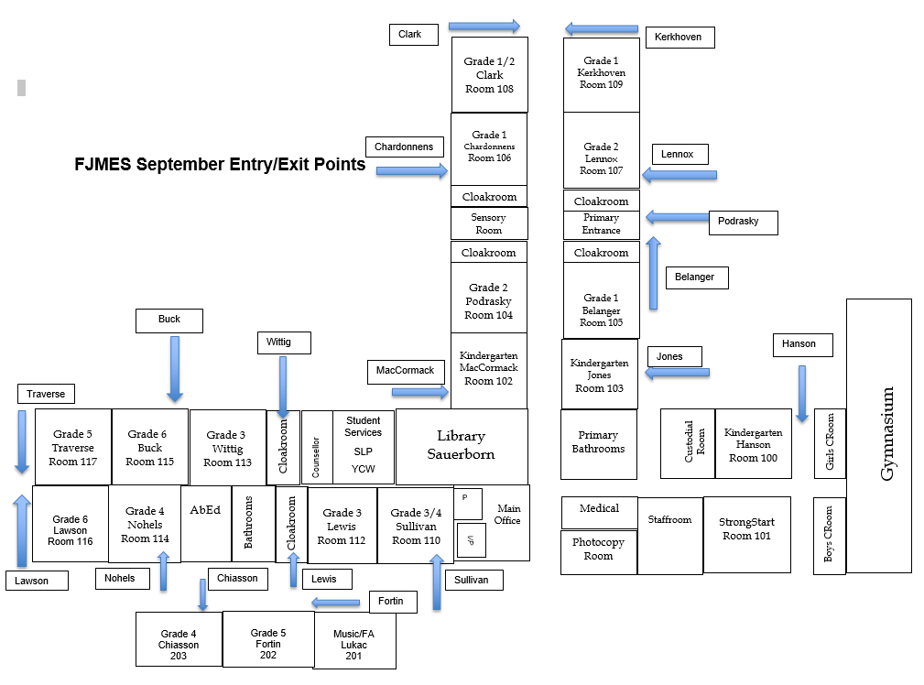

***Playground Zones***

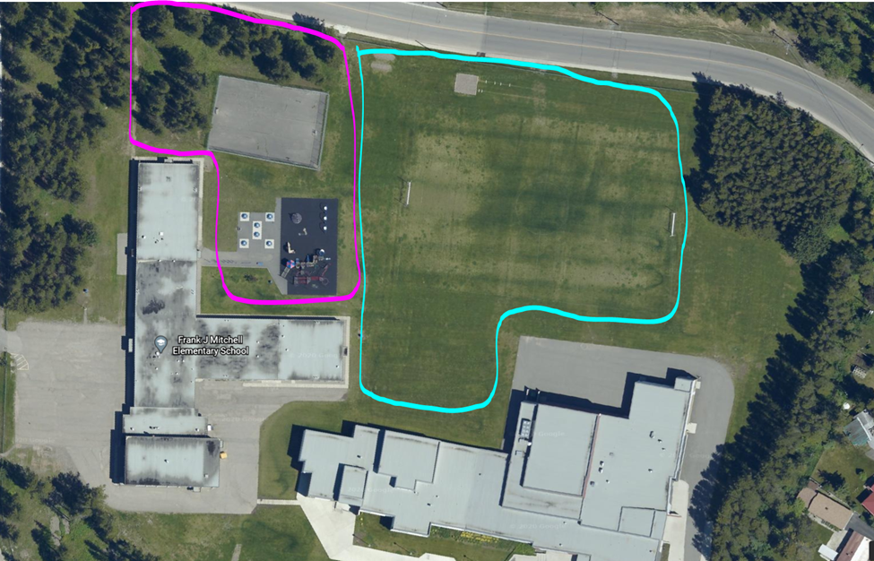

B

A



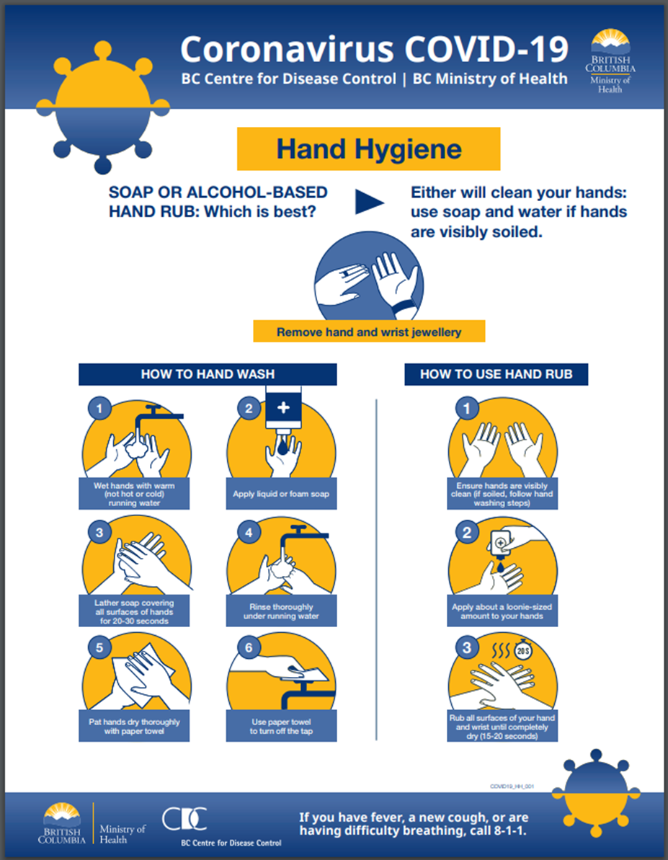



***Appendices:***

**A:** <https://www2.gov.bc.ca/assets/gov/education/administration/kindergarten-to-grade-12/safe-caring-orderly/k-12-education-restart-plan.pdf>

**B:** <http://www.bccdc.ca/Health-Info-Site/Documents/COVID_public_guidance/Guidance-k-12-schools.pdf?bcgovtm=20200506_GCPE_AM_COVID_9_NOTIFICATION_BCGOV_BCGOV_EN_BC__NOTIFICATION>

**C:** <http://www.bccdc.ca/Health-Info-Site/Documents/CleaningDisinfecting_PublicSettings.pdf>

**D:** Guidance for teaching Music in BC During Covid 19 <https://7fd068f4-68ea-47f4-b927-7d1f32730842.filesusr.com/ugd/e89cf1_29d484fe08cb4becb025ec5978c0928a.pdf>