HES School Plan – Return to School Protocols
Stage 2 Restart Plan
Section 1: Stage 2 Information

Following the Ministry of Education COVID-19 Health & Safety Guidelines for K-12 Settings and SD5 protocols, we look forward to welcoming our students to Highlands Elementary School as well as continuing to connect with you.

https://www2.gov.bc.ca/assets/gov/education/administration/kindergarten-to-grade-12/safe-caring-orderly/k-12-covid-19-health-safety-guidlines.pdf

What Does Stage 2 Look Like?

Central to British Columbia’s plan to reopen schools this fall is the formation of Learning Groups within schools. It is important that we all have a clear understanding of what these are and how they will work.
Stage 2 is a full return to in-class instruction for all students for the maximum time possible within learning group limits. The learning group size for elementary schools is up to 60 per cohort (for example: two grade 6 classes could form a cohort). Class sizes and learning conditions will remain the same as any other year.

Section 2: Learning Groups
What is a learning group? | - Students will be organized into learning groups for in-class instruction. This helps to limit contact and potential exposure. The learning group will consist of their regular classroom teacher(s), students and regular scheduled Education Assistants.  - Each elementary learning group will be comprised of a maximum of 60 people (will most likely be two classes paired together)  - Administration will keep a detailed list of learning groups for contact tracing purposes  - Learning Groups will be created and organized with staff input and communicated to families once they are finalized  - Example, Grade 2/3  - Your child is in grade 2 and is part of a grade 2/3 learning group made up of two classes.  - All curriculum instruction for your child is provided by your child’s classroom teacher with the potential that the teacher of the grade 3 class may switch with your child’s teacher to provide some instruction in areas where they have particular skills and interests.  - The two classrooms will be located close to each other and students will share recess and lunch times and may participate in outdoor learning activities together as part of the learning group.

How do they work? | - The composition of the learning group will remain consistent for all activities that occur in schools. Students may interact freely with those people in their learning group.  - Within the learning group minimal physical contact should be encouraged, but a physical distance of two meters does not need to be maintained.  - Within the learning group, there should be no sharing of personal items including school supplies. Papers and textbooks are allowed to be shared as there is no evidence that the COVID – 19 virus is transmitted via paper-based products.  - If students would like to interact with peers in other learning groups they may do so outside during breaks as long as they are maintaining physical distance (outdoors is a lower risk environment).  - Staff members who enter into various learning groups must wear PPE and physically distance in that setting.
Section 3: Shape of the Day / School Specific Information
Before School |  | - Students are asked to arrive no earlier than 8:35. Parents are encouraged to drop off their children and then exit the parking lot area to prevent overcrowding.  - Class in session as normal 8:40 – 2:50  - Student line up at their assigned door to enter the school (students will be informed prior to the start of school, via email, as to which class they will be in)  - Bus students will arrive according to their bus schedules  - Students will be required to wash/sanitize hands immediately when entering their classroom (as per protocols attached)
Washroom/body breaks |  | - Students must stay with their learning group except to use the bathrooms (one student at a time)  - no wandering the hallways
Recess |  | - Staggered recess – same schedule that we set in June  Group 1 – 10:25-10:40 6 classes  Group 2 – 10:45-11:00 5 classes
Lunch |  | - Staggered lunch – same schedule that we set in June.  Group 1 – outside 11:30 to 12:05, eat from 12:05 to 12:20  Group 2 – eat from 11:50-12:05, outside 12:05 to 12:40
Technology |  | - Wash your hands before using iPads/laptops  - iPads/laptops must be sanitized after each use
Library |  | - Wash your hands before going to the library, or the library teacher can teach students in their designated classroom and bring in a book cart (this will be decided during our staff meetings Sept. 8th and 9th)
PE |  | - Wash your hands before entering the gym  - Teachers should plan physical activities that limit the use of shared equipment and minimize physical contact  - Shared equipment between cohorts should be cleaned and disinfected after each use  - Teachers can use their own PE kits
Fine Arts |  | - All classes, programs and activities can occur where physical contact is minimized for those within the same learning group  - Students will go to the music room, or Fine Arts teacher can teach students in their designated classroom (this will be decided during our staff meetings Sept. 8th and 9th)
General |  | - Assemblies – virtual assemblies  - No interschool sporting events  - No school wide performances
After school |  | - Students will wash hands and leave through the appropriate classroom door. Ensure physical distancing when picking up. Please promptly pick up children at the end of the day. No hanging around the playground.
Teaching and Learning
Curriculum |  | - Focus on core competencies  - Ministry of Education BC curriculum still followed
Instruction |  | - Build relationships and community first  - Addressing students passion and interests  - Trauma informed practice will guide our instruction  - Instruction within learning group  - How will manipulatives be used? We will discuss this as a staff.
Communicating Student Learning |  | Parents can expect that reporting and communication will be following past practice which will include:  - Provincial curriculum for all students at all grade levels  - Regular reporting  - Regular assessments at the classroom and provincial level
Kindergarten |  | - Updated gradual entry schedules will be distributed reflecting the September 10th start date for student attendance.  - Kindergarten classrooms will maintain a focus on play-based learning, while limiting the use of shared materials and follow the cleaning and disinfecting protocols  - Teachers will be implementing pre-transition strategies to familiarize students with the people, spaces, and expectations as they start school
Itinerant and other Staff
 |  | - Staff outside of a learning group must practice physical distancing when interacting with the learning group. For example, a learning assistance teacher or a counsellor can work with students from multiple learning groups, but they should maintain physical distance from students and other staff as much as possible. If they are unable to maintain physical distance, PPE must be used.
Transportation
 |  | - In consultation with the transportation department, bussing will continue with enhanced safety protocols.
 |  | - Parents will be encouraged to drive their children if possible, but bus service will be available
Parent Specifics
Preparing your child to return to school |  | It may be helpful to have conversations with your child about the possibility of having to wear masks and the following:  - No physical contact  - Physical distancing  - Classrooms look different  - More structure  - Handwashing and hygiene  - No personal items brought and shared at school (please clearly label school supplies with the student’s first and last name)  - Remind children of the importance to remember to cough/sneeze into elbow, sleeve or tissue  - Remind children to avoid touching their faces
Health Checks |  | - The parent will be responsible for completing daily health checks prior to sending their child to the bus stop and school. If the child answers “yes” to any of the items on the checklist, he or she must stay home.
School access |  | - Limit visitors or no community use in Stage 2  - Exceptions: Visitor access during school hours will be prioritized to those supporting activities that benefit student learning and well-being (e.g. teacher candidates, public health nurse)  *Any access must be arranged through the office in advance.
Communication |  | - Please check school website for up to date COVID plans (these will be posted by August 26th)  - Highlands will host a Parent Information Evening (details will be posted on our website, PAC Facebook page, and via email)  - E-mail and telephone  - PAC Facebook page
If child gets sick at school |  | - Any child who appears or vocalizes feeling unwell will be sent home to ensure safety of all staff and students in the building  - Parents are required to pick up their child immediately  - Parents must have an emergency contact  If you have questions about whether or not you should be tested for COVID-19, use the self -assessment tool at https://bc.thrive.health/covid19. The province has created a phone service to provide non-medical information about COVID-19, including the latest information on travel restrictions. Information is available in more than 110 languages, 7:30 a.m. - 8 p.m. Pacific Standard Time at 1-888-COVID19 (1-888-268-4319) or via text message at 604-630-0300
Other information: |  | - Parents are encouraged to transport their own children to school, though bussing is available consistent with our transportation eligibility policy.  - For children being picked up at the end of the day, Parents/Guardians are required to be at the school at bell time  - Parent/Guardians are required to stay outside of the building for both drop off and pick up of students  - Appointments: If your child has an appointment during the day, please make arrangements with your child’s teacher to have them ready to be picked up at the assigned location and include the office in your communication.  - Phone Messages: Secretaries will inform teachers if there is a message to a student from a parent. Please try to limit any interruptions as much as possible.  - No food sharing is permitted  - No toys, stuffed animals, etc. are to be brought to school  - Parents/Guardians are required to provide a filled water bottle daily as fountains are closed – refill stations remain open  - Cutlery will not be provided - all students need to bring everything they need for their lunch.  - No access to microwaves  - Students should arrive at school dressed appropriately for the weather and for outdoor learning.  - Any sunscreens or lotions must be applied at home.  - Lunch choices that students can open on their own are encouraged  - Easy to open bags, etc.  - Students will bring recyclables and refundable back home with them in their lunch kits for proper cleaning and sorting.
Staff Specific Information
Entering the building |  | - Please wash your hands and/or hand sanitize when you enter the building.
Breaks |  | - In common areas (staffroom): When staff are interacting with people outside of their learning group, if physical distance cannot be consistently maintained, staff are required to wear a non-medical mask.
PPE and Physical distancing |  | As of March 31st, all staff, adult volunteers and visitors, and all Grade 4 to 12 students should wear a non-medical mask or face covering (a “mask”) at all times while indoors at school, subject to the exceptions noted below.  Exceptions:  The recommendations above should not apply as follows:  • To a person who is unable to wear a mask because they do not tolerate it (for health or behavioural reasons);  • To a person unable to put on or remove a mask without the assistance of another person;  • If the mask is removed temporarily for the purposes of identifying the person wearing it;  • If the mask is removed temporarily to engage in an educational activity that cannot be performed while wearing a mask (e.g. actively playing a wind instrument, high-intensity physical activity, etc.);  • If a person is eating or drinking;  • If a person is behind a barrier;  • While providing a service to a person with a disability or diverse ability (including but not limited to a hearing impairment), where visual cues, facial expressions and/or lip reading/movements are important.  Staff, adult volunteers, and all Grade 4 to 12 students should wear a mask at all times while on a bus, subject to the exceptions noted below.  Exceptions:  The recommendation above should not apply as follows:  • To a bus driver while driving;  • To a person who is unable to wear a mask because they do not tolerate it (for health or behavioural reasons);  • To a person unable to put on or remove a mask without the assistance of another person;  • If the mask is removed temporarily for the purposes of identifying the person wearing it; or  • While eating or drinking.  Kindergarten to Grade 3 students are encouraged to wear a mask at school and on buses, but should not be required to do so.
Common areas |  | - Photocopying room, staffroom, library, office, etc. maintain physical distancing (2m) for staff when interacting outside of their learning groups. When staff are interacting with people outside of their learning group, and physical distance cannot be consistently maintained, staff are required to wear a non-medical mask.
If you are sick at home |  | - District TTOC Plan will be implemented
If staff become sick at school |  | - Put your absence in SRB and notify admin to cover
Section 4: Health and Safety Protocols
Covid-19 Protocols for School Operation |  | - District Document Link will be placed here.
Cleaning |  | - An additional daytime custodian has been hired in addition to our two evening custodians  - A general cleaning/disinfecting of the premises will occur once every 24 hours  - High touch surfaces will be cleaned twice in a 24 hour period  - Teachers will have disinfectant and wipes in their classroom spaces to also wipe down surfaces when needed  - Checklist will be created by the manager of the facility for custodial staff to keep track of cleaning
Hand hygiene |  | - Teachers/Parents will teach and review proper hand washing technique  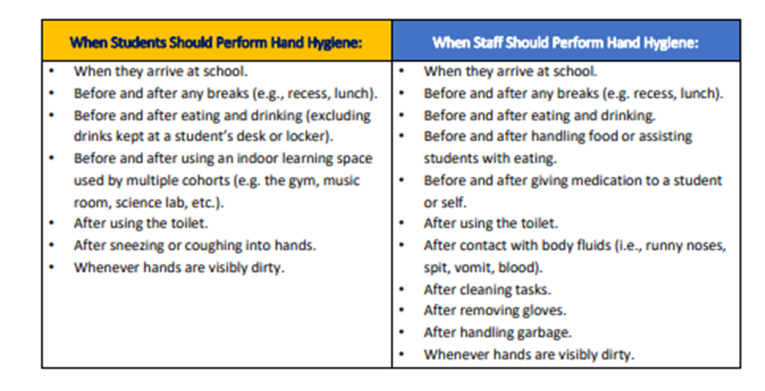
Personal Protective Equipment (PPE) |  | - Supply of PPE will be stored in the medical room  - Students will store their masks in a plastic, sealed bag on their desk/table area when not needed (teacher input)  - Masks will be made available to all staff and students  - Non-medical masks are required to be used in situations where a person cannot maintain physical distance and is in close proximity to a person outside of their learning group or household
Entering/exiting the building |  | - Students will enter and exit through designated doors at all times when coming into the school (indicated in attached map – see Appendix A)  - Staff will enter through the staff entrance and hand sanitize  - Parents/visitors will not be allowed in the building without previous consent from the office and must complete a health screening check upon entering.
Physical Distancing |  | - Students and staff will be placed in learning groups of no more than 60 people total  - Plastic barriers will be placed in areas where there may be higher traffic (between clerical staff, at office counter, at library counter, portable barriers available)  - All assemblies or big school events will be held virtually with students remaining in their classrooms
Traffic Flow |  | - Directional arrows have been placed in the hallways to indicate flow of traffic  - Students will line up in their designated entrance and exit doors  - Staggered recess and lunch
First Aid |  | - Extra PPE (masks, face shields, gloves) will be on hand for our first aid attendants to use when treating injuries  - If an injury is minor, it is recommended that the first aid attendant talks the student through the injury (ie. cleaning or bandaging a minor wound, applying an ice pack)  - Classrooms will have supplies of band-aids and cleaning wipes on hand to minimize students needing to go to the office for first aid
Health & Safety Checks (checklist can be found in Appendix B on page 16 of document) |  | Staff: Staff are required to complete a daily health screening before coming to work. If they have any of the listed symptoms they are to stay home, and log their absence in SRB  Students: Parents/guardians are responsible for completing daily health care screening for their child before sending their child to school or the bus stop.  An example of the daily health check is below:  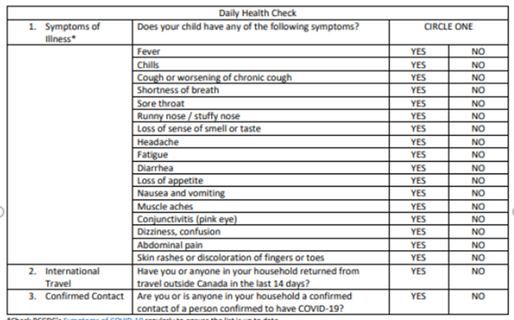  If children answer “yes” to any of the questions on the health checklist, they are required to stay home, as they will not be admitted on to the school bus or into the school, no exceptions.  *Parents will be provided with two copies of this Health Check. One will be completed and provided to the school on first day of attendance.  - Once at school, any child who appears or vocalizes feeling unwell will be sent home to ensure safety of all staff and students in the building  - Parents are required to pick up their child immediately  - Parents must have an emergency contact on hand in the event that a parent cannot get to the school right away.  - If you have questions about whether or not you should be tested for COVID-19, use the self -assessment tool at https://bc.thrive.health/covid19. The province has created a phone service to provide non-medical information about COVID-19, including the latest information on travel restrictions. Information is available in more than 110 languages, 7:30 a.m. - 8 p.m. Pacific Standard Time at 1-888-COVID19 (1-888-268-4319) or via text message at 604-630-0300.  Visitors/Parents: Please note: No parent visitors are permitted without prior office approval. Please contact the school office for appointments.  Any necessary visitors will be asked the BC CDC guidelines listed above and that documentation will be kept on file by administration
Health and Safety Training |  | - Staff will receive orientation in the school on September 8th and 9th and do a walk through of the space to understand safety protocols  - Students will receive orientation on September 10th (shape of the day TBD)
Health and Safety Continuance |  | - The school Joint Occupational Health and Safety committee (JOHS) comprised of Bill Johnson (P), Christie Johnson (VP), and a representative from both CUPE and the CDTA will meet monthly or on an as needed basis to review and ensure school-wide maintenance of health and safety protocols
Isolation Room if staff or student becomes ill |  | - Sick room

Section 5: Students with Diverse Abilities/Disabilities
- Planned with district staff
In alignment with the Equity and Inclusion Guiding Principles, our SBT (School Based Team) is planning for students with diverse abilities/disabilities ensuring students and communicating to parents on the following, to ensure students will:
- be able to attend school full time or have a plan to ensure supports and learning continue if a student needs to learn at home
- have access to the necessary health and safety supports
- continue to receive supports and services as identified in their IEP, including 1:1 supports
- not be grouped in segregated settings as a part of the establishment of learning groups
- our staff and SBT will continue to identify students needing additional supports and will utilize our resources to meet student needs.
- Parents with students that are immune compromised are encouraged to talk with their family physician and let the school know about concerns to develop a plan together.

Appendix A (Map of Highlands)
The following map shows the traffic flow throughout the building and the outside doors that students can use to access the various classrooms.

