Kootenay Orchards Elementary School
‘Welcoming Spaces, Welcome Minds to Welcome Hearts’

Following the Ministry of Education COVID-19 Health & Safety Guidelines for K-12 Settings and SD5 protocols, Kootenay Orchards Elementary School Safety Protocol for the fall 2020 school entry is found below:

https://www2.gov.bc.ca/assets/gov/education/administration/kindergarten-to-grade-12/safe-caring-orderly/k-12-covid-19-health-safety-guidlines.pdf

Learning Groups
What is a learning group?  (More information can be found in the link in Appendix B on pages 6-7) | - Students will be organized into learning groups for in-class instruction. This helps to limit contact and potential exposure. The learning group will consist of their regular classroom teacher(s), students and regularly scheduled Education Assistants.  - Each elementary learning group will be comprised of a maximum of 60 people (in most instances two classes paired together)  - Administration will keep a detailed learning group list for contact tracing purposes  - Kootenay Orchards Learning Groups are as follows:  - Cross & Linardic  - S. Potter & Adams  - Boss & Flegel  - Thomson & Schadeli  - C. Potter & Halldorson  - All curriculum instruction for your child is provided by your child’s classroom teacher with the potential that the learning group teacher of the other group may switch with your child’s teacher to provide some instruction in areas where they have particular skills and interests.  - The two classrooms will be located close to each other and students will share recess and lunch times and may participate in outdoor learning activities together as part of the learning group.
How do they work? | - The composition of the learning group will remain consistent for all activities that occur in schools. Students may interact freely with those people in their learning group  - Within the learning group minimal physical contact should be encouraged (“hands to yourself”), but a physical distance of two meters does not need to be maintained  - If students would like to interact with peers in other learning groups they may do so outside during breaks as long as they are maintaining physical distance (outdoors is a lower risk environment)  - Staff members who enter into various cohorts must wear PPE and physically distance in that setting

Shape of the Day
Before School | - Students are asked to arrive no earlier than 8:40  - Class in session as normal 8:45 – 12:10, 1:00 – 2:55  - Student line up at their assigned door to enter the school. This will be communicated when class lists are posted.  - Bus students will arrive according to their bus schedules  - Students will be required to wash/sanitize hands immediately when entering their classroom (as per protocols attached)
Washroom/body breaks | - Students must stay with their learning group except to use the bathrooms (one student at a time)  - No wandering the hallways
Lunch | - Staggered  Lunch Schedule  Kindergarten, Grade1, Grade 2, Grade 3: Play Outside (12:10-12:35); Eat Lunch Inside (12:35-1:00)  Grade 4, 5, 6: Eat lunch Inside (12:10-12:35); Play Outside (12:35 – 1:00)  Students will be requested to bring a full water bottle; all recyclables and refundables will go home to be sorted
Recess | - Staggered  - Recess Schedule  - In consultation with staff and communicated during student orientation  - K, 1, 2 & 3: To be determined  - Grades 4, 5 & 6: To be determined  Playground will be divided into two spaces and alternate sharing days will be implemented so all students have access to the equipment
Technology | - Wash/Sanitize hands before using iPads/laptops  - iPads/laptops must be sanitized after each use & hands washed
Library | - The library will initially be closed to students; students will have the library teacher come to their classes & bring in a book cart. The Library teacher will wear PPE or physical distance where possible.
PE | - Wash your hands before entering the gym and upon return to the classroom once class/ activity is over  - Physical activities will be planned that limit the use of shared equipment and minimize physical contact  - Shared equipment between cohorts should be cleaned and disinfected after each use  - Teachers can create their own PE kits
Fine Arts | - All classes, programs and activities can occur where physical contact is minimized for those within the same learning group  - When students are attending music in the Fine Arts room, they may wear a mask in the hallway or the Fine Arts teacher can teach students in their designated classroom wearing PPE or physically distancing as possible  - Band and other music delivery programming are being co- operatively developed by the district music specialists.
General | - Assemblies – virtual assemblies  - No interschool sporting events  - No school wide performances
After School | - End of Day: Students will wash hands and leave through the appropriate classroom door; physical distancing emphasized  - For children being picked up at the end of the day, Parents/Guardians are required to be at the school at bell time and have their child meet them at their pre-arranged location

Teaching and Learning
Curriculum | - Focus and emphasis on core competencies  - Ministry of Education BC curriculum still followed
Instruction | - Emphasis will be placed on building relationships and community first  - Addressing student’s passion and interests  - Trauma informed practice will guide our instruction  - Instruction within learning group  - For consideration: use of manipulatives and cleaning will require Teacher input
Communicating Student Learning | - Parents can expect that reporting and communication will be following past practice which will include:  - Provincial curriculum for all students at all grade levels  - Regular reporting  - Regular assessments at the classroom and provincial level
Kindergarten | - Gradual entry will start on September 10 with small groups (the revised schedule will be sent out via email and posted on the school website)  - Kindergarten classrooms will maintain a focus on play-based learning, while limiting the use of shared materials and follow the cleaning and disinfecting protocols  - Teachers will be implementing pre-transition strategies to familiarize students with the people, spaces, and expectations as they start school  - Toys and items for “show and tell” will be guided by the Kindergarten teacher keeping in mind the safety of the item (photos may be a great way to share without needing to bring actual items into the school)

Itinerant and other Staff
- Continued support from out itinerant staff will still be available
- Staff outside of a learning group must practice physical distancing when interacting with the learning group. For example, a learning assistance teacher or a counsellor can work with students from multiple learning groups, but they should maintain physical distance from students and other staff as much as possible and or wear PPE if the 2-metre distance is not possible. Itinerant staff may be requested to document school visits in compliance with contact tracing.
- Itinerant staff includes: Aboriginal Education Workers, Youth Care Workers, Speech Language Pathologists and Speech Language Assistants, Counsellors and Student Service teachers.

Transportation
- In consultation with the transportation department, bussing will continue with enhanced safety protocols.
- Parents will be encouraged to drive their children if possible but bus service will be available

Parent Specifics
Preparing your child to return to school | - Wearing masks, no physical contact, physical distancing, classrooms look different, more structure, handwashing and hygiene, no personal items brought and shared at school, ensure they can open items, put on shoes, coats etc.
Health Checks | - Parents / guardians will be responsible for completing daily health checks prior to sending their child to school. If there are any changes to the initial symptoms that include a “yes” response the child is to stay home and the school contacted.
School access | - Limit visitors & no community use in Stage 2  - Exceptions: Visitor access during school hours will be prioritized to those supporting activities that benefit student learning and well-being (e.g. teacher candidates, public health nurse)  *Any access must be arranged through the office in advance and all outside visitors must wear PPE and track for the purpose of contact tracing.
Communication | - Please refer to the school and school district website for up to date COVID plans  - We strongly encourage you to check your email for possible updates/changes
If child gets sick at school | - Any child who appears or vocalizes feeling unwell will be sent home to ensure safety of all staff and students in the building  - Parents are required to pick up their child immediately  - Parents must have an emergency contact  If you have questions about whether or not you should be tested for COVID-19, use the self -assessment tool at https://bc.thrive.health/covid19. The province has created a phone service to provide non-medical information about COVID-19, including the latest information on travel restrictions. Information is available in more than 110 languages, 7:30 a.m. - 8 p.m. Pacific Standard Time at 1-888-COVID19 (1-888-268-4319) or via text message at 604-630-0300
Other information: | - Parents are encouraged to transport their own children to school, though bussing is available consistent with our transportation eligibility policy.  - Encourage your child to minimize physical contact with their friends  - Parents/Guardians, please remind children to cough/sneeze into elbow, sleeve or tissue  - Remind children about keeping their “hands to yourself”  - For children being picked up at the end of the day, Parents/Guardians are required to be at the school at bell time  - Parent/Guardians are required to stay outside of the building for both drop off and pick up of students  - Appointments: If your child has an appointment during the day, please make arrangements with your child’s teacher to have them ready to be picked up at the assigned location (outside of their classroom) and include the office in your communication.  - Phone Messages: Secretaries will call into a classroom if there is a message to a student from a parent. Try to limit any interruptions as much as possible.  - No food sharing is permitted  - No toys, stuffed animals, etc. are to be brought to school  - Parents/Guardians are required to provide a filled water bottle daily as fountains are closed – refill stations remain open  - Cutlery will not be provided; all students need to bring everything they need for their lunch.  - Students are required to dress appropriately for weather at home  - Any sunscreens or lotions must be applied at home  - Lunch choices that students can open on their own are encouraged  - Easy to open bags, etc.  - Students will bring recyclables and refundable back home with them in their lunch kits for proper cleaning and sorting.

Staff Specifics
Entering the building | - Please wash your hands and/or hand sanitize when you enter the building
Breaks | - In common areas (staffroom): When staff are interacting with people outside of their learning group; physical distance cannot be consistently maintained; staff are required to wear a non-medical mask.
PPE and Physical distancing | - Non-medical masks are required to be used in situations where a person cannot maintain physical distance and is in close proximity to a person outside of their learning group or household
Common areas | - Photocopying room, book room, staffroom, library, office, etc… maintain physical distancing (2m) for staff when interacting outside of their learning groups. When staff are interacting with people outside of their learning group; physical distance cannot be consistently maintained; staff are required to wear a non-medical mask
If you are sick at home | - Absence to be placed in the SRB in order to communicate with SD5 call – out dispatch
If staff become sick at school | - Absence to be placed in SRB and notify administration to cover until Teaching Teacher On Call arrives

Health and Safety Protocols
Covid Protocols for SD5 School Operations | - SD5 School Protocols - COVID (August 18).docx
Cleaning | - An additional part-time daytime custodian has been hired in addition to our two evening custodians  - A general cleaning/disinfecting of the premises will occur once every 24 hours  - High touch surfaces will be cleaned twice in a 24 hour period  - Teachers will have disinfectant and wipes in their classroom spaces to also wipe down surfaces when needed  - Checklist to be created by Manager of Facilities for custodial staff to keep track of cleaning
Hand hygiene | - Teachers/Parents will teach and review proper hand washing technique  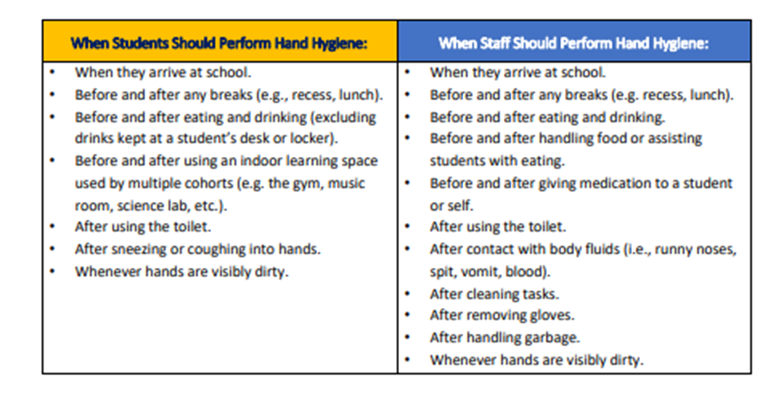
Personal Protective Equipment (PPE) | - Supply of PPE will be stored in the medical room  - Students will store their masks in a labeled bag or envelope on their desk/table area when not needed (teacher input)  - Masks will be made available to all staff and students  - Non-medical masks are required to be used in situations where a person cannot maintain physical distance and is in close proximity to a person outside of their learning group or household
Entering/exiting the building | - Students will enter and exit through their outside classroom door (boot room) at all times when coming into the school  - Staff will enter through the main entrance and hand sanitize upon arrival  - Parents/visitors will not be allowed in the building without previous consent from the office and must complete a health screening check upon entering (see below)
Physical Distancing | - Students and staff will be placed in learning groups of no more than 60 people total (cohorts will be determined after consultation with staff)  - Plastic barriers will be placed in areas where there may be higher traffic (between clerical staff, at office counter, at library counter, portable barriers available  - All assemblies or school events that are above the allowed cohort number will be held virtually with students remaining in their classrooms
Traffic Flow | - Directional arrows and appropriate signage will be placed in the hallways to indicate flow of traffic  - Students will line up in their designated entrance and exit doors  - Staggered recess and lunch will be established so as to minimize outside learning groups to interact  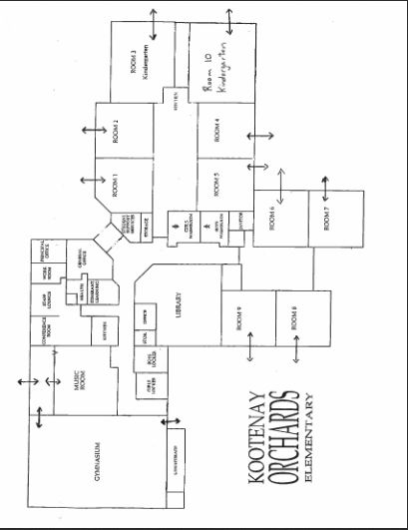
First Aid | - Extra PPE (masks, face shields, gloves) will be on hand for our first aid attendants to use when treating injuries  - If an injury is minor, it is recommended that the first aid attendant talks the student through the injury (ie cleaning or bandaging a minor wound, applying an ice pack)  - Classrooms will have supplies of band-aids and cleaning wipes on hand to minimize students needing to go to the office for first aid
Health & Safety Checks (checklist can be found in Appendix B on page 16 of document) | Staff: Staff are required to complete a daily health screening before coming to work. If they have any of the listed symptoms they are to stay home, and log their absence in SRB  Students: Parents / guardians are required to keep symptomatic children home.  Children showing symptoms of COVID-19 or with a temperature greater than 38 degrees Celsius must not come to school.  Parents/guardians are responsible for completing daily health care screening for their child before they arrive at school or enter a bus.  Students: The parent will be responsible for completing daily health checks prior to sending their child to school.  Refer to Appendix B. School Administrators will provide the questions to the parents in advance of the students’ attendance at school. Children who answer ‘Yes’ to any of the questions on the health checklist will not be admitted into the school or school bus, there will be no exceptions.  *Parents will be provided with two copies of this Health Check. One will be completed and provided to the school on first day of attendance.  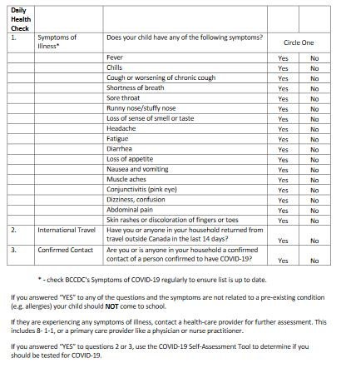  - Once at school, any child who appears or vocalizes feeling unwell will be sent home to ensure safety of all staff and students in the building Parents are required to pick up their child immediately  - Parents must have an emergency contact on hand if a parent cannot get to the school right away.  - If you have questions about whether you should be tested for COVID-19, use the self -assessment tool at https://bc.thrive.health/covid19. The province has created a phone service to provide non-medical information about COVID-19, including the latest information on travel restrictions. Information is available in more than 110 languages, 7:30 a.m. - 8 p.m. Pacific Standard Time at 1-888-COVID19 (1-888-268-4319) or via text message at 604-630-0300.  Visitors/Parents: Please note: No parent visitors are permitted without prior office approval. Please contact the school office for appointments.  Any necessary visitors will be asked the BC CDC guidelines listed above and that documentation will be kept on file by administration
Health and Safety Orientation | - Staff orientation will occur in the school on September 8th and 9th and perform a walk-through of spaces to understand safety protocols  - Student orientation will occur on September 10 &11
Health and Safety Continuance | - The school Joint Occupational Health and Safety Committee (JOH&SC) comprised of Judi Poole (P), Deb Ingham (CUPE), Carrie Lukan (CUPE) & Kim Lutz (CDTA), will meet monthly or more frequently if necessary to review and ensure school-wide maintenance of health and safety protocols
Isolation Room if staff or student becomes ill | - Medical Room in the main office space

Students with Diverse Abilities/Disabilities
- Planned with district staff
In alignment with the Equity and Inclusion Guiding Principles, our school will plan for students with diverse abilities/disabilities and communicating to parents on the following: Students will:
- be able to attend school full time or have a plan to ensure supports and learning continue if a student needs to learn at home
- have access to the necessary health and safety supports
- continue to receive supports and services as identified in their IEP, including 1:1 supports
- not be grouped in segregated settings as a part of the establishment of cohorts

*September 8 and 9 will allow for small group meetings with our Student Services Teacher to determine student case load for those students attending school

*For Students who are immunocompromised protocols will be established to ensure appropriate programming. Out – reach programming may replace in school learning.

Appendices:
A: https://www2.gov.bc.ca/assets/gov/education/administration/kindergarten-to-grade-12/safe-caring-orderly/k-12-education-restart-plan.pdf

B: http://www.bccdc.ca/Health-Info-Site/Documents/COVID_public_guidance/Guidance-k-12-schools.pdf?bcgovtm=20200506_GCPE_AM_COVID_9_NOTIFICATION_BCGOV_BC

