Following the Ministry of Education COVID-19 Health & Safety Guidelines for K-12 settings and SD5 protocols, we look forward to welcoming our students to Sparwood Secondary School for the 2020/21 school year.

Semester System
What is a Semester System? | - In order to reduce the number of contacts students and staff have we have moved to a semester system for the 20/21 school year.  - There are 2 terms within a year. Each term is 20 weeks long.  - Students attend 4 classes a day per term, two classes in the morning and two in the afternoon. After a 20 week term students switch to another 4 classes for the next 20 week term.  - As much as possible, the same group of students attend classes together. They, along with their teachers and other support staff, become a learning group.

Learning Group
What is a Learning Group? (Appendix B on pages 6-7). | - Students have been organized into learning groups for in-class instruction. This helps to limit contact and potential exposure.  - For grade 7-9 the maximum learning group size is 60 people.  - For grade 10-12 the maximum learning group size is 120 people.  - There are 6 learning groups at SSS and are as follows:  - 2 Grade 7  - 2 Grade 8/9  - 1 Grade 10  - 1 Grade 11/12/STRIVE  - Administration will keep a detailed cohort list for contact tracing purposes.  - Within a learning group masks are not always required (though students and staff are welcome to wear masks if they choose).  - In certain classes (e.g., French) masks may be required within learning groups.  - Any staff working with a student who is not a member of that  - student’s cohort will have to wear a mask and physically distance. For example administrators, counsellors, student services teachers, or teachers teaching on call will all have to wear masks.  - In instances where a class is not part of a cohort masks must be worn by all and physical distancing adhered to.  - Learning groups will remain consistent for all school based activities.  - Students and staff from the same learning should still practice physical distancing whenever possible.  - School administrators will need to stay up to date on the composition of each learning group and are responsible for providing contact information to public health as needed for contact tracing purposes.  - Students from different learning groups can be in the same space at the same time if physical distancing can be maintained and there is adequate space to prevent crowding of those in the same learning group.

Health & Safety
Cleaning  (Appendix E page 13-15) | - Sparwood Secondary has an onsite daytime custodian.  - Cleaning will be done once every 24 hours and frequently  - touched surfaces (door knobs, toilet handles, tables, desks, chairs, etc.) twice every 24 hours.  - Students will be trained to wipe tools in shops and classrooms before and after use as part of cleaning protocols for a class.
Hand Hygiene (Appendix E page 19) | - Each classroom will have a handwashing station where students and staff will wash hands upon entering and exiting the classroom and as needed throughout the class.
Respiratory Etiquette (Appendix E page 20) | - Students will be encourages to cover their mouth and cough into their elbow and to not touch their faces.  - Students will have access to tissues. When used they must be thrown away immediately and hands washed/sanitized.
Masks (Appendix E page 20-21) | - Staff and students must wear a mask at all times except when sitting or standing at their desk/workstation in a classroom/learning space, there is a barrier in place, eating or drinking, or outdoors.  - Masks are not a replacement for physical distancing.  - Must be worn by staff and students on the bus at all times and should be on before loading.
Physical Distancing (Appendix E page 8) | - Students and staff must maintain physical distancing when in groups outside of their learning groups.  - School wide assemblies can only occur virtually.  - In high traffic areas (e.g., library and main office) and in some office spaces (e.g., counsellors office) clear plastic barriers will be installed and PPE will be required.  - Unless staff are from the same learning group, they should maintain physical distance (2m) from one another.
Traffic Flow | - Students and staff will move through the halls keeping to the right.  - To minimize congestion and maintain flow there will be staggered transition times between classes.  - Interior doors will be open by 8:15 am to allow smooth flow of traffic from halls into classrooms.  - There should be no lingering at lockers, waiting for others or physical contact in the hallways.  - There is no eating or drinking in the hallways.  - Masks must always be worn in common areas such as bathrooms, hallways, etc.
Health Checks (Appendix B page 16-17 for the checklist and Appendix E page 17-18)  Appendix F | - Staff are required to complete a daily health screening before coming to work in Microsoft Forms. If they have any of the listed symptoms they are to stay home, and log their absence in SRB.  - Students: Parents are responsible for completing daily health checks prior to sending their child to school. If “yes” is checked off for any of the symptoms on the checklist, the student is to stay home and the school contacted about the absence. Please keep students at home if they are sick or asked to isolate by the local health authority.  - Before the first day of school a waiver will be sent home for families to sign acknowledging parental responsibility to conduct health checks each day. This must be signed and returned to the school prior to students being admitted into the building.  - There is now a K-12 daily health check app for families to use to assess student health (Appendix F)
Visitors (e.g. Community groups, support workers, parents, etc) Appendix E page 15-16 | - No parents and visitors are allowed in the building unless there is an emergency.  - Visitor access during school hours will be prioritized to those supporting activities that benefit student learning and well-being (e.g. itinerant workers, support staff/teacher candidates, public health nurse, RCMP).  - No community use of school facilities in Stage 2

Grade 8/9 Blue/Purple Entrance
Shape of the Day
Morning | - Upon arrival to school students will move to their first class and join their cohort within the learning group. Students will have lockers which they can access prior to and after each class.  - Doors will be open to classrooms by 8:15 am.  - There is no loitering or wandering in the halls, so students are requested to arrive no earlier than 8:15 am.  - Morning classes run from 8:33 am to 9:56 am and then 10:10 am to 11:32 am.  - A maximum of one student per class will be allowed to leave the classroom at a time during class time.  - Avoid crowding at entrance and exits.  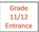  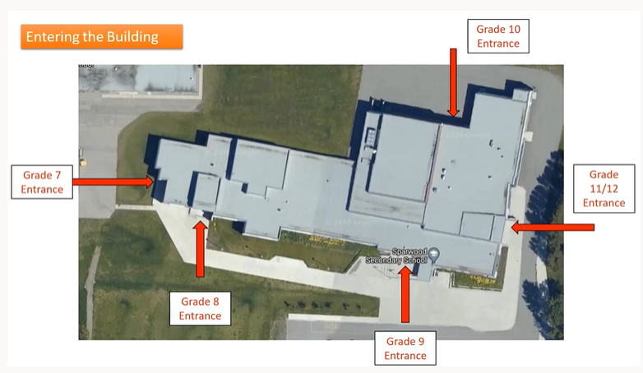  Grade 8/9 Green/Yellow Entrance
Lunch | - Lunch runs from 11:32 to 12:22.  - Some off timetable classes and clubs may meet at lunch (masks for those classes are required).  - Students wishing to stay at school for lunch may eat with others from their learning group.  - Grade 7 (Grey) – Room 109  - Grade 7 (Navy/Golden) – Outside Room 108  - Grade 8/9 (Blue/Purple) – MPR (Right side)  - Grade 8/9 (Green/Yellow) – MPR (Left Side)  - Grade 10 - Library Commons Side  - Grade 11/12/STRIVE – Library Computer Side  - Students leaving the school for lunch should return for their afternoon class (i.e., no wandering the halls).  - We encourage kids to stay at school for lunch whenever possible.  - Microwaves will not be available for use so please plan lunches accordingly.  - Students will also have the option to eat outside by learning group when weather permits.  - No sharing of food and drink.  - Wear a mask to and from tables and while in hallways moving to and from lunch area.
Afternoon | - After lunch students will proceed directly to their afternoon class.  - If a student leaves the school the student will enter through the designated entrance  - Classes run from 12:22 pm – 1:45 pm and 1:48 pm – 3:11 pm  - Same rules as the morning apply.  - Students will leave through the designated exit (same at the designated entrance)  - If waiting for busses students will wait as learning groups  - Learning group waiting areas will be marked on the concrete in front of the building
Breaks | - Breaks during the morning and afternoon classes are not formally scheduled. The teacher of each class will allow appropriate breaks as suits each class and situation.  - Breaks are taken with a cohort and within the class, unless the teacher moves the class as an entire cohort to another location (e.g., outside).  - Bathroom breaks, as needed, will be limited to one student at a time monitored by the teacher. Masks must be worn in halls and in the bathroom.  - Hands will need to be sanitized/washed upon entry and exit of the classroom  - Student breaks are held in their classrooms.
Off Timetable Classes | - Classes that run off timetable, either before school, at lunch, or after school may not be part of a learning group.  - Therefore, when they meet masks must be worn and social distancing adhered to.  - Off timetable classes will be indicated on students personalized schedules which are distributed on the first day of school.
Homerooms | - On Friday Mornings grade 7 students will have homeroom classes with a staff member from their learning group. Grade 8-12 students will have homeroom classes once a month in semester 2.  - This time is spent on items like mental health literacy, building meaningful connections, community connections, pursuing passions, building resiliency, creative conflict resolution, leadership, and more. The homeroom time is heavily directed by student’s wants and needs.  - We encourage all students to participate in homeroom classes as students will learn meaningful life skills that tie the curriculum to life outside of school.
First Day of School | - The first day of school will be September 10, 2020 which will be a full day for all students.  - Bussing will be available at the regular times.  - Students will receive an orientation on the first day of school that review all of the COVID protocols and everything they will need to know for the coming school year.
Late Students | - Students that are late for class need to use the main door once the bell has rung. After sanitizing hands please sign into the school with Pam and Jenn and head directly to class.  - Students will be called through the automated Safe Arrivals system. Parents can use the app to log absences and lates.
Breakfast and Lunch Program (Appendix D – Food Service) | - Breakfasts and lunches will still be provided by the Ab Ed Worker and Youth Care Worker upon student request.  - Breakfast and Lunches will be brown bagged with packaged items that do not require microwaving.  - Students will pick up the breakfast and head to first class or lunch and head to their designated lunch area.
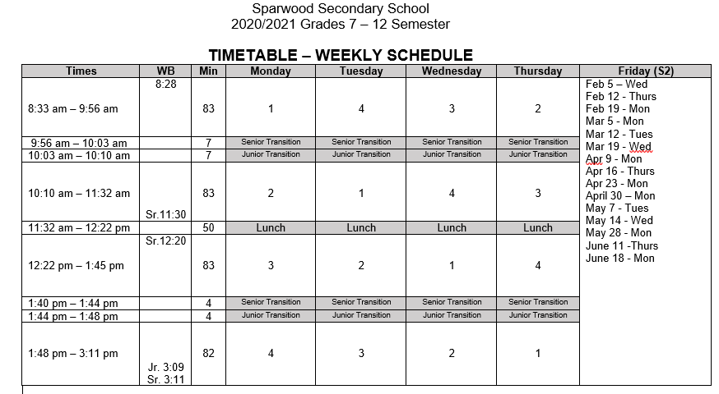

Teaching and Learning
Instruction (Classroom specific guidelines can be found in the Appendix E pages 23-32) | - In stage 2, instruction is face to face and in school. Our hope is that with a semestered system students and teachers will be able to quickly develop a relationship conducive to efficient and effective learning. By having 4 of 8 courses at a time if we do have to switch to a blended model or a fully online program the transition should be easier.  - This framework has provided us with the opportunity to try some new and inventive ways of teaching this year which is exciting. Some examples are as follows:  - Junior shop classes with a design element  - grade 7 rotation with cross curricular project based and place based learning centered around community and team building  - non enrolling student services blocks to enrich student learning  - all electives still offered within the school  - Outdoor Ed classes outside of the timetable  - At this time instruction will be 100% face-to-face.  - Students seating arrangements should avoid them facing each other.  - Consistent seat assignments should be used where practical.  - Breaks in the classroom should be done outside when possible.
Curriculum | - The curriculum is the standard Graduation Program curriculum from the BC Ministry of Education
Communicating Student Learning | - Reports on student progress will be according to the Ministry regulations. You should receive a midterm and final term report for each class.
Supplies | - There will be no sharing of supplies. Students will need to come to class prepared with their own materials.  - It is recommended to have materials stored in plastic pencil cases and backpacks that are wipeable.  - Paper-based products have a low risk of contamination and thus do not need to be cleaned, disinfected or quarantines for any period of time or for hand hygiene to be practiced.

Other Information
Sick At School | - If a student becomes sick or develops symptoms at school they will be isolated in a sick room. Student must wear a mask even when separated from others.  - Parents will be informed to arrange immediate transportation home. Please ensure the office has up to date emergency contact information.  - Students do not need a sick note or a doctor’s note to return to school. Families can call 8-1-1 if unsure about symptoms or use the online daily health check tool: https://www.k12dailycheck.gov.bc.ca/healthcheck?execution=e1s1
Inter-School Sports/Events (Appendix E page 32) | - At present there will be no team sports against other schools nor events like music and drama festivals with other schools.  - We are looking into ways of offering sports within the guidelines and frameworks provided to the school through BC School sports.  - Individual sports will be promoted at the school and arranged through our athletic director.
Transportation (Appendix E page 12 & Appendix D – Buses and School Transportation) | - Masks must be worn before loading staff and students.  - Drivers must wear masks on school bus unless medical/disability reasons.  - If a child is sick please do not take the bus.  - Windows will be opened when weather permits.  - School buses will be running under “stage 2” protocols.  - More information will be provided by the transportation team.  - Parents and students are strongly encouraged to arrange a means of getting to school that does not rely upon School District 5 busses.
Communication | - Updates and further information will be posted on our website, on our Facebook page and emailed home.  - We will have Orientation nights for parents (Aug 31), staff (Sept 8-9) and Students (Sept 10-11)
Student Timetables and Changes | - Student timetables are still being adjusted to create learning groups. They will be available on the first day students come to school.  - Opportunities to adjust timetables for semester one will be completed in the first week of school. There is limited flexibility in the schedule since we are offering the same classes as we normally would but have cohort and learning group sizing to contend with.
Teachers Teaching On Call and Casual workers | - Any TTOC’s and casual workers in the building will be given an orientation to SSS and will wear the appropriate PPE for the duration of time they are in the building.
Cohort Sickness Scenarios | - Contact tracing for COVID related illnesses are completed by Interior Health. Administration will provide interior health with information requested but they will contact families that are affected by a COVID related illness.  - If you are in doubt of whether to send your child to school please call 8-1-1.
Immunocompromised Students (Appendix A page 5) | - Please contact the school if you have an immunocompromised child (Doctor’s note will be required). This will be dealt with on a case by case basis through the school based team meeting process in consultation with district management.
Parent Orientation | - There will be a parent orientation meeting over TEAMS on August 31 at 5:00 pm where the school plan will be presented for SSS. There will be time for a Q&A period. An invitation will be emailed to all families closer to the date with an agenda. If you have any questions please email them to sss.mailing@sd5.bc.ca so they can be addressed during the parent night.
Staff Only Spaces | - Ensure physical distancing of at least 2m in staff only spaces regardless of whether masks are worn or not.  - Please abide by the occupancy limits of the rooms.  - If staff room is full during lunch then please use room 101.  - Sanitize your spaces before and after use.  - Meetings will be held virtually.

Appendices
A: Ministry of Education K-12 Restart Plan | https://www2.gov.bc.ca/assets/gov/education/administration/kindergarten-to-grade-12/safe-caring-orderly/k-12-education-restart-plan.pdf
B: BCCDC COVID-19 Public Guidance for K-12 School Settings | http://www.bccdc.ca/Health-Info-Site/Documents/COVID_public_guidance/Guidance-k-12-schools.pdf?bcgovtm=20200506_GCPE_AM_COVID_9_NOTIFICATION_BCGOV_BCGOV_EN_BC__NOTIFICATION
C: SD#5 COVID-19 Related Information | https://www.sd5.bc.ca/COVID2020-2021/Pages/default.aspx#/=
D: Worksafe BC Guidelines | https://www.worksafebc.com/en/about-us/covid-19-updates/covid-19-returning-safe-operation/education
E: Provincial COVID-19 Health & Safety Guidelines for K-12 Settings | https://www2.gov.bc.ca/assets/gov/education/administration/kindergarten-to-grade-12/safe-caring-orderly/k-12-covid-19-health-safety-guidlines.pdf
F: K-12 Daily Health Check Tool | https://www.k12dailycheck.gov.bc.ca/healthcheck?execution=e1s1

Following the Ministry of Education COVID-19 Health & Safety Guidelines for K-12 Settings and SD5 protocols, we look forward to welcoming our students to Mount Baker Secondary School for the 2020/21 school year.
 | Learning Groups
What is a learning group?  (More information can be found in Appendix B on pages 6-7) | - Students have been organized into learning groups for in-class instruction. This helps to limit contact and potential exposure.  - At secondary schools the maximum size of a cohort (learning group) is 120 people. By having two classes a day per term we hope to keep our cohort size down to 60.  - Administration will keep a detailed cohort list for contact tracing purposes.  - Within a learning group masks are not always required (though students and staff are welcome to wear masks if they choose). In certain classes (e.g., Foods) masks may be required within learning groups.  - Any staff working with a student who is not a member of that student’s cohort will have to wear a mask. For example administrators, student services teachers, or teachers on call will all have to wear masks.  - In instances where a class is not part of a cohort masks must be worn by all and physical distancing adhered to.

 | Quarter System
What is a quarter system? | - In order to reduce the number of contacts students and staff have we have moved to a quarter system for the 20/21 school year.  - There are 4 terms within a year. Each term is 10 weeks long.  - Students attend 2 classes a day per term, one class in the morning and the other in the afternoon. After a 10 week term students switch to another 2 classes for the next 10 week term.  - As much as possible, the same group of students attend a morning and afternoon class. They, along with their teachers and other support staff, become a learning group or cohort.

 | Health and Safety Protocols
Cleaning | - Mount Baker has an onsite daytime custodian.  - Cleaning will be done once every 24 hours and frequently touched surfaces (door knobs, toilet handles, tables, desks, chairs, etc.) twice every 24 hours.  - Students will be trained to wipe tools in shops before and after use as part of cleaning protocols for a class.
Hand Hygiene | - Each classroom will have hand sanitizer to allow for regular/consistent hand hygiene.
Masks | - Masks must be worn in hallways, bathrooms and common areas such as the library (when not exclusively used by a learning group).  - Masks must also be worn by everyone in a class that is not made up of an exclusive learning group (e.g., some off timetable classes like theatre production, stagecraft).
Physical Distancing | - Students and staff must maintain physical distancing when in groups outside of their learning groups.  - School wide assemblies can only occur virtually.  - In high traffic areas (e.g., library and main office) clear plastic barriers will be installed.
Traffic Flow | - Students and staff will move through the halls keeping to the right.  - To minimize congestion and maintain flow there will be no lockers assigned.  - Interior doors will be open by 8:00 am to allow smooth flow of traffic from halls into classrooms.
Health and Safety Checks  (Health checklist can be found in Appendix B on page 16) | - Staff are required to complete a daily health screening before coming to work. If they have any of the listed symptoms they are to stay home, and log their absence in SRB.  - Students: Parents are responsible for completing daily health checks prior to sending their child to school. If “yes” is checked off for any of the symptoms on the checklist, the student is to stay home and the school contacted about the absence.  - See page 16 of Appendix B for the checklist.
Visitors | - Limited access for visitors. Any access must be arranged through the office in advance.  - Visitor access during school hours will be prioritized to those supporting activities that benefit student learning and well-being (e.g. teacher candidates, public health nurse, RCMP).  - No community use in Stage 2

DRAFT

DRAFT

DRAFT

 | Shape of the Day
Morning | - Upon arrival to school students will move to their first class and join their cohort. Students do not have lockers.  - Doors will be open to classrooms by 8:00 am. There is no loitering or wandering in the halls, so students are requested to arrive no earlier than 8:00.  - Morning classes run from 8:45 to 11:30.
Lunch | - Lunch runs from 11:30 to 12:30. Some off timetable classes may meet at lunch (masks for those classes are required).  - Students wishing to stay at school for lunch may eat with others from their cohort in their morning classroom.  - Students leaving the school for lunch should return for their afternoon class (i.e., no wandering the halls).
Afternoon | - Afternoon classes run from 12:30 to 3:13.
Breaks | - Breaks during the morning and afternoon classes are not formally scheduled. The teacher of each class will allow appropriate breaks as suits each class and situation.  - Breaks are taken with a cohort and within the class, unless the teacher moves the class as an entire cohort to another location (e.g., outside).  - Bathroom breaks, as needed, will be limited to a student at a time monitored by the teacher. Masks must be worn in halls and to the bathroom.
Off Timetable Classes | - Classes that run off timetable, either before school, at lunch, or after school will not be part of a learning group. Therefore, when they meet masks must be worn and social distancing adhered to.  - Off timetable classes include some music classes, some theatre classes, leadership/warriors classes, yearbook, and Career Life Connection and Capstone classes.

DRAFT

 | Teaching and Learning
Instruction | - In stage 2, instruction is face to face and in school. Our hope is that with only two classes a day students and teachers will be able to quickly develop a relationship conducive to efficient and effective learning.
Curriculum | - The curriculum is the standard Graduation Program curriculum from the BC Ministry of Education
Communicating Student Learning | - Reports on student progress will be according to the Ministry regulations. You should receive a midterm and final term report for each class.

 | Other Information
Sick at School | - If a student becomes sick or develops symptoms at school they will be isolated in a sick room.  - Parents will be informed to arrange immediate transportation home.
Inter-school Sports/Events | - At present there will be no team sports against other schools nor events like music and drama festivals with other schools.
Transportation | - School buses will be running under “stage 2” protocols.  - Parents and students are strongly encouraged to arrange a means of getting to school that does not rely upon School District 5 busses.
Communication | - Updates and further information will be posted on our website and emailed.
Student Timetables | - Student timetables are still being adjusted to create learning groups. They will be available on the first day students come to school.  - Opportunities to adjust timetables for quarter one will be limited to those with incomplete quarter one timetables and new registrations.

DRAFT

 | Appendices
A  K-12 Education Restart Plan | https://www2.gov.bc.ca/assets/gov/education/administration/kindergarten-to-grade-12/safe-caring-orderly/k-12-education-restart-plan.pdf
B  BCCDC Covid-19 Public Guidance for K-12 School Settings | http://www.bccdc.ca/Health-Info-Site/Documents/COVID_public_guidance/Guidance-k-12-schools.pdf?bcgovtm=20200506_GCPE_AM_COVID_9_NOTIFICATION_BCGOV_BCGOV_EN_BC__NOTIFICATION

