2020

Alan Rice, Secretary Treasurer

SD5 Southeast Kootenay

5/27/2020

COVID-19 Protocols for School Operations



Contents

General Information 2

Guiding Principles 2

COVID-19 Preventative Measures 2

Guidelines from the Provincial Health Officer 3

Public Health Measures 3

Environmental Measures 4

Staffing 7

Health Checks for Staff 7

Arrival Procedures 8

Child Health Screening 8

Hand Washing Protocols 8

Custodial 9

Toys and Sports Equipment 9

Food 9

Sick Child and Occupational First Aid Attendants (OFAAs) 10

Hazardous Materials 11

Student Transportation on Buses 11

Children of Essential Service Workers, Students with Disabilities/Diverse-Abilities and Students Who Require Additional Supports 11

Some Additional Points to Remember in Situations Where You Interact with Students with Complex Needs 12

Appendix A Daily Health Checks for Staff 15

Appendix B Daily Health Checks for Children 15

Appendix C Hand Washing Protocol 16

Appendix D Enhanced Cleaning Procedures 17

Appendix E Universal Precautions 18

Appendix F Safe Diapering 19

Appendix G How to Use a Mask 20

# General Information

As information on COVID-19 illness is evolving, up-to-date information on symptoms and prevention can be found on the [Canada.ca](https://www.canada.ca/en/public-health/services/diseases/2019-novel-coronavirus-infection.html), [BCCDC](http://covid-19.bccdc.ca/) and [WHO Novel Coronavirus](https://www.who.int/westernpacific/emergencies/novel-coronavirus) websites*.* This document is a living document with the most current version to be found on the School District 5 (SD5) website, refer to [SD5 Website.](https://www.sd5.bc.ca/Pages/default.aspx#/=) This website also has the link to additional links and resources.

# Guiding Principles

1. Ensure a healthy and safe environment for all students, families and employees.
2. Provide the services needed to support children of our essential workers.
3. Support vulnerable students who may need special assistance.
4. Provide continuity of educational opportunities for all students.

# COVID-19 Preventative Measures

Staff, students and visitors will:

* Wash your hands often with soap and water for at least 20 seconds, especially after blowing your nose, coughing, or sneezing; going to the bathroom; and before eating or preparing food.
* Maintain safe physical distancing of six feet/two metres between yourself and others where possible.
* If you have to cough or sneeze, try to do it into your elbow or a tissue, and then throw out the tissue if used and wash your hands afterwards.
* Avoid touching your eyes, nose, and mouth with unwashed hands.
* **Stay home if you have a fever, a cough, are having difficulty breathing or any other symptoms of the common cold, influenza or COVID-19.**
  + - Additional symptoms may include: **fever, chills, cough, shortness of breath, sore throat and painful swallowing, stuffy or runny nose, loss of sense of smell, headache, muscle aches, fatigue or loss of appetite.**
* **If you are sharing a residence with someone who has been exposed to COVID-19 or is showing other symptoms noted above, stay at home and contact your supervisor or school administrator.**
* **If you are under mandatory self-isolation for International travel, contact your supervisor or administrator for direction.**
* Avoid close contact with people who are sick.
* Clean and disinfect frequently touched objects and surfaces.
* If you have questions about whether or not you should be tested for COVID-19, use the self -assessment tool at <https://bc.thrive.health/covid19>. The province has created a phone service to provide **non-medical** information about COVID-19, including the latest information on travel restrictions. Information is available in more than 110 languages, 7:30 a.m. - 8 p.m. Pacific Standard Time at **1-888-COVID19** (1-888-268-4319) or via text message at **604-630-0300**.

The Professional Standards for Educators sets out the principles that guide educators’ professional practice. Standard 1 states that *“educators value and care for all students and act in their best interest”.*

# Guidelines from the Provincial Health Officer

The following requirements reflect first and foremost all guidelines from the Provincial Health Officer (PHO). The Ministry, in consultation with education partners, has added additional detail or context to some of the parameters below to provide clarity. PHO guidelines for the K-12 sector can be found here:

<https://www2.gov.bc.ca/gov/content/health/about-bc-s-health-care-system/office-of-the-provincial-healthofficer/current-health-topics/covid-19-novel-coronavirus>



## Public Health Measures

1. Mass Gatherings

The Provincial Health Officer’s Order for Mass Gatherings continues to prohibit gatherings and events of people in excess of 50 people, however, this Order does not apply to regular school activities. As such, there can be more than 50 students and staff in a school at any given time if they are not all in one area and if they are actively engaged in physical distancing to the greatest extent possible. Large assemblies of staff and students shall not be held.

1. Case Finding, Contact Tracing and Outbreak Management

Active testing of people with mild COVID-19 like symptoms *(case finding)* helps us identify cases early in the course of their disease, determine whether others in close contact with them are at risk for infection *(contact tracing),* and ensure they get appropriate care and follow-up. Enhancing policies regarding reporting employee and student absenteeism to public health can be helpful in early identification of clusters and outbreaks *(Note: this does not necessarily mean that Boards must update their policies but rather the practice of timely reporting suspected cases and/or elevated absenteeism).*

Should a COVID-19 positive person be identified by Public Health staff, significant efforts are undertaken to determine if they are part of a cluster of cases or part of a local outbreak. Specific Public Health measures are implemented in facilities where an outbreak occurs to prevent further transmission of COVID-19 and keep others safe in a school or workplace.

1. Self-isolation and Quarantine

Should children, youth and staff have common-cold, influenza, or COVID-19 like symptoms they must stay home, be assessed by their health care provider and tested for COVID-19. When someone is symptomatic, they should self-isolate and follow directions provided by their health care provider. Self-isolation is also advised for those who are considered a close contact of a confirmed case and are waiting to see if they develop COVID-19 illness.

'Quarantine' is a term typically reserved for persons who return from travel outside the country are at risk of developing COVID-19.

If a person is found to be a confirmed case of COVID-19, public health staff will ensure there is robust contact tracing and management of any clusters or outbreaks. They will also ensure that children, staff, parents and caregivers have access to health care providers and that appropriate supports are in place.

## Environmental Measures

Applicable to all areas used for school operations:

* Where possible, workers should perform only essential tasks to maintain the student's education and well-being.  Tasks which are non-essential should be deferred until directed otherwise by the Provincial Health Officer and Ministry of Education.
* Adherence to the Enhanced Cleaning Procedures (Appendix D).
* Good ventilation that meets or exceeds WorkSafeBC standards. Good ventilation reduces the potential for COVID-19 transmission.
* A separate room to isolate an individual who presents symptoms of COVID-19, common cold or influenza.
* Double the number of waste receptacles normally required in classrooms.
* Access to a hand washing sink with soap and warm water, or a conveniently located hand sanitizer station when a sink is not available in the classroom.
* Tissues located within easy reach and in direct proximity to each commonly used entrance and exit to the classroom.
* Additional boxes of tissues strategically located in the room to provide ready access.
* Limit items which are not easily cleaned (e.g. fabric or soft items).
* Provide paper hand towels rather than hand dryers.
* Disable water fountains. Contactless bottle fill stations are acceptable.
* Organize students into smaller groups that stay together throughout the day.
* Strive to minimize the number of different teacher(s) and educational assistant(s) that interact with groups of students throughout the day (e.g. minimize the amount of mixing between student and different staff in the setting)

There is no evidence that the COVID-19 virus is transmitted via textbooks, paper or other paper-based products. As such, there is no need to limit the distribution of books or paper based educational resources to students because of COVID-19.

Entering/Leaving the Building

* Maintain safe physical distancing guidelines of **six feet/two metres** between people when entering and leaving the building.
* Do not enter or leave the building in groups.
* Each school administrator will identify entrances and exits to be used by staff and students.
* School will develop entry and departure protocols taken into account, capacity, flow of people and physical distancing measures.
* Wash your hands after you enter the building and disinfect your workspace as needed.

School Hours/Access

* Schools doors will be locked during the day to control public access.
* Volunteers or parents/guardians are encouraged to call or email school Administrators rather than visit in-person. Appointments are required for all visitors.
* The Administrator will determine the workload allocations and school hours of operations.
* A Daytime Custodian will provide assistance with cleaning and disinfecting during the hours outside of regular custodial services.
* The employee is responsible for notifying the custodial staff of areas where their services are required (as identified in the subsequent procedures).
* SD5 Maintenance or Operations staff must contact the Administrator of the school to coordinate; make every effort to access the school when children are not present; thoroughly sanitize hands prior to entering the school; and, notify custodial staff to ensure cleaning is completed after exiting.

Daily Sanitizing Routines

* Wash your hands when you arrive at school.
* Disinfect your work area as needed.
* If you must meet in an alternate space (as identified by your administration), disinfect the used, surfaces, furniture, equipment etc. after the meeting (or notify custodial staff).
* Disinfect the used surfaces, furniture equipment etc. when finished (or notify custodial staff). Where custodial is not available, disinfecting supplies will be provided.
* Do not share food/drinks.

Physical Distancing and Minimizing Physical Contact

Physical distancing *(e.g. maintaining a distance of 2 metres between two or more people)* is challenging in a K-12 school setting, particularly with younger students. As such, it is reasonable to establish different expectations for varying age levels and activities. For example, younger students should be supported to have minimized physical contact with one another, while older students and adults should seek to maintain a safe physical distance whenever possible.

The following physical distancing strategies should be implemented where possible in the K-12 school setting: (Note: This includes all related school activities including field trips, fundraising, etc.)

* Avoid close greetings *(e.g. hugs, handshakes).* Regularly remind students about keeping their *“hands to yourself”.*
* The number of students in a space should not exceed the ability to maintain health and safety measures.
* Spread people out into different areas.
  + - *Consider different classroom and learning environment configurations to allow distance between students and adults (e.g. different desk and table formations).*
* Stagger pick-up and drop-off times *(including bussing).*
* Stagger recess/snack, lunch and class transition times to provide a greater amount of space for everyone.
* Take students outside more often.
  + *Organize learning activities outside including snack time, place-based learning and unstructured time.*
  + *Take activities that involve movement, including those for physical health and education, outside.*
  + *Reassure students, parents and caregivers that playgrounds are a safe environment, and encourage appropriate personal hygiene practices before, during, and after outdoor play.*
* Incorporate more individual activities or activities that encourage more space between students and staff.
  + *For younger students, adapt group activities to minimize physical contact and reduce shared items.*
  + *For adolescent students, minimize group activities and avoid activities that require physical contact.*
* Manage flow of people in common areas, including hallways and bathrooms.
* Parents and caregivers and other non-staff adults entering the school should be minimized. They should also be reminded to practice diligent hand hygiene and maintain physical distance when they are in the school.
* Assemblies and other school-wide events should be held virtually to avoid large gatherings of people in one space.

Photocopier or Supply Room

* If you need to use the photocopier, wash your hands before you begin.
* Disinfect the photocopier (or notify custodial staff) before and after use.
* Disinfect any shared surfaces or equipment at the photocopy area/room such as staplers, hole punches, etc that you used (or notify custodial staff).
* Only **one** person allowed at the photocopier, in the photocopy room and in the supply room at a time.
* When you are finished at the photocopier or in the supply room, wash your hands again before you go back to your office or workspace.

Bathrooms

* Follow the plan for bathroom use established by your Administrators. This plan will include which staff will use which bathrooms (both staff and student bathrooms may be used by staff).
* Make sure to wash your hands before you leave the bathroom.
* Follow COVID-19 handwashing guidelines as posted.
* Administrators and JOHSC will develop site specific plans taking into account flow of people, people in the building and physical distancing measures.

Staffroom and Breaks

* Wash your hands before you go into the staffroom.
* School administrators and Joint Occupational Health and Safety Committee’s (JOHSC) will determine practices for access to the staff-room. Physical distancing should be considered in determining these arrangements.
* If employees or students leave the school during lunch, they should make sure to follow the same protocols for arrival and departure.
* Efforts should be made to bring a lunch/snack that does not require a lot of preparation (to limit microwave use, surface use, utensil use, etc).
* Disinfect the areas, surfaces, appliances, etc. that you use in the staffroom.
* When you are finished, wash your hands again before you go back to your classroom, office or workspace.
* Do not share food or drink.

Other Shared or Specialty Spaces

* Due to the hazard of common-touch surfaces, shared or specialty spaces are not to be used for their normal purpose.
* Spaces may be used for team meetings or other uses considered acceptable as long as the use complies with physical distancing measures.
* Administrators will develop protocols for use of other shared spaces within their individual buildings (libraries, gyms, shops, etc.) adhering to capacity limitations provided in this document.

# Staffing

Staffing levels in school areas must be such that a symptomatic child can be isolated and supervised without compromising minimum required supervision ratios. The student levels will be dependent on available staff and are not to exceed 50% (K-5) and 20% (6-12) of the respective school’s enrolment, and 50% (K-12) of the regular class size limits of the respective class.

Administrators will assign an adult to assist with arrival and departure of students. Administrators and JOSHC will determine best practices for each site.

Staff meetings will be offered virtually and may be offered in person when physical distancing measures are adhered. In-person meetings are considered voluntary for employees.

# Health Checks for Staff

SD5 employees must complete daily health checks. No person who answers yes to any of the health check questions listed in the health check document may enter/occupy the school. See Appendix A. Schools will determine best practices to ensure the employees are aware of the health check and that they are completed daily.

# Arrival Procedures

Wherever possible schools shall work with parents/guardians and arrange for staggered arrival and pick-up times for parents/ guardians. Physical distancing of 2 meters should be maintained regardless of the number of parents/ guardians arriving.

Parents must remain outside of the facility to drop off their children.

Children must wash their hands when they arrive and before they go home.

# Child Health Screening

Parents / guardians are required to keep symptomatic children home.

Children showing symptoms of COVID-19 or with a temperature greater than 38 degrees Celsius must not be allowed in the facility.

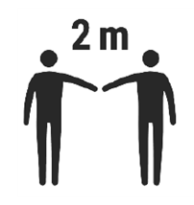Parents/guardians are responsible for completing daily health care screening for their child before they arrive at school or enter a bus. Refer to Appendix B. School Administrators will provide the questions to the parents in advance of the students’ attendance at school. Children who answer ‘Yes’ to any of the questions on the health checklist will not be admitted into the school or school bus, there will be no exceptions. This is to ensure we are following the guidelines provided in this document.

# Hand Washing Protocols

Refer to standard BCCDC procedures in Appendix C.

Children and employees must wash their hands:

* When they arrive at school and before they go home
* Before and after any transitions within the school setting (e.g. to another classroom, indoor-outdoor transitions, moving to on-site childcare, etc.)
* Before eating and drinking (or handling food)
* After using the toilet
* After sneezing or coughing into hands (refer to Sick Child procedures)
* Whenever hands are visibly dirty
* After cleaning tasks (employees)

Hand Hygiene

Rigorous hand washing with plain soap and water is the most effective way to reduce the spread of illness. Both students and staff can pick up and spread germs easily, from objects, surfaces, food and people. Everyone should practice diligent hand hygiene. Parents, caregivers and staff can teach and reinforce these practices amongst students.

How to practice diligent hand hygiene:

* Wash hands with plain soap and water for at least 20 seconds. Antibacterial soap is not needed for COVID-19.
* If sinks are not available *(e.g., students and staff are outdoors),* use alcohol-based hand rub containing at least 60% alcohol.
* If hands are visibly soiled, alcohol-based hand rub may not be effective at eliminating respiratory viruses. Soap and water are preferred when hands are visibly dirty.
* To learn about how to perform hand hygiene, please refer to the BCCDC’s hand washing poster (Appendix C).

# Custodial

Custodial staff must clean the school thoroughly every evening after the school is closed. Custodians must also clean all touch points and check supplies in the school at least twice daily, or at another time as agreed to by the Administrator.

Custodians are also required to complete daily health checks (see Appendix A).

Custodians will follow standardized “enhanced cleaning procedures” as directed by the SD5 Custodial Manager. See Appendix D.

Custodians will use liquid solutions only with no dry sweeping. The detergents and disinfectant products will adhere to the requirements of the BCCDC and the instructions on the labels will be closely followed.

# Toys and Sports Equipment

School staff will select the minimum number of toys and sports related equipment required. Selected items must be easily cleaned. No stuffed toys.

Parents/guardians must not allow children to bring toys from home without first notifying school staff. Items from home will be considered personal items for use of the child (or children within the same household) and not to be shared with other children. No stuffed toys.

There will be no access to outdoor play structures. Green spaces and limited equipment will be available during outside play.

# Food

Children and employees must wash their hands before and after eating.

Food is the responsibility of the parent/guardians. No food sharing is permitted. Parents should provide food that requires minimal preparation. Microwaves will not be accessible to students.

Please contact your school Principal if there are unforeseen circumstances with respect to your child’s food requirements.

Food consumption procedures and policies will be administered at the school level in conjunction with input from employees and JOHSC.

Tips for ensuring food / packaging are sanitized: Wash all fruits and vegetables with soap and cold water then rinse (only applicable for SD5 provided items). In the event an employee is required to assist with a child’s food, they should wash hands thoroughly before and after handling and make every effort to avoid contact with the food.

# Sick Child and Occupational First Aid Attendants (OFAAs)

Any child exhibiting COVID-19 symptoms (refer to Appendix B), or feeling ill, must be isolated from others and supervised in a separate room with a door. Parents / guardians must be notified and will be advised to pick-up the child **immediately**. Staff supervising symptomatic children must use strict hand washing techniques and wear a surgical mask.

**Parents / guardians must provide an emergency contact number and be available to pick up their child as soon as possible in order to protect the other children and employees.**

Where available, help a symptomatic child don a child sized surgical mask.

OFAA’s must become familiar with the protocols for attending a first aid incident ([First Aid Protocols during the COVID-19 Pandemic](https://www.worksafebc.com/en/about-us/news-events/announcements/2020/May/new-resource-for-first-aid-protocols-during-covid-19-pandemic?origin=s&returnurl=https%3A%2F%2Fwww.worksafebc.com%2Fen%2Fsearch%23q%3DOFAA%26sort%3Drelevancy%26f%3Alanguage-facet%3D%5BEnglish%5D)).

Except for the designated Supervisor or OFAA, there must be no access to the seclusion room during isolation. Contact Joe Tank (Operations: 250-417-2085 or joe.tank@sd5.bc.ca) immediately if a child or employee shows symptomatic signs. There must be no access to the room after child pick-up until cleaning has been effected by custodial staff. The isolation room must be Super Cleaned before reuse.

Employees who become symptomatic during the work day should contact their OFAA and Administrator immediately.

**Students may be required to provide medical clearance before they are able to return to the school.**

Wear disposable gloves when cleaning blood or body fluids (e.g. runny nose, vomit, stool, urine). Wash hands before and after removing gloves.

Respiratory Etiquette

Students and staff should:

* Cough and sneeze into their elbow, sleeve, or a tissue. Throw away used tissues and immediately perform hand hygiene.
* Refrain from touching their eyes, nose or mouth with unwashed hands.
* Refrain from sharing any food, drinks, unwashed utensils, cigarettes, or vaping devices.

Cloth or homemade masks are not recommended, particularly for children. There is limited evidence outside of health care settings and only in uncontrolled situations where physical distancing between adults cannot be maintained for extended periods of time *(greater than 15 minutes with a person who has probable or lab confirmed COVID-19)*.

Parents, caregivers and staff can teach and reinforce these practices amongst students.

Personal Protective Equipment

Personal protective equipment (PPE), such as masks and gloves are not needed, beyond those used by staff as part of regular precautions for the hazards normally encountered in their regular course of work. They should only be used when all other controls fail *(e.g. only used when other control methods cannot reduce the risk to a low enough level).* If a mask is requested, SD5 will supply non-medical masks to employees.

Managing students with complex behaviours, on a delegated care plan or experiencing a health emergency may require staff to be in close physical proximity with the student. No additional personal protective equipment is required *(for reducing COVID-19 transmission)* beyond precautions regularly taken or previously identified for the use with a specific student.

There is no evidence to support the use of medical grade, cloth or homemade masks in school settings at this time. Wearing a mask is a personal choice. It is important to treat people wearing masks with respect.

More information about COVID-related mask use is available on the BC Centre for Disease Control website.

# Hazardous Materials

All disinfectants, detergents, hand sanitizers must be safely stored out of reach of children.

Soap and water is the preferred method of cleaning a child’s hands and hand sanitizers should only be used with children under the direct control of school staff.

All chemicals must be properly labelled in accordance with WHMIS requirements.

# Student Transportation on Buses

Buses used for transporting students will be cleaned and disinfected according the guidance provided in the BCCDC’s Cleaning and Disinfectants for Public Settings document. Additional measures include:

* Encouraging private (e.g. parents or caregivers) vehicle use where possible to decrease transportation density.
* Providing bus drivers with PPE when requested.
* Children who are showing symptoms will not be allowed to board the bus.
* Children who become symptomatic during the day will be prohibited from entering the bus at the end of their day. Parents/guardians should be prepared to transport children if this situation arises.
* 1 student per row, alternating sides of the bus at each row.
  + Students from the same household can share seats if space is limited.
    - Seats will be clearly marked for availability.

# Children of Essential Service Workers, Students with Disabilities/Diverse-Abilities and Students Who Require Additional Supports

Children of essential service workers, students with disabilities/diverse-abilities and students who require additional supports will have access to 5 days per week of in-school instruction and/or school day care at the choice of the parent(s) or guardian(s) to return to in-class instruction. Remote or virtual learning remains an option. The District calendar is in effect - non-instructional days are not available.

For some medically fragile kids are at higher risk during the pandemic and restart. Check BC CDC website for information <http://www.bccdc.ca/health-info/diseases-conditions/covid-19/priority-populations>

It is anticipated that most children requiring in-person instruction in K-12 school settings will be capable of following the District Health and Safety procedures outlined.

Some students will require more personal assistance and care. These student may require hands-on support.

# Some Additional Points to Remember in Situations Where You Interact with Students with Complex Needs

Universal Precautions

There are number of universal precautions (see Appendix A) we have in place around the regular personal care we provide students before our current pandemic. Please be vigilant in using universal precautions.

Please use your Mandt Training

* Keep Your Radar On.
* Use Crisis Cycle knowledge and remember inverted Maslow.
* Use Graded and Gradual Hierarchy of Interventions.

The Use of Personal Protective Equipment (PPE)

* Gloves are not needed, beyond those used by staff as part of regular precautions for the hazards normally encountered in their regular course of work.
* Gloves must be used when dealing with all bodily fluids.
* There is no evidence to support the use of medical grade, cloth or homemade masks in school settings at this time.
* Wearing a non-medical mask is a personal choice for staff and students. It is important to treat people wearing masks with respect. The school district will provide non-medical masks to employees upon request.

Behaviour Support Plans and Staff Response Plans

* Children should be screened case by case to determine levels of support required to safely bring students into the school environment and any support plans will be provided to the School Principal.
* Staff working with children that have Behaviour Support Plans and/or Staff Safety Plans in place should review these plans prior to working with the child.
* Managing students with complex behaviours or experiencing a health emergency may require staff to be in close physical proximity with a student. No additional personal protective equipment is required *(for reducing COVID-19 transmission)* beyond precautions regularly taken or previously identified for the use with a specific student.

Physical Distancing Recommendations

* Maintain physical distancing of 2 metres between adults in the building.
* Minimize physical contact - Remind children, “Hands to Yourself!”
* Provide additional EA support 1-1, 2-1
* Avoiding close greetings like hugs or handshakes; remind children to keep hands to themselves
* Help younger children learn about physical distancing by creating games.
* Use social stories where appropriate
* Use visuals for communication
* Older children can be provided age appropriate reading material and encouraged to self-regulate.
* NO food or drink sharing.
* Encourage independent learning and distancing from each other.

Recommendations on Spitting

* Although this behaviour is challenging, if the student is asymptomatic and healthy, the risk of transmission is low, especially if the behaviour is paired with handwashing and cleaning
* Wipe down any area with saliva with approved sanitizer or disinfectant wipes
* If in contact with saliva, wash hands and/or affected areas

Recommendations on Biting

* If in contact with saliva, wash hands and/or affected areas

Recommendations on Toileting or Diapering

* Wear gloves
* Wash hands before and after toileting
* Safe diapering (see Appendix B)

Children requiring a Nursing Support Services Care Plans

* At this time, Public Health is not able to create new delegated care plans, nor does Public Health want to exclude students who have/require a plan.
* During this time that NSSC nurses are not available, plans are not viable (suspended) because there is no delegating nurse to oversee the care.
* At this time parents will be required to complete the care themselves until this has been sorted out.

Recommendations on Toys and School Supplies

* Keep enough toys out to encourage individual play.
* Items that may encourage group play in proximity or increase the risk of hand-to-hand contact such as playdough should be removed from the classroom.
* Try to limit toys and other items to those that can be easily cleaned.
* Sharing of school supplies will not be allowed.
* Like other respiratory viruses, there is no evidence that the COVID-19 virus is transmitted via textbooks, paper, or other paper products. As such, there is no need to limit the distribution of books or paper based educational resources to students due to concerns about virus transmission.

Recommendations on Keeping Parents/Caregivers Informed

* Keep parents and caregivers informed about what you are doing at your school to take extra precautions, be responsive to children. Be clear about our policy that children need to stay home if they are sick.

Needing Assistance?

If you are having difficulty implementing any of the recommended strategies, please contact the District Principal of Student Services or the Student Services Coordinators

# Appendix A Daily Health Checks for Staff

Employees must ensure the answer to these questions is No, before they enter the workplace:

* Do you have a fever?
* Do you have a cough?
* Do you have congestions?
* Do you have a nasal drip?
* Are you sneezing?
* Is anyone in your household sick?

# Appendix B Daily Health Checks for Children

Parents must ensure the answer to these questions is No, before their child enters the school:

* Have your children shown any symptoms or illness?
* Do they have a fever?
* Do they have a cough?
* Any congestions or runny nose?
* Are you sneezing?
* Is anyone in your household sick?

In addition, there may be additional questions which a school may request information:

* Does you student have a lunch/snacks for the day?
* Any medications or other information that may be required?
* Contact and emergency contact in the event parents/guardians need to be contacted.

# Appendix C Hand Washing Protocol

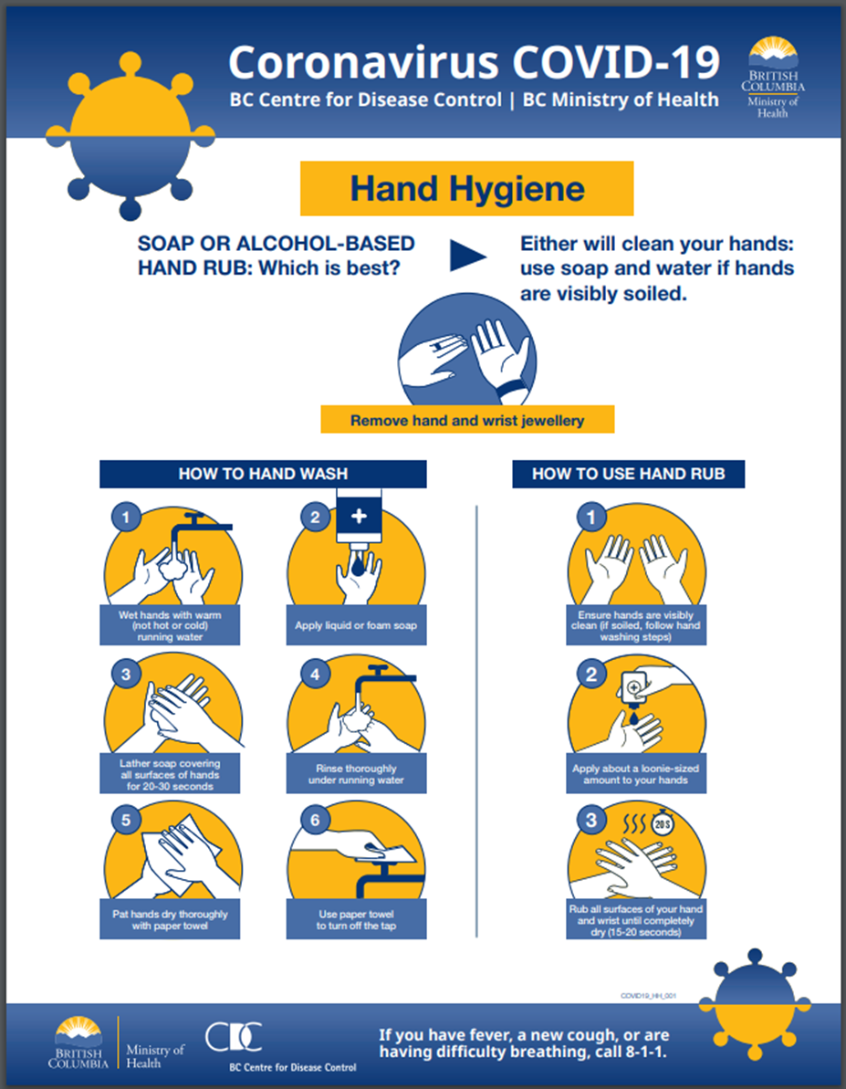

# Appendix D Enhanced Cleaning Procedures

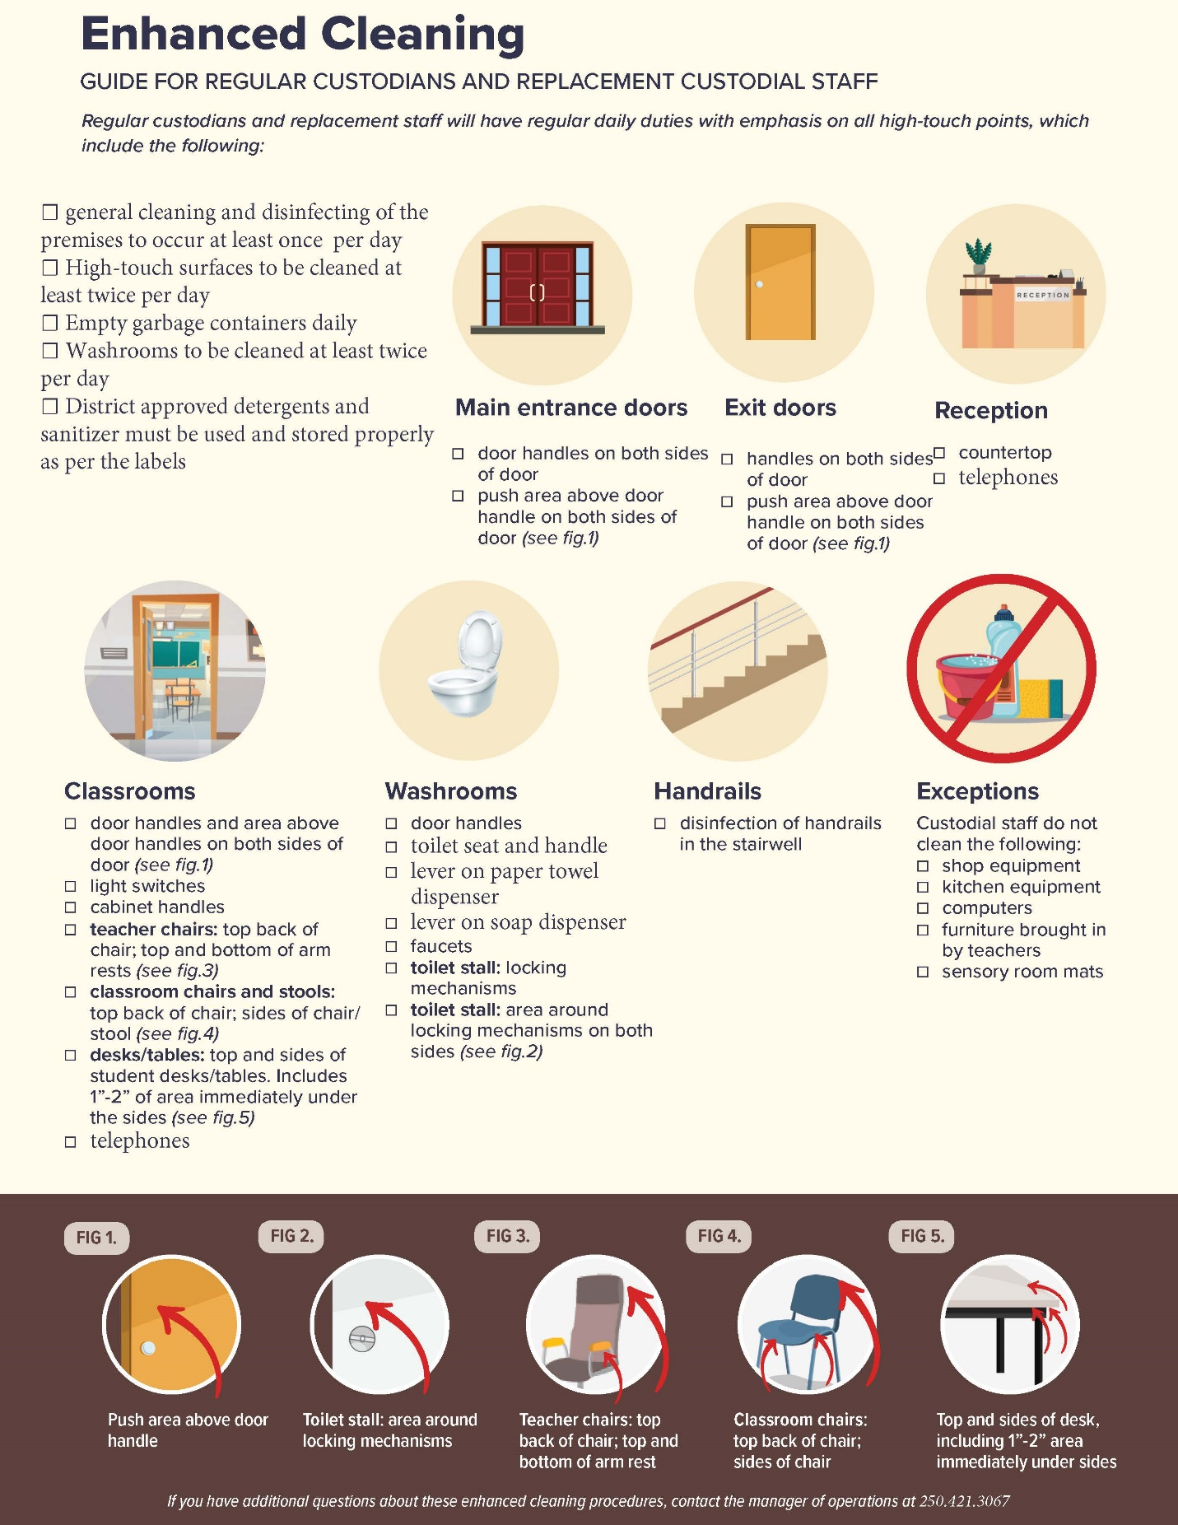

# Appendix E Universal Precautions

The rules and principles of infection control are the same no matter what infectious agent is the cause for concern.

Components of Universal Precautions include:

* Personal Protective Equipment
  + Wearing gloves, masks, eye protection
  + Gloves must be discarded after each use.
  + Hands must be washed each time gloves are discarded
* Hand washing
* Decontamination
  + Cleaning methods, spill clean up, disinfectant spray
* Waste Disposal
  + Sharps containers, Biohazard bags, double bagging
  + Treat all human blood and potentially infectious body fluids as contagious.
  + Precautious should be taken when handling stool, urine, nasal secretions, and vomit.
* When lifting
  + Use good body mechanics
  + Good posture
  + Use both hands
  + Avoid twisting

# Appendix F Safe Diapering



# Appendix G How to Use a Mask

